Multi-Session
Instructor Teaching
Guide

The Foundations for Safety Leadership 4 Residential Construction (FSL4Res) course was developed collaboratively by

Development of the FSL4Res training was supported with funding from a cooperative agreement to CPWR - The Center for Construction Research and Training (#U60OH009762) from the National Institute for Occupational Safety and Health (NIOSH) The FSL4Res is based on the original FSL training created by CPWR under an earlier NIOSH cooperative agreement (#OH009762) The contents are solely the responsibility of the authors and do not necessarily represent the official views of NIOSH. All Rights Reserved.
Table of Contents

Introduction 4
Goal of FSL4Res 4
Learning Objectives 4
Information for Teaching the FSL4Res 5
Purpose of the Instructor Guide 5
Teaching Materials & Tips 5
Key Terms & Concepts 5
Multi-Session Description and Outline 7
Applying Leadership Skills in Real World Scenarios 8
Scenario Structure, Character Naming & Activities 8
PowerPoint Navigation & Instructor Tips 9
Session 1 10
Session Outline 11
Welcome 11
Characteristics of Ineffective & Effective Leaders 12
Importance & Benefits of Safety Leaders 14
Introduction of Safety Leadership Skills 14
Session 2 20
Session Outline 21
Welcome 21
Safety Leadership Skill Review 22
Derailing the Job Scenario 26
Session 3 32
Session Outline 33
Welcome 33
Brief Skill Review 34
Reality Check Scenario 37
Session 4 43
Session Outline 44
Brief Skill Review 45
Cover Up Scenario 45
Don’t Shortcut Safety Scenario 50
Booster Session 56
Session Outline 57
Welcome 57
Self-Assessment 58
Taking it Back to the Jobsite 58
Additional FSL4Res Resources 59
Take Aways 59

For alternate scenarios, additional tools, and resources on safety climate, visit cpwr.com

Introduction

Everyone, from the company owner to the experienced foreman and new trainee/apprentice, needs to own safety and be a safety leader. The Foundations for Safety Leadership 4 Residential Construction (FSL4Res) training module is designed to introduce construction workers, particularly those with supervisory responsibilities, to safety leadership principles and give them the skills to be a safety leader who can help create and sustain a safe and productive jobsite. The FSL4Res module was developed by a curriculum development team that included experienced OSHA 10 and 30-hour outreach trainers, construction workers, safety and health professionals from the construction industry, and safety, health, and leadership experts.

The first part of the FSL4Res module introduces foremen/workers to reasons why safety leadership is important and describes the safety leadership skills emphasized in the training. The remainder provides opportunities to work through real-world construction-based scenarios allowing students to think more about how to apply the safety leadership skills on the jobsite.

Goal of FSL4Res
Introduce frontline leaders to critical safety leadership skills they can use to improve safety climate and safety outcomes on the job site.

Learning Objectives
By the end of this training students will be able to:
- Explain why safety leadership is important
- Describe critical safety leadership skills
- Discuss how an effective leader can apply safety leadership skills on the jobsite

Information for Teaching the FSL4Res

Purpose of the Instructor Guide
This guide is designed to provide instructors/trainers with all the information and materials needed to successfully conduct the Foundations for Safety Leadership 4 Residential Construction (FSL4Res) training.

Teaching Materials & Tips
- Instructor Guide - Includes:
  - Numbered thumbnails of PowerPoint slides
  - Instructor notes for each slide (also in the PowerPoint slides)
  - Questions to engage students in discussion
  - Written scenarios
  - Short quiz to use at the conclusion of training
- Student Handout – Includes:
  - Foundational information on importance of safety leadership
  - Written scenarios
  - Leadership skills and action checklist
- PowerPoint slides - Include:
  - Slides plus notes for all foundational material
  - Slides for two teaching modes for all four scenarios:
    - Watch – Animated videos and discussion questions
    - Read – Bullet points from script and discussion questions

Key Terms & Concepts
Safety Leader Definition - Safety leaders have the courage to demonstrate that they value safety by working and communicating with team members to identify and limit hazardous situations, even in the presence of other job pressures such as scheduling and costs. There are many skills that safety leaders can use to demonstrate leadership.

Critical Safety Leadership Skills and Actions are covered in the FSL4Res training module:
Skills and Actions of an Effective Safety Leader
Leadership Skills | Good Leadership Actions
Leads by Example | - Establishes safety expectations as a core value  - Shares safety vision with team members  - Demonstrates a positive attitude about safety  - ‘Walks the Talk’  - Leads up!
Engages and Empowers Team Members | - Engages, encourages, and empowers team members to identify and act upon unsafe situations by…  - Reporting hazards and safety concerns  - Providing solutions  - Reporting near misses  - Stopping work if necessary
Actively Listens | - Actively listens to hear what team members are saying  - Treat team members with respect when they are speaking and listen to hear what is said vs. coming up with a response  - Pay attention to non-verbal cues and ask clarifying questions
Practices 3-way Communication | - Is direct and concise, and makes sure s/he has the listener’s attention  - Asks team member to repeat message, and clarify misunderstandings
Develops Team Members Through Teaching, Coaching, and Feedback | - Respectfully teaches and coaches workers  - Watches the learner fix the hazardous situation or perform the task to make sure it's done correctly  - Focuses on potential consequences rather than on the team member  - Uses the FIST principle: Facts, Impact, Suggestions, Timely
Recognizes Team Members for a Job  Well Done | - Privately and/or publicly acknowledges team members for going above and beyond when it  comes to safety

Multi-Session Description and Outline
The information covered in the Multi-Session and 2.5 hour versions of the FSL4Res is the same. We created the multi-session version to enhance flexibility when training is conducted on a residential construction site.

The four scenarios in this training were chosen by our stakeholders as the most relevant to residential construction. However, you are free to use any of the additional scenarios available on the CPWR website You can use either the Watch (video) or Read (script) teaching mode and may want to choose different modes for different scenarios.

Below is a high-level description of the five sessions. More detail and guidance on presenting them is provided on the following pages.

Session 1
- Welcome & introductions, training goals, learning objectives, importance of effective leadership, leadership skills covered in the FSL4Res, and self-assessment.
Session 2
- Review leadership skills covered in Session 1, share experiences using/seeing these skills used on the jobsite, and review self-assessment.
- Scenario: “Derailing the Job” - Tomas, a trainee, removes a guardrail in order to finish his drywall taping job. Before leaving, he forgets to replace the guardrail, creating a fall hazard for the carpentry crew.
Session 3
- Review leadership skills, share experiences using/seeing them used on the jobsite.
- Scenario: “Reality Check” - Eduardo, an experienced worker, sees trainees Troy and Tara getting ready to climb onto the roof of a house and asks if they have secured the ladder and inspected the harnesses, ropes, and anchor points. The trainees tell Eduardo that everything is fine.
Session 4
- Scenario: “Cover Up” - There is a large hole in the plywood floor causing a fall hazard for the electricians installing new wiring, Frank, AMB’s foreman asks Tia, a trainee, to fix the hazard, assuming she know exactly what to do.
- Scenario: “Don’t Shortcut Safety” - Franklin, the foreman, tells his apprentice Aarón to install some shutters but doesn’t fully communicate his expectations about safety.
Session 5
- Brief review, share experiences using/seeing leadership skills applied on the jobsite.
- Setting up for success
- Wrap-up

Applying Leadership Skills in Real World Scenarios

Scenario Structure, Character Naming & Activities

Structure
Each scenario illustrates a frontline leader’s response to a worker facing a fall safety hazard. Because the goal of the FSL4Res is to teach leadership and not safety skills, you should keep the discussion focused on the leadership skills the scenario is designed to illustrate rather than the safety hazard. If students identify a particular safety issue while working through the scenario, use the moment to recognize them for noticing it, but then quickly get back to the leadership skills.

The scenarios start by illustrating a fall related safety situation on a construction site. This is followed by two possible outcomes in which a frontline leader either uses or doesn’t use one or more of the leadership skills.
- Situation – A fall hazard is present
- Outcome A – Leader does not use leadership skills
- Outcome B – Leader uses leadership skills

Character Naming
In each scenario, you’ll introduce students to a number of different characters. The first letter of each character’s name is based on their job position: Superintendent, Foreman, Experienced worker, or Trainee/apprentice. For example:
- Stan is a Superintendent
- Frank is a Foreman
- Emilio is an Experienced worker
- Tia is a Trainee/apprentice

Activities
- Analyze whether the characters used any of the safety leadership skills.
- Discuss what could have been done better.

PowerPoint Navigation & Instructor Tips
Active Buttons
On each scenario’s introductory slide, there are hyperlinked icons for the teaching modes.
Watch activity slides contain the three animated video sections and discussion questions.
Read activity slides contain key points from the full scenario, plus discussion questions. The expectation is that the students will read the scenario or instructor will read it aloud to the class.

Keeping Track of Where You Are
In the upper left-hand corner of each slide there is an icon and text to give you a quick indication of which scenario and activity you are on.
1. Cover Up!

Instructor Notes
Throughout the facilitator guide, you will see italic text. These are additional notes, suggestions, and background information that you may need as you are leading the session. You will also see larger sections of italic text in a blue box. The information inside the blue boxes is not required to be read aloud to the class, but additional information for you to use if needed.

Scenario Leadership Checklist
While facilitating the scenario discussion using either of the teaching modes, consider drawing a table like this one. After each outcome (A and B), you may use the discussion questions to ask the students which leadership skills were demonstrated and keep track of their responses in the table. Keep in mind that a single scenario won’t cover all safety leadership skills.

Leadership Skills | Outcome A | Outcome B
Lead by Example | ___YES ___NO | ___YES ___NO
Engage and Empower | ___YES ___NO | ___YES ___NO
Actively Listen | ___YES ___NO | ___YES ___NO
Practice 3-Way Communication | ___YES ___NO | ___YES ___NO
Develop: Teach, Coach, Feedback | ___YES ___NO | ___YES ___NO
Recognize Team Members | ___YES ___NO | ___YES ___NO

Session 1

Session Outline
Session 1 | Time | Page # / Slide # | Description
Welcome | 5 min | Page 11-12 / Slides 1-4 | - Introductions, goals and learning objectives
Characteristics of ineffective and effective leaders | 5 min | Page 12-14 / Slides 5-8 | - Engage students in discussion of their experiences with ineffective and effective leaders.  - Definition of a Safety Leader  - Who are Safety Leaders?
Importance and benefits of effective safety leadership | 5 min | Page 14 / Slide 9 | - Summarize benefits of effective safety leadership
Introduction of safety leadership skills | 15 min | Page 14-19 / Slides 10-20 | - Present and discuss:  - Safety leadership skills & how to use them on the job  - Provide self-assessment & skill sheets  - Takeaways

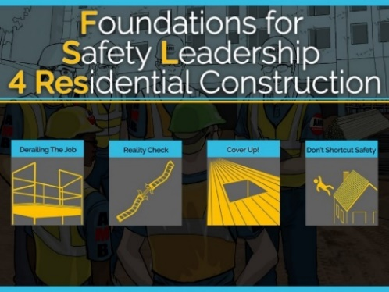
NOTES FOR SLIDE 1

Welcome
Introductions:
- Name
- Trade
- Position
- Years in construction

Most of the slides are in the student handout starting on page 4. You can follow along and take notes.

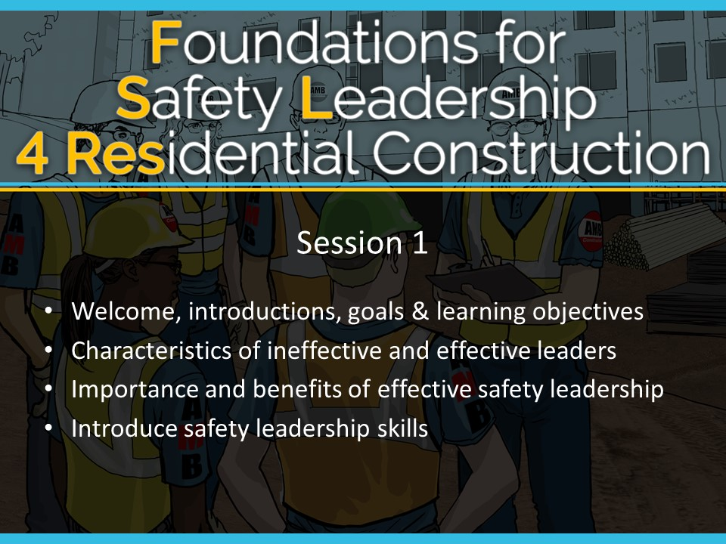NOTES FOR SLIDE 2
Today we will be going over:
- Goals & learning objectives for the session
- The definition of a safety leader
- Characteristics of ineffective and effective leaders
- The importance and benefits of effective safety leadership
- Finally, I’ll introduce the safety leadership skills that we will be discussing throughout this course

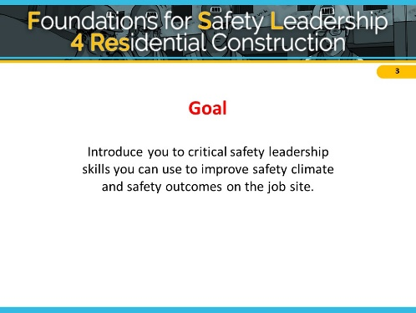
NOTES FOR SLIDE 3
The overall goal of this training is to give you the opportunity to learn and enhance some critical safety leadership skills that you can use to improve the safety climate and safety outcomes on jobsites.
ASK CLASS: How many of you have heard the term safety climate? Do you have any thoughts about what it means? [Discuss]
When we use the term safety climate, we are talking about how well a company’s safety policies, procedures, and practices are actually implemented on the jobsite. When team members practice safety leadership skills they are helping to create a strong safety climate to ensure that everyone works productively, efficiently, and safely.

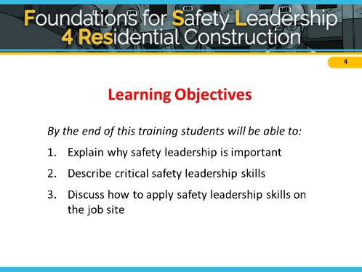
NOTES FOR SLIDE 4
We expect that by the end of this training each of you will be able to:
- Explain why safety leadership is important
- Describe the critical safety leadership skills
- Discuss how an effective leader can apply safety leadership skills on the jobsite

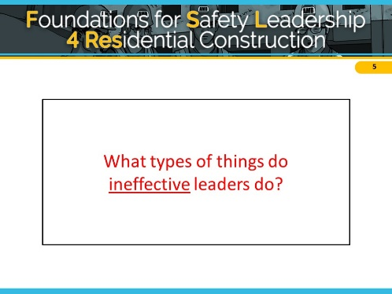
NOTES FOR SLIDE 5

Characteristics of Ineffective & Effective Leaders
To get us started, let’s brainstorm about the types of actions that effective and ineffective leaders display. Think about someone you believe was an ineffective leader. It can be someone you work or have worked with, or maybe he or she was a coach, a teacher, or a parent, or even a friend.
ASK CLASS: What are some behaviors that make
or made them ineffective leaders? [Discuss]
If students provide only a few (or no) ideas, you can ask a few of these questions.
- What are some of the basic behaviors ineffective leaders display? (e.g. lies to protect themselves, withholds information, blames worker, blames superiors, reacts angrily to a problem without addressing the problem and seeking solutions)
- In what ways might ineffective leaders communicate with their team members? (e.g., yell, say “just do it and don’t ask questions”, threaten them with retaliation)
- How might an ineffective leader fail to create a sense of teamwork? (e.g. say things like, “I’m in charge here and you’ll do as I say.” “You don’t need to ask X for their opinion.” )
- How might an ineffective leader fail to lead by example? (e.g. is a poor role model by having team members wear PPE and demands safety from them, but doesn’t ‘walk the talk,’ ignores worker safety concerns, etc)

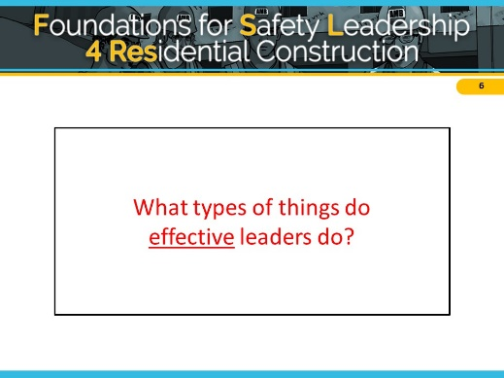
NOTES FOR SLIDE 6
Now, think of someone who you believe is or was an effective leader, or may have even been a really great leader.

ASK CLASS: What are some behaviors that type of person displayed? [Discuss]

If students provide only a few (or no) ideas, you can ask a few of these questions.
- What are some behaviors effective leaders demonstrate? (e.g. never goes back on their word, tells the truth, works hard)
- How do effective leaders communicate with other people? (e.g. listens to hear vs. listens to speak, asks questions, gives clear instructions and expectations)
- How might an effective leader create a sense of teamwork? (e.g. s/he might ask about a team member’s family or weekend activities, make sure team members know each other, highlight the importance of working together as a team to improve safety and ensure no one is working on their own, etc.)
- How might an effective leader lead by example? (e.g. always wears PPE, never takes or encourages workers to take shortcuts, gets the resources necessary to work safely, conducts productive daily safety huddles and pre-task planning meetings during which they ask workers for input on how to best carryout their tasks safely, makes sure team members are working safely, is fair, holds everyone accountable for being safe and reporting hazards, etc.)

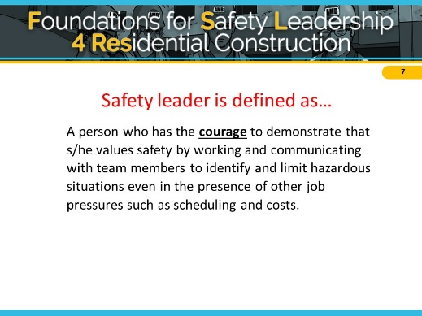
NOTES FOR SLIDE 7
ASK CLASS: How would you define a safety leader? [Give class time to respond]

In the FSL4Res course, we define a safety leader as...
A person who has the courage to demonstrate that s/he values safety by working and communicating with team members to identify and limit hazardous situations even in the presence of other job pressures such as scheduling and costs.
ASK CLASS:
- What do you think about the word courage?
- Does it take courage to be a leader?
- Does the amount of courage depend on your role or position on the jobsite?
- When a company values safety and it’s not just a priority, how might that affect the need for courage? [Discuss]

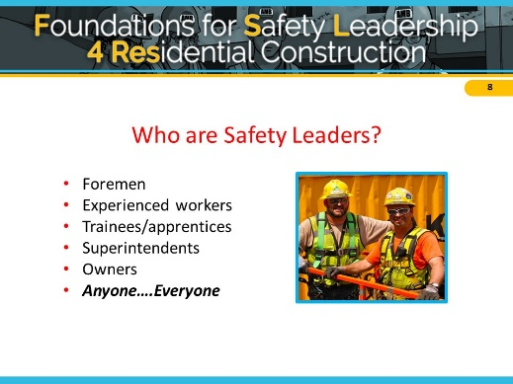
NOTES FOR SLIDE 8
ASK CLASS: Who are the safety leaders on a jobsite? [Discuss]
Anyone, regardless of their title or role, who values their safety and well-being and that of their fellow workers, is responsible for being an effective safety leader. This means that everyone needs to develop and use safety leadership skills.

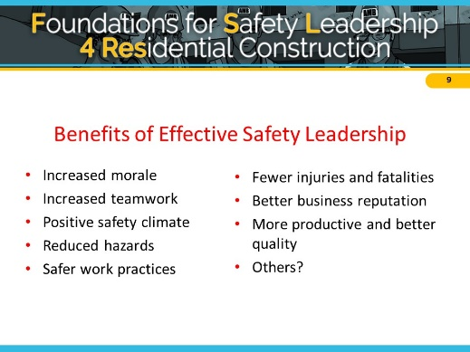
NOTES FOR SLIDE 9

Importance & Benefits of Effective Safety Leadership
ASK CLASS: So, to summarize, tell me what you think some of the benefits are of being an effective safety leader on a jobsite? [Discuss]
We’ve gone over ineffective and effective leadership and how good leadership can improve safety climate and safety outcomes. Next we’re going to go over what skills she or he can use on the jobsite.

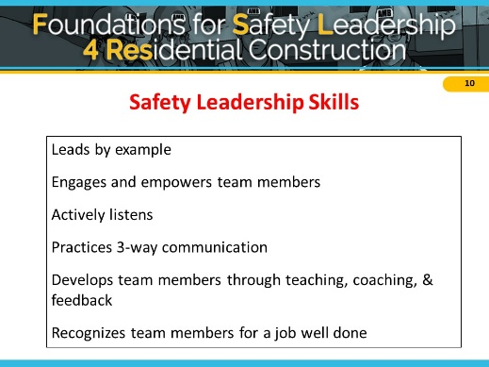
NOTES FOR SLIDE 10

Introduction of Safety Leadership Skills
The FSL4Res course focuses on critical skills that you as a safety leader can use to create a strong jobsite safety climate and reduce safety incidents.
Here they are… [Reveal skills to class]
If you are going to use the wallet cards, distribute them now. Tell class: These wallet cards list the leadership skills. I’d encourage you to put it in your wallet and look at it every so often to refresh your memory of what you will learn today.
Next, we are going to discuss the specific actions you can use to demonstrate each of these on the jobsite.

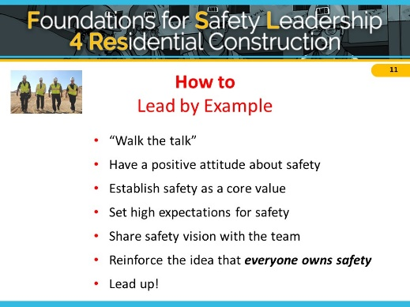
NOTES FOR SLIDE 11
Leading by example is probably the most important of the safety leadership skills in the FSL4Res course. Team members learn from their leaders. They notice when they cut corners, don’t follow safety policies or procedures, or give inconsistent safety messages.
The first way to lead by example is to “Walk the talk” – follow safe work procedures and safe practices; practice what you preach in terms of safety; don’t practice the old way of “Do as I say, but not as I do.”
Demonstrate a positive attitude about safety - Use optimistic language when discussing safety with your crew. Praise crew members who come to you with safety concerns.
Establish safety as the team’s core value - Demonstrate that safety is one of your core values by considering the safety implications of every decision you and your crew make. As a safety leader you must set high safety expectations for every team member - Regularly let your crew know that you expect them to always use safe work practices.
Develop and share your safety vision with your team - Consider the safety implications of all your decisions and share those with your team; Talk about the importance of safety for you and your crew and be consistent. Emphasize that safe work goes hand-in-hand with productive, quality work and that injuries will impact their work and home life.
Consistently communicate that everyone owns safety - It’s not just the foreman’s or safety person’s responsibility. It’s up to everyone to keep the jobsite safe for themselves and others.
A final way to lead by example is to lead up by working to persuade individuals like company owners and others in supervisory positions to improve jobsite safety and health. These actions send the message that safety is an integral part of working every day and not just a way to avoid safety violations.

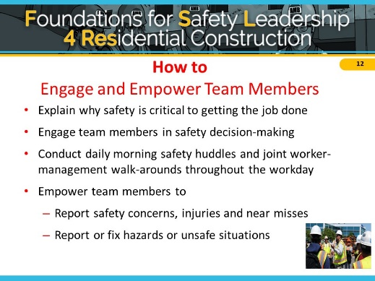
NOTES FOR SLIDE 12
The next leadership skill is to engage and empower team members in the safety process.
You can explain why working safely is critical to getting the job done and not just say “be safe.”
You can engage the team in safety-related decisions so they can see how they, too, own safety. These skills can be used with the whole group as well as with individual workers.
Involving workers in daily huddles and joint management walk-arounds lets the team know that safety is valued, it is an essential aspect of how work gets done, and they are a critical part of the overall safety effort.
Finally, as a leader, you need to empower team members to report jobsite hazards, safety concerns, and near misses. Encourage your team to immediately act upon unsafe or hazardous situations by reporting the issue to you. Ask their opinions on how to fix the issue and be open to their suggestions. Make it clear that there will be no negative consequences or retaliation when they report safety concerns, injuries or near misses.
You can develop an “action list” to show how issues raised are addressed and place the list in a prominent place to help ensure accountability and build trust. You can also encourage them to tell you about potential safety issues ahead of time so you can take care of them and prevent injuries before they occur.

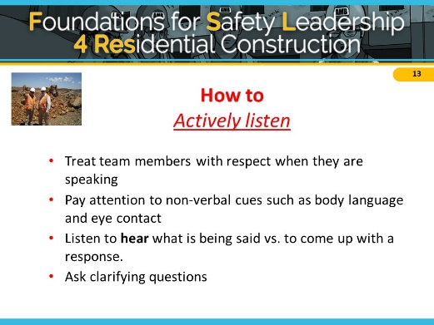
NOTES FOR SLIDE 13
Being able to communicate effectively is at the core of all the other leadership skills and is critical to becoming an effective safety leader.
Learning to actively listen first involves treating your team member with respect and giving that person your full attention. Don’t check phones, emails, or read other materials during the conversation.
Pay special attention to your and the speaker’s body language because it can sometimes convey more information than words. Maintain eye contact; avoid making negative facial expressions or raising your voice. If you’re feeling resentful or insulted, make an extra effort to maintain professional conduct. Most importantly, you need to listen to hear what the person is saying rather than listening just to come up with a response.
Finally, ensure you understand what speaker is saying or asking by asking clarifying questions or paraphrasing what the crew member said back to them, so you can ensure you heard them correctly (i.e., “What I hear you saying is….”).

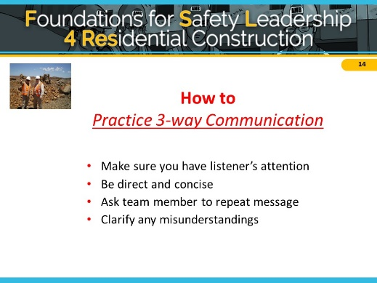
NOTES FOR SLIDE 14
This skill outlines a simple strategy you can use to reduce misunderstandings between you and the person you’re speaking with. Practicing 3-way communication helps ensure everyone understands your message or instructions.
Here is how you do this -
- First, make sure you have the listener’s attention - Before you start speaking, make sure you have your crew member's undivided attention; be sure that neither of you are preoccupied with phones, computers, or other distractions.
- Be direct and concise - Be specific when you give directions or assignments. Avoid giving unrelated information that might lead to confusion.
- Ask the listener repeat what you said to be sure the message was understood. - Don’t assume your listener understood what you said. Ask crew members to repeat your message to confirm that they understand what you’re asking. If you feel uncomfortable asking them to repeat the directions, you can say: “Just to be sure we are on the same page, can you tell me exactly what you are going to do?” This is the key to 3-way communication.
- Finally, clarify any misunderstandings - If you hear any misunderstanding from the crew, clarify and get final confirmation that everyone is on the same page.

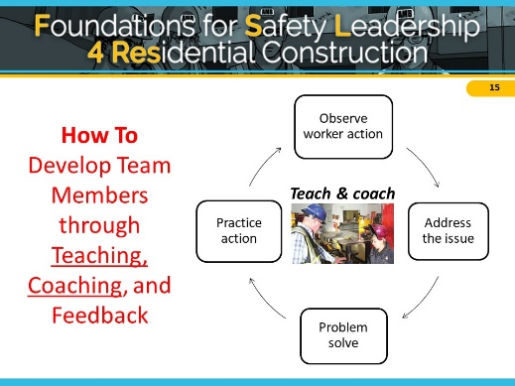
NOTES FOR SLIDE 15
Effective safety leaders work to develop their team members by teaching and coaching them on how to do things correctly and safely on the jobsite. They also provide feedback to let them know how they are doing and if any changes are needed.
Teaching = telling; Coaching = watching; Feedback = evaluating performance
First, we’ll talk about teaching and coaching.
When you want to teach a team member a new or better way to do something, respectfully ask questions to understand why s/he is doing it that way and then problem-solve together (even if you already have a solution) to find a better or safer approach to completing the task. Show the team member how to perform the activity correctly, then watch him/her to be sure they have learned how to do it. If they need to be corrected, treat the person with respect and be a coach. Encourage team members to constantly update their knowledge and skills so they can do their jobs better and safer.

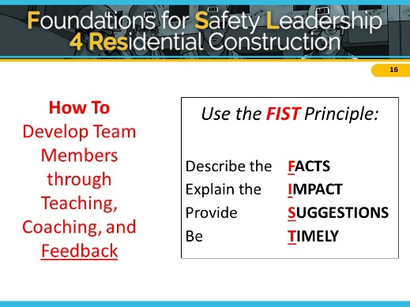
NOTES FOR SLIDE 16
Providing constructive feedback is another leadership skill you can use to develop your team members. When giving constructive feedback, try hard to focus on the situation or behavior rather than the person. The FIST principle can help you do that.
First, describe the Facts: What is the situation or activity/ behavior for which you are providing feedback? When and where did it occur? What were the circumstances?
Then explain the Impact that are the potential consequences that may result (good or bad)? Then, offer Suggestions: Work together to problem-solve and come up with solutions. Think of ways team members might use the same approach in the future. Be Timely: Don’t wait to provide feedback. It is more effective when you give it close to when the situation/behavior occurred.

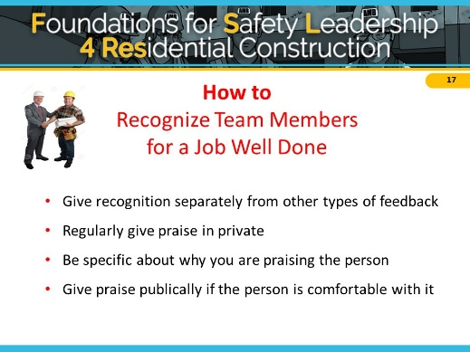
NOTES FOR SLIDE 17
The final skill effective safety leaders display is recognizing team members when they go above and beyond to maintain a strong positive jobsite safety climate.
When you recognize team members:
- Give recognition separately from other types of feedback
- Regularly give praise in private
- Be specific about why you are praising the person
- Give praise publicly if the person is comfortable with it
Appreciation motivates and encourages team members to continue working to maintain and improve the jobsite safety climate. Like other types of feedback, recognition should be given in a timely manner, and it must be sincere. It may be as simple as saying “good job,” giving a hand shake, or saying “thank you” for going the extra mile for safety or for something really well done.
It’s important to know your team members as individuals so you can use praise and acknowledgement effectively. For those who are comfortable with public praise, it is a great way to show others that safety is valued. However, a person uncomfortable with public praise may be more embarrassed rather than pleased. There are generational differences, as well as differences between individuals. Some workers like to feel valued and appreciated while others feel uncomfortable with praise in public. Think about personality of individuals and jobsite culture or climate. Be careful to consider any perceived preferential treatment.

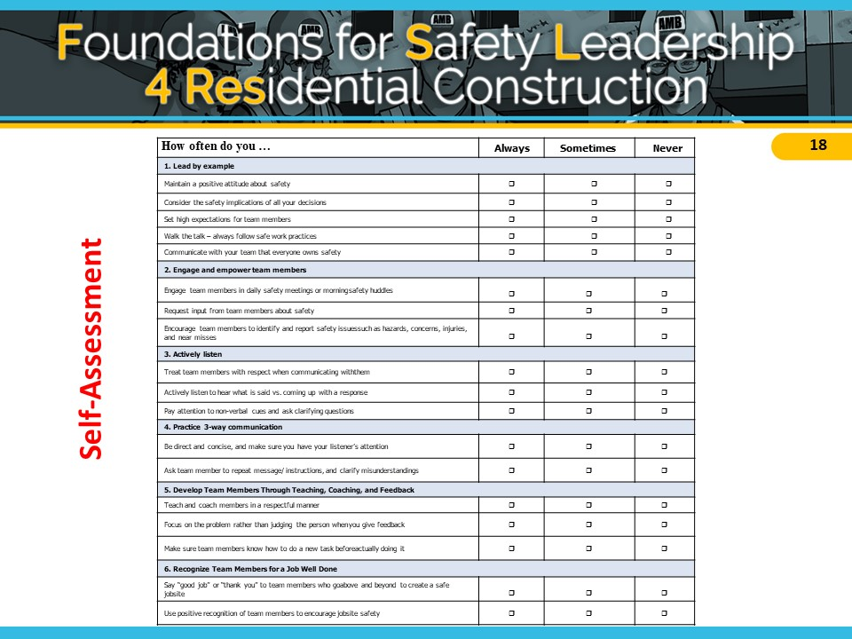NOTES FOR SLIDE 18
[Pass out self-assessment worksheet]
This worksheet will give you an idea of how often you already use the leadership skills and which ones are new to you. Please complete the worksheet and bring it to Session 2 so we can discuss how often you use the skills on the jobsite.

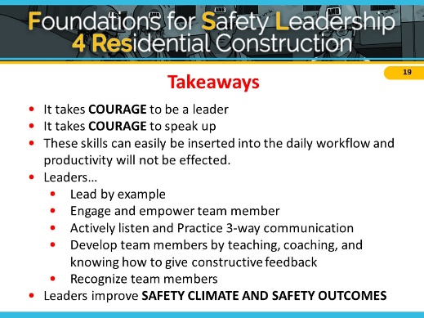
NOTES FOR SLIDE 19
We’ve come to the end of the first session, and we’ve covered a lot.
Before we uncover the take away messages, tell me one or two things you learned today, or even better, something you’re going to start or maybe stop doing when you get back to the jobsite.
So, here are the key points I hope you will take away with you and put into practice on the jobsite:
It takes courage to be a leader and speak up.
You can use these skills on a daily basis without affecting workflow and productivity

Leaders…
- Lead by example
- Engage and empower team members
- Actively listen
- Practice 3-way communication
- Develop team members by teaching, coaching, and knowing how to give constructive feedback
- Recognize team members for going above and beyond for safety
And finally, if you use these skills on the jobsite and become a true safety leader, you can improve both jobsite safety climate and safety outcomes.

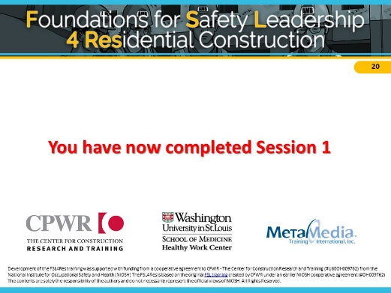
NOTES FOR SLIDE 20
This ends session 1.
Please remember to complete your self-assessment and bring it with you to session 2.

Session 2

Session Outline
Session 2 | 30 min total | Page # / Slide # | Description
Welcome | 2 min | Page 21 / Slides 1-2 | - Introductions and session outline
Safety leadership skill review | 13 min | Pages 22-26 /  Slides 3-11 | - Review the definition of safety leadership  - Present skill sheets and review leadership skills; discuss how they have used them on the job  - Review self-assessment results and discussion
“Derailing the Job” and discussion | 15 min | Pages 26-31 / Slides 12-27 | - Use the Read or Watch teaching mode to review “Derailing the Job” scenario and discuss the characters’ use or non-use of safety leadership skills

NOTES FOR SLIDE 1

Welcome
Introductions (if needed)

Refer to student handout to take notes. We’ll be reviewing skills taught in Session 1, which can be found starting on page 4.

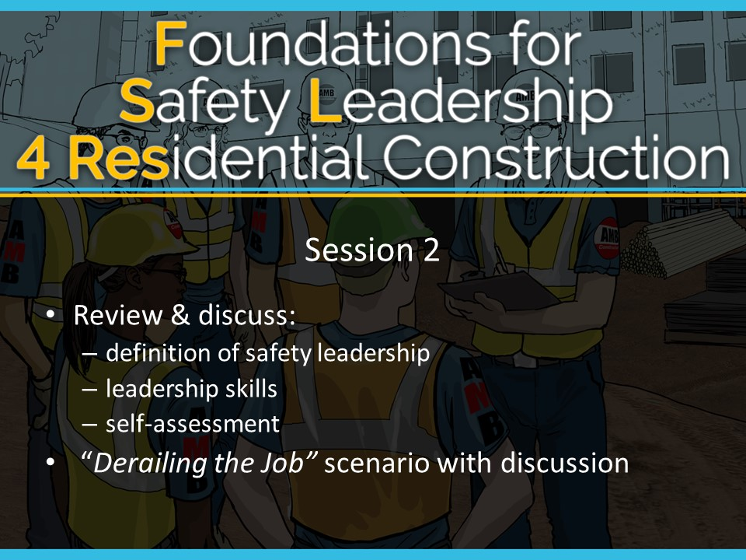NOTES FOR SLIDE 2
Today we will:
Review & discuss:
- The definition of safety leadership
- Safety leadership skills
- Your self-assessment

We will also go through the “Derailing the Job” scenario and discussion.

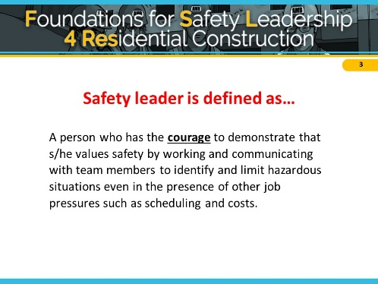
NOTES FOR SLIDE 3

Safety Leadership Skill Review
ASK CLASS: Can someone remind me of how we’re defining a safety leader in the FSL course and the importance of the word courage?
A person who has the courage to demonstrate that s/he values safety by working and communicating with team members to identify and limit hazardous situations even in the presence of other job pressures such as scheduling and costs.

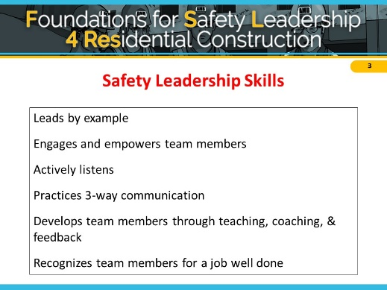
NOTES FOR SLIDE 4
In session 1 we went over six skills an effective safety leader uses on the jobsite to create a strong jobsite safety climate and reduce safety incidents.

ASK CLASS: Can someone name one or more of the safety leadership skills we discussed? [Reveal answers after giving students a chance to respond. For the sake of time, limit discussion and move through review quickly]

The first thing we’re going to do today is briefly review the steps you can take to practice these skills on the jobsite.

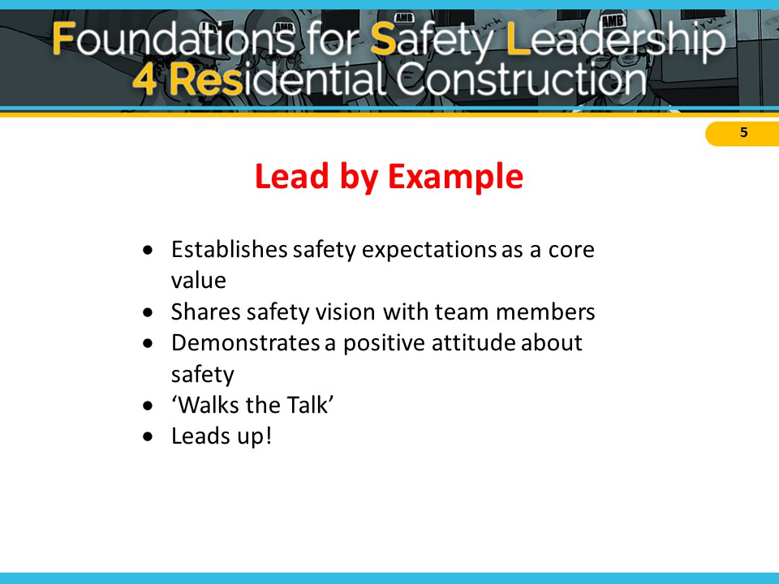

NOTES FOR SLIDE 5
Recall that leading by example encourages everyone to prioritize a safe work environment as team members learn from their leaders. They notice when they cut corners, don’t follow safety policies or procedures, or give inconsistent safety messages.
ASK CLASS: Can you recall some ways to lead by example that we discussed in Session 1?

In the interest of time - we recommend clarifying points as the class offers the details of this skill and only reviewing the material below if not brought up in discussion.
- Set high safety expectations for every team member. Let them know on a regular basis that you expect them to always use safe work practices and ensure that other team members do too, and immediately report hazardous conditions and all injuries or near misses.
- Share your safety vision with team members. You can talk about the importance of safety and that safe work goes hand-in-hand with productive and quality work. Also consider the safety implications of all your decisions and share those with your team.
Show that you personally value safety and consistently demonstrate a positive attitude about safety. Establish safety as the team’s core value by building it into all aspects of the job.
- Don’t practice the old way of “Do as I say, but not as I do,” and instead, “Walk the talk” by always following safe work procedures and practicing safe practices.
- Lead up by working to persuade individuals like company owners and others in supervisory positions to improve jobsite safety and health. Find out what has (and hasn’t) worked in the past to motivate them to improve safety and health policies; Try to get them to think about safety in a new way; Present solutions, rather than only pointing out problems; and find others (workers, foremen, etc.) to help you convey your message.

ASK CLASS: Has anyone had the opportunity to practice or observe this skill? [Discuss]
It can take courage to take these actions, but it lets everyone know that everyone is responsible for keeping the jobsite safe for themselves and others.

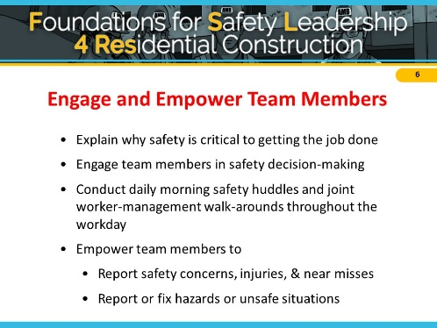
NOTES FOR SLIDE 6
The next leadership skill we went over in Session 1 was engaging and empowering team members…
Engaging and empowering your team members in the safety process lets the team know that safety is valued, and helps the team understand how they, too, can own safety.

ASK CLASS: What are leadership actions you can take to engage and empower your team members? [Discuss]

In the interest of time - provide clarifying points as the class offers the details of this skill and only review the material below if not brought up in discussion:
- Involve crew members in safety decision-making.
- Conducting daily morning safety huddles and walk-arounds throughout the day to speak with workers about tasks and any safety issues.
- Make it clear that no one will get in trouble for reporting unsafe conditions, near misses, or injuries.
- Create trust so that identified safety issues are taken seriously.
- Develop an “action list” that shows how issues raised are addressed and post the list in a prominent place to help ensure accountability and build trust.

ASK CLASS: Has anyone had the opportunity to practice or observe this skill? [Discuss]

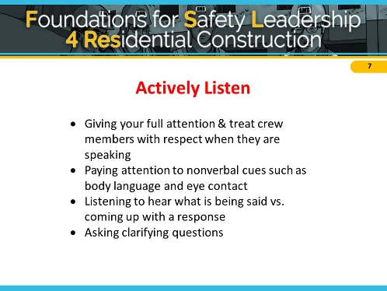
NOTES FOR SLIDE 7
Active Listening was the third leadership skill we discussed. Recall that communicating effectively is at the core of all the other leadership skills and is critical to becoming an effective safety leader. Actively listening will help you and your team members avoid miscommunication and will let your team know their voice is valued.
ASK CLASS: What are some of the steps needed to actively listen? [Discuss]
In the interest of time - provide clarifying points as the class offers the details of this skill and only review the material below if not brought up in discussion:
- Treat team member with respect and give that person your full attention.
- Pay special attention to your and the speaker’s body language.
- Maintain eye contact; avoid making negative facial expressions or raising your voice.
- Most importantly, listen to hear what the person is saying rather than listening just to come up with a response. You can miss key information if you are already formulating what you want to say back to your crew.
- Make sure to ask clarifying questions to ensure you understand what speaker is saying or asking.
ASK CLASS: Has anyone had the opportunity to practice or observe this skill? [Discuss]
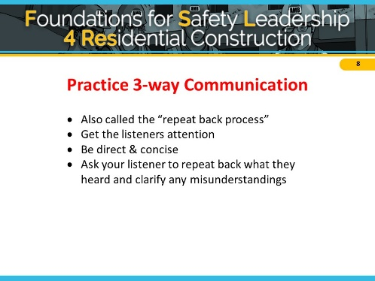

NOTES FOR SLIDE 8
As a safety leader you should be setting your workers up for safety success by making sure they have the training for the job, they are physically able to carry out the instructions, and that they understand your message and instructions. Practicing three-way communication helps your crew feel safe and comfortable completing their tasks and speaking out if they have any questions
ASK CLASS: Recall the second important communication skill is practicing 3-way communication. What are some of the steps needed to practice this skill? [Discuss]

In the interest of time - provide clarifying points as the class offers the details of this skill and only review the material below if not brought up in discussion:
- Get the listener’s attention. Make sure there are no distractions so you can both focus on the conversation at hand.
- Be direct & concise. Keep the conversation short and focused.
- Ask your listener to repeat back what they heard and clarify any misunderstandings,
ASK CLASS: Has anyone had the opportunity to practice or observe this skill? [Discuss]

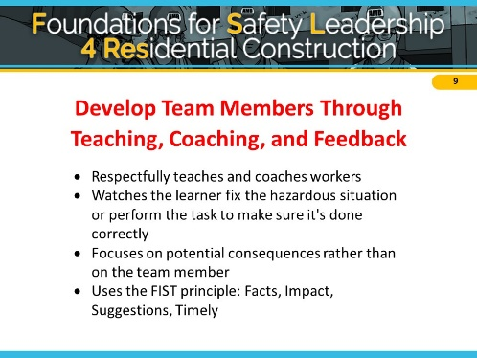
NOTES FOR SLIDE 9
The fourth skill we discussed last time was how to develop team members through teaching, coaching, and feedback.
ASK CLASS: What are the steps leaders should take to teach, coach, and provide feedback to team members? [Discuss]

In the interest of time - provide clarifying points as the class offers the details of this skill and only review the material below if not brought up in discussion:
- Observe crew members. Be attentive to whether your crew members are performing tasks safely and properly.
- Teach by problem solving together. If a crew member is not performing a task safely, respectfully ask questions to understand why they are performing the task that way and then problem-solve together to find a better or safer approach to completing the task.
- Coaching involves showing folks how to perform tasks correctly and safety, as well as watching them fix the hazardous situation or perform the task to make sure it’s done correctly.
- We discussed the FIST principle for providing constructive feedback, where the leader focuses on the Facts, Impact, making Suggestions, and doing all of this in a Timely manner.
ASK CLASS: Has anyone had the opportunity to practice or observe this skill? [Discuss]

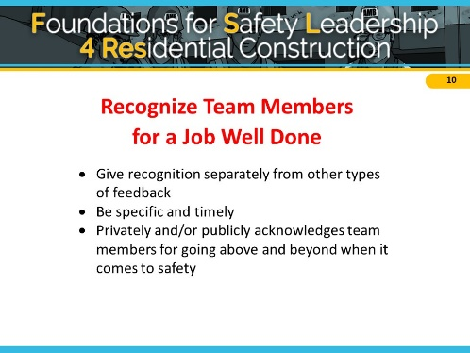
NOTES FOR SLIDE 10
The last skill we discussed was the importance of recognizing team members for a job well done. Recognizing team members (even something as simple as “thank you”) helps create a positive jobsite safety climate, and let workers know they are valued.
ASK CLASS: What is important to remember about recognizing team members? [Discuss]
In the interest of time - provide clarifying points as the class offers the details of this skill and only review the material below if not brought up in discussion:
- Give recognition separately from evaluative types of feedback
- Make sure the crew member knows why you’re praising them and do it shortly after the situation occurs.
- Don’t hold back from privately acknowledging crew members for going above and beyond when it comes to safety, and if the crew member is comfortable receiving praise publicly, it can be a great way to show others how highly you value safety.
ASK CLASS: Has anyone had the opportunity to practice or observe this skill? [Discuss]

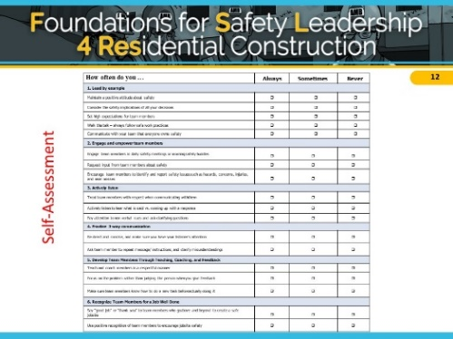
NOTES FOR SLIDE 11
Now that we’ve reviewed the safety leadership skills and discussed how to practice them in the real world, let’s talk about what you learned from your self-assessments..

ASK CLASS: Did any of your answers surprise you? Do you use any of the skills already? What skills are used more than others? [Discuss]

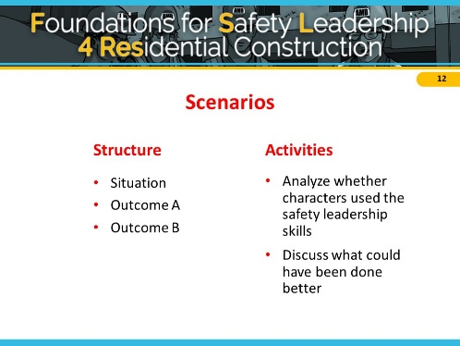
NOTES FOR SLIDE 12
Next we’re going to work through the first real-world scenario. All the scenarios you’ll work through during the course start with a description of a fall-related safety situation on a construction site. This is followed by two possible outcomes where a leader either uses or doesn’t use one or more of the leadership skills.
We’ll be analyzing if the characters use any or all of the safety leadership skills and then discuss what they could have done better.
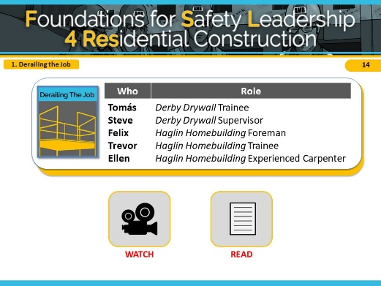
To help facilitate this discussion, you can create a Scenario Leadership Checklist as described on page 9 using a whiteboard or flip chart.

NOTES FOR SLIDE 13

Derailing the Job Scenario
The primary safety leadership moment illustrated in “Derailing the Job” is what can happen when production and scheduling are prioritized over safety.
This scenario shows a two-story single-family home being built in a new residential neighborhood.
As soon as the drywall crew is finished, the carpenters will begin putting up the crown molding.
Remember that these scenarios are meant to illustrate how the safety leadership skills you’ve learned can be used to address a safety situation.
This scenario is designed to illustrate the following safety leadership skills:
- Leading by example
- Actively listening
- Engage & Empower
- Recognize team members
CLICK ON DESIRED TEACHING MODE…

Scenario Script

Derailing the Job
Tomas – Derby Drywall Trainee
Steve – Derby Drywall Supervisor
Felix – Haglin Homebuilding Foreman
Trevor – Haglin Homebuilding Trainee
Ellen – Haglin Homebuilding Experienced Carpenter

Situation
A crew from the Derby Drywall company is trying to finish taping the drywall in a two-story residential home. Their supervisor, Steve, told them earlier that the job must be completed by the end of the day because they have another job starting tomorrow.
Tomas, a trainee, is unable to finish his taping work on the stairwell because one of the scaffold guardrails is in his way. Keeping in mind what Steve said, Tomas removes the guardrail and finishes taping, but forgets to reinstall the guardrail before leaving for the day.
When the Haglin Homebuilding carpentry crew arrives to begin installing the crown molding, Trevor, a trainee, notices the missing guardrail and tells Felix, his foreman, about it.
Outcome A
Felix thanks Trevor for letting him know and tells him to “deal with it.” Trevor isn’t sure if he should put the guardrail back up since Felix didn’t tell him to but decides it’s better to be safe than sorry.
Later, Felix notices that the guardrail is up, but doesn’t say anything to Trevor or any other crew members.
Outcome B
Felix is surprised and asks if this has happened before. The workers nod and Ellen says she noticed the same thing last week, but she put it back up without saying anything.
Felix reminds the crew that if the guardrails aren’t attached, someone could fall and get seriously injured. He thanks Trevor and Ellen for paying attention to hazards and for speaking up. Felix says he’s going to talk to the drywall company supervisor.
Later that day, Steve, the Derby Drywall supervisor, stops by the site. Felix calls over Trevor and Ellen and tells Steve about the guardrail being removed. Steve gets defensive, exclaiming that he and his crew always put safety first! He also admits that he’s under pressure from the owner because another job started today.
In a stern voice, Felix says to Steve that Derby’s actions are putting workers at risk of falling. Steve agrees but points out that his crew is unable to work easily or quickly around guardrails. Felix and Steve then work together to develop a process for ensuring that guardrails are in place at all times.

Watch Mode

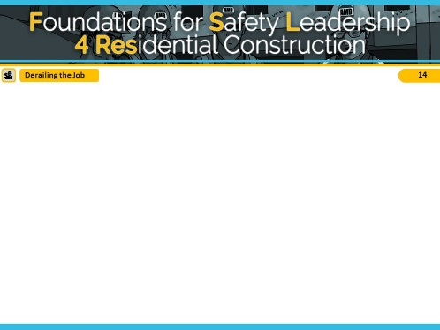
NOTES FOR SLIDE 14
VIDEO WILL START AUTOMATICALLY

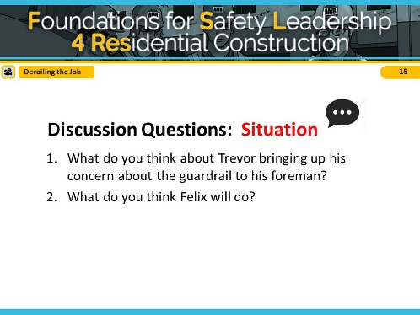
NOTES FOR SLIDE 15
Reveal the discussion questions and/or use the Scenario Leadership Checklist to go through skills.

Try not to spend too much time on the situation so you have time for both outcomes.

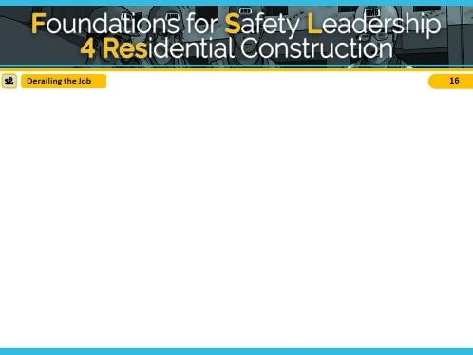
NOTES FOR SLIDE 16
VIDEO WILL START AUTOMATICALLY

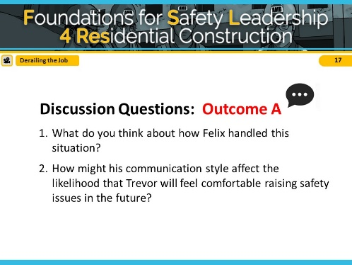
NOTES FOR SLIDE 17
Reveal the discussion questions and/or use the Scenario Leadership Checklist to go through the skills.
Try not to spend too much time on Outcome A so you have time for both outcomes.
In Outcome A, Felix did not use any safety leadership skills and he missed opportunities to utilize the skills and promote a safe worksite.
ASK CLASS: What leadership skills could he have used in this scenario? [Short Discussion]

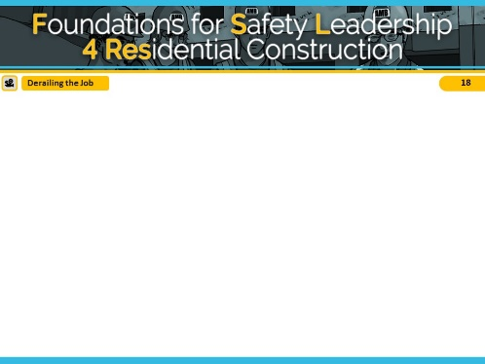
NOTES FOR SLIDE 18
VIDEO WILL START AUTOMATICALLY

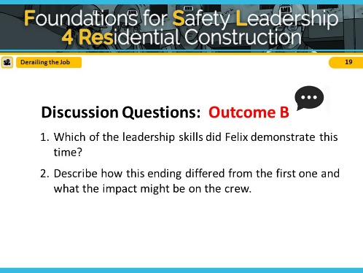
NOTES FOR SLIDE 19
Reveal the discussion questions and/or use the Scenario Leadership Checklist to go through skills.
To recap: In Outcome B, when the guardrail concern was brought to his attention, Felix lead by example and actively listened by asking clarifying questions and showing his team that safety is important by bringing the issue to the drywall supervisor’s attention. He engaged and empowered his team
members when he explained why safety is critical and shared how he’s going to talk to the drywall supervisor and included them in the conversation. Finally, he recognized his crew for bringing the issue to his attention and thanked them for putting safety first.

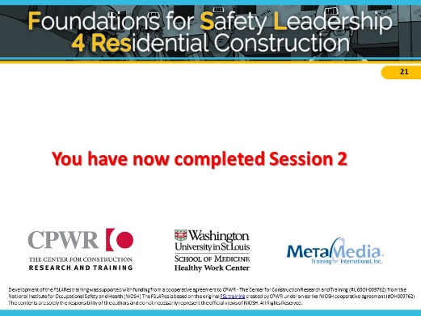
NOTES FOR SLIDE 20
This ends Session 2.

Before next session, choose one or more of the leadership skills to practice by our next session. Make sure to note your experience(s).such as how easy was it to use and how did your crew respond? Please bring these experiences to the next session.

Read Mode

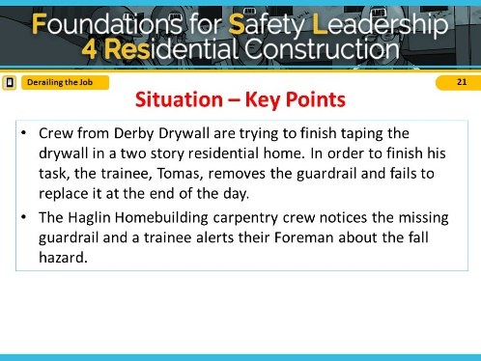
NOTES FOR SLIDE 21
Refer students to page 18 in the student guide.
Read out loud or ask students to read the situation in the “Derailing the Job” script.

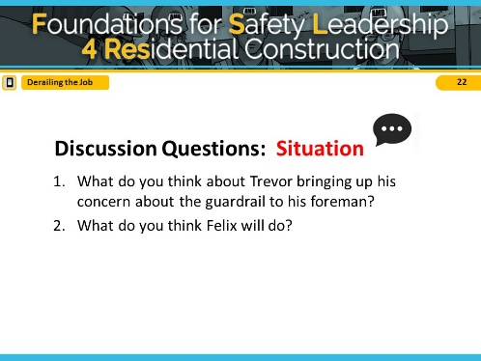
NOTES FOR SLIDE 22
Reveal the discussion questions and/or use the facilitation table to go through skills.
Try not to spend too much time on the situation so you have time for both outcomes.

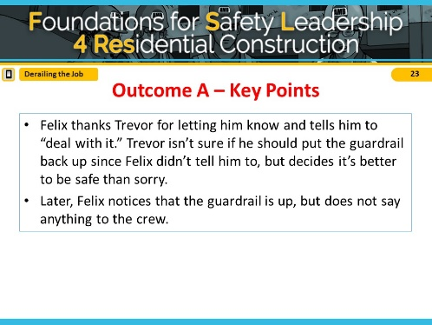
NOTES FOR SLIDE 23
Read out loud or have students read Outcome A in “Derailing the Job” script.

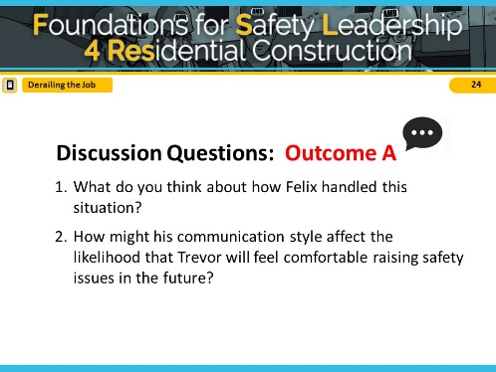
NOTES FOR SLIDE 24
Reveal the discussion questions and/or use the Scenario Leadership Checklist to go through skills.
Try not to spend too much time on Outcome A so you have time for both outcomes.
In Outcome A, Felix did not use any safety leadership skills and missed opportunities to utilize the leadership skills and promote a safe worksite.
ASK CLASS: What leadership skills could he have used in this scenario? [Short Discussion]

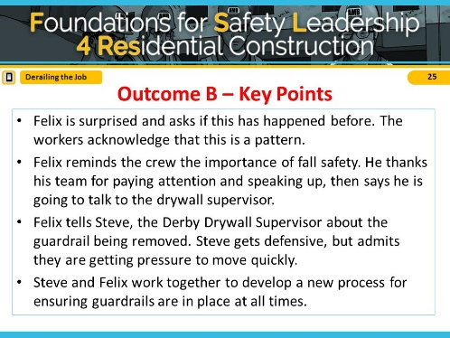
NOTES FOR SLIDE 25
Read aloud or have students read Outcome B in “Derailing the Job” script.

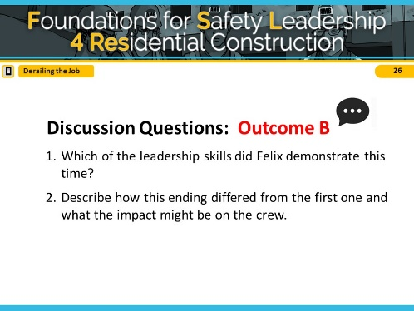
NOTES FOR SLIDE 26
Reveal the discussion questions and/or use the Scenario Leadership Checklist to go through skills.
To recap: In Outcome B, when the guardrail concern was brought to his attention, Felix lead by example and actively listened by asking clarifying questions and showing his team that safety is important by bringing the issue to the drywall supervisor’s attention. He engaged and empowered his team
members when he explained why safety is critical and shared how he’s going to talk to the drywall supervisor and included them in the conversation. Finally, he recognized his crew for bringing the issue to his attention and thanked them for putting safety first.

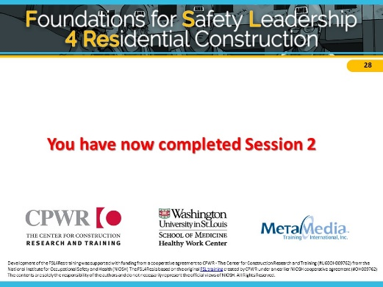
NOTES FOR SLIDE 27
This ends Session 2.

Before next session, choose one or more of the leadership skills to practice by our next session. Make sure to note your experience(s).such as how easy was it to use and how did your crew respond? Please bring these experiences to the next session.

Session 3

Session Outline
Session 3 | 30 min total | Page # /  Slide # | Description
Welcome | 2 min | Page 33 / Slides 1-2 | - Introductions and session outline
Brief skill review | 13 min | Pages 34-36 / Slides 3-9 | - Review the safety leadership skills & how to use them on the job.  - Discuss recent experiences and opportunities for using leadership skills.
“Reality Check” Scenario and discussion | 15 min | Pages 37-42 / Slides 10-25 | - Use the Read or Watch teaching modes to review “Reality Check” and discuss the characters’ use or non-use of safety leadership skills.

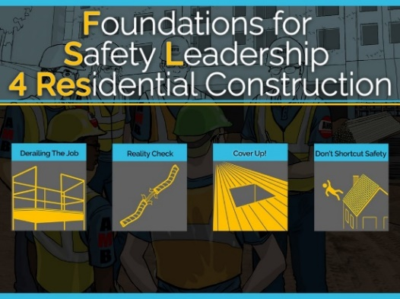
NOTES FOR SLIDE 1

Welcome
Introductions (if needed)

You may refer to student handout to take notes. We’ll first be reviewing the leadership skills, which can be found starting on page 4.

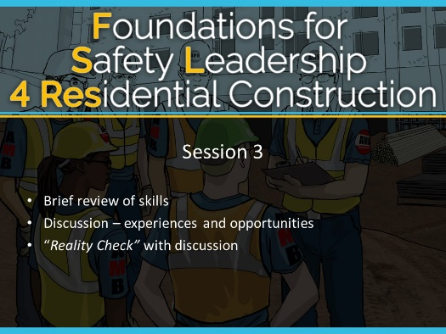
NOTES FOR SLIDE 2
Today we will:
- Briefly review leadership skills
- Discuss recent experiences and opportunities to use leadership skills
- Work through the “Reality Check” scenario with discussion
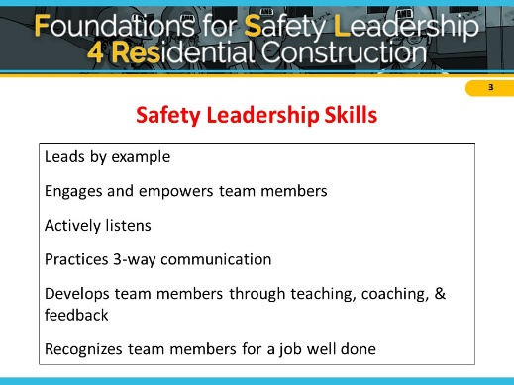
NOTES FOR SLIDE 3

Brief Skill Review
ASK CLASS:
- What are the safety leadership skills of the FSL4Res? [Reveal answers after giving students a chance to respond. For the sake of time, limit discussion and move through review quickly]
- Were you able to practice your chosen leadership skill since last session? Which skill did you choose and what was the experience like?

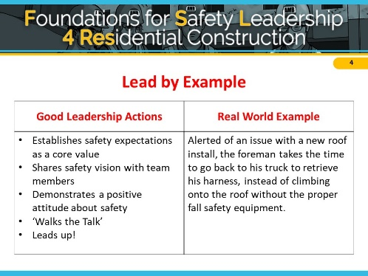
NOTES FOR SLIDE 4
ASK CLASS: What are some of the leadership actions we've discussed for Leading by Example? [Reveal answers after giving students a chance to respond. For the sake of time, limit discussion and move through review quickly]
Leading by example encourages everyone to prioritize a safe work environment. Team members notice when their
leaders’ cut corners, don’t follow safety policies or procedures, or give inconsistent safety messages.
ASK CLASS: Can you give an example of what Leading by Example looks like on the jobsite? [Discuss]
Here is another real world example of what Leading by Example might look like on the jobsite: Alerted of an issue with a new roof install, the foreman takes the time to go back to his truck to retrieve his harness, instead of climbing onto the roof without the proper fall safety equipment.

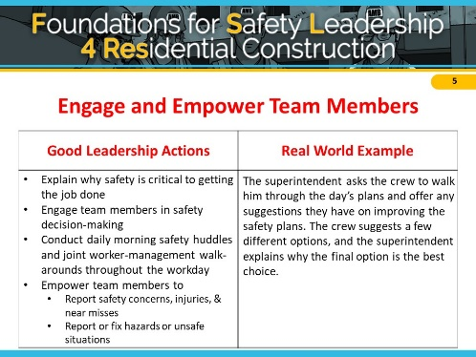
NOTES FOR SLIDE 5
ASK CLASS: What are some of the leadership actions for Engaging and Empowering Team Members we’ve discussed? [Reveal answers after giving students a chance to respond. For the sake of time, limit discussion and move through review quickly]
Engaging team members in the safety process and empowering them to report hazardous situations without fear of retaliation lets the team know that safety is valued, and helps the team understand how they, too, can own safety.
ASK CLASS: Can you give an example of what Engaging and Empowering Team Members looks like on the jobsite? [Discuss]
Here is another real world example of Engaging and Empowering Team Members: The superintendent asks the crew to walk him through the day’s plans and offer any suggestions they have on improving the safety plans. The crew suggests a few options and the superintendent explains why the final option is the best choice.

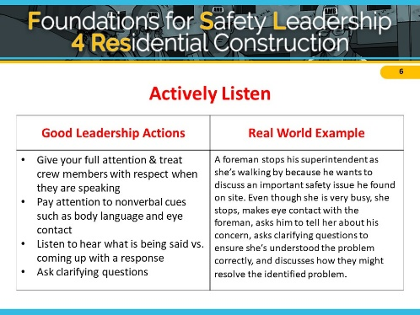
NOTES FOR SLIDE 6
ASK CLASS: What are some of the leadership actions we’ve discussed for Active Listening? [Reveal answers after giving students a chance to respond. For the sake of time, limit discussion and move through review quickly]
Being able to communicate effectively is at the core of all the other leadership skills and is critical to becoming an effective safety leader. Practicing active listening lets your team know their voice is valued and helps avoid miscommunication.
ASK CLASS: Can you give an example of what Active Listening looks like on the jobsite? [Discuss]
Here is another real world example of Active Listening: A foreman stops his superintendent as she’s walking by because he wants to discuss an important safety issue he found on site. Even though she is very busy, she stops, makes eye contact with the foreman, asks him to tell her about his concern, asks clarifying questions to ensure she’s understood the problem correctly, and discusses how they might resolve the identified problem.

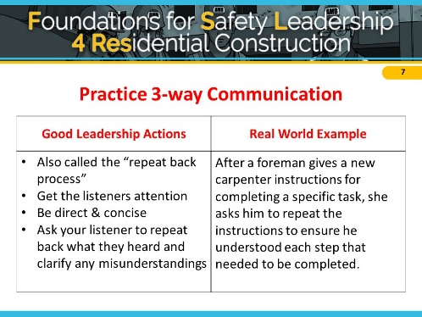
NOTES FOR SLIDE 7
ASK CLASS: What are some of the leadership actions we’ve discussed for Practicing 3-Way Communication [Reveal answers after giving students a chance to respond. For the sake of time, limit discussion and move through review quickly]
3-way communication has also been called the ”repeat back process” and is the best way to ensure that everyone understands your message and instructions and leads to less confusion and poor outcomes.
ASK CLASS: Can you give an example of it looks like to Practice 3-Way Communication on the jobsite? [Discuss]
Here is another real world example of Practicing 3-Way Communication: After a foreman gives a new carpenter instructions for completing a specific task, she asks him to repeat the instructions to ensure he understood each step that needed to be completed.

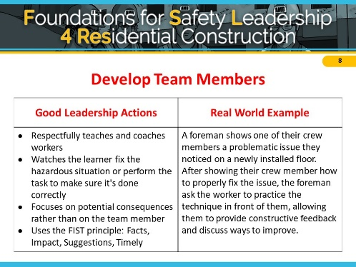
NOTES FOR SLIDE 8
ASK CLASS: What are some of the leadership actions for Developing Team Members? [Reveal answers after giving students a chance to respond. For the sake of time, limit discussion and move through review quickly]
Developing team members through teaching, coaching, and feedback helps correct issues in a way that is respectful and well received.
ASK CLASS: Can you give me an example of what Developing Team Members looks like on the jobsite? [Discuss]
Here is another real world example of Developing Team Members: A foreman shows one of their crew members a problematic issue they noticed on a newly installed floor. After showing their crew member how to properly fix the issue, the foreman asks the worker to practice the technique in front of them, allowing them to provide constructive feedback and discuss ways to improve.

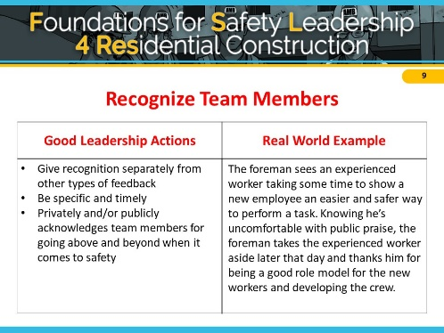
NOTES FOR SLIDE 9
ASK CLASS: What are the leadership actions we’ve discussed for Recognizing Team Members? [Reveal answers after giving students a chance to respond. For the sake of time, limit discussion and move through review quickly]
Recognizing your team for a job well done (even something as simple as “thank you”) creates a strong positive jobsite safety climate, and let workers know they are valued.
ASK CLASS: Can you give me an example of what Recognizing Team Members looks like on the jobsite? [Discuss]
Here is another real world example of Recognizing Team Members: The foreman sees an experienced worker taking some time to show a new employee an easier and safer way to perform a task. Knowing he’s uncomfortable with public praise, the foreman takes the experienced worker aside later that day and thanks him for being a good role model for the new workers and developing the crew.

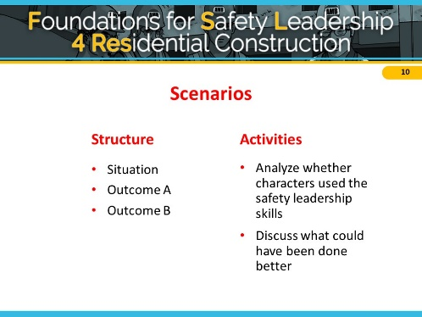
NOTES FOR SLIDE 10
Next we’re going to work through another real-world scenario like we did in the last session. As a reminder, all the scenarios you’ll work through during the course start with a description of a fall-related safety situation on a construction site. This is followed by two possible outcomes where a leader either uses or doesn’t use one or more of the leadership skills.
We’ll be analyzing if the characters use any or all of the safety leadership skills and then discuss what they could have done better.
To help facilitate this discussion, you can create a Scenario Leadership Checklist as described on page 9 using a whiteboard or flip chart.

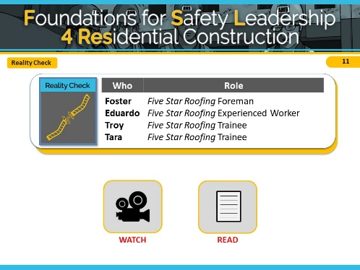
NOTES FOR SLIDE 11

Reality Check Scenario
“Reality Check” takes place on a residential jobsite where a two-story single-family home is being built. Five Star Roofing is on site to shingle the roof.

Remember that these scenarios are meant to illustrate how the safety leadership skills you’ve learned can be used to address a safety situation.

This scenario is designed to illustrate the following safety leadership skills:
- Lead by example
- Actively listen
- Develop team members
- 3-way communication
- Recognize team members

CLICK ON DESIRED TEACHING MODE…

Scenario Script

Reality Check
Foster – Five Star Roofing Foreman
Eduardo – Five Star Roofing Experienced worker
Troy – Five Star Roofing Trainee
Tara – Five Star Roofing Trainee
Situation
As Eduardo, an experienced roofer, arrives at the worksite, he sees trainees Troy and Tara start to climb onto the roof to begin their work. Eduardo asks if they’ve secured the ladder and inspected all of the fall protection harnesses, anchor points, and lines they’ll be using.
Troy snaps back, saying they’d just put the ladder up and the rest of the equipment was checked yesterday. Tara chimes in, saying she’s sure it’s all fine.
Outcome A
Eduardo shrugs. The job has a short timeline and yesterday’s check is probably okay. He tells Troy and Tara to get up on the roof and get started.
Troy reaches the roof and connects his harness to the roof anchor line. As he walks across the roof to retrieve some shingles, he stumbles, but catches himself before falling. Relieved that he is OK after this close call, Troy inspects the anchor line and notices a section that is badly frayed. He realizes that if he had fallen, the anchor line might have snapped, and he could have been seriously injured.
Outcome B
Troy and Tara’s reaction makes Eduardo wonder if they actually know how to inspect the fall protection equipment. Or worse, maybe they think it’s okay to cut corners. He tells them that even though they checked the harnesses, anchor points, and lines the day before, their company requires them to be checked every day, since their fall protection equipment is what keeps them from being injured. Eduardo tells Foster, the foreman, his concerns and suggests it might be a good time to have a huddle to discuss procedures and expectations.
Foster agrees, calls the crew together, and asks them to bring their fall protection equipment with them. He asks Tara and Troy to explain the process for checking the harnesses, anchor points and lines. After a minute or so, Troy admits that they’re not 100% sure what to look for because they’ve always trusted others to check. Rather than being angry, Foster thanks him for being honest and then carefully goes over the OSHA rules and manufacturer's recommendations for checking equipment. When he’s done, he asks Troy and Tara to take turns repeating the rules and demonstrating how to inspect everything.
While doing his checks, Troy finds that part of his anchor line is frayed and shows everyone. As a group, they discuss why this is dangerous and how it reinforces why all equipment must be inspected daily. Foster then watches Troy inspect a new anchor line and properly connect it.
Foster tells them again how much he appreciates their good work, and for admitting when they didn’t know how to do something, particularly when it could have such serious safety consequences. Then Tara surprises Foster by thanking him for recognizing their value as team members, and for saying so.

Watch Mode

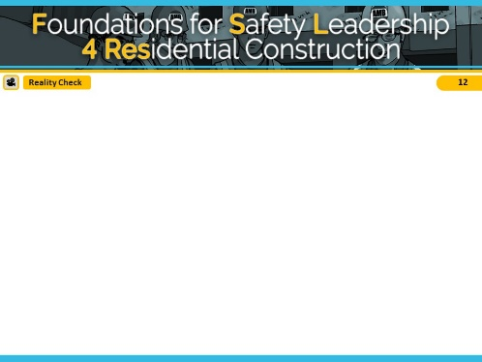
NOTES FOR SLIDE 12
VIDEO WILL START AUTOMATICALLY

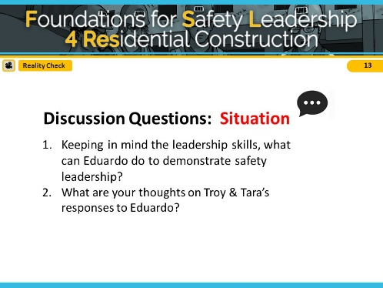
NOTES FOR SLIDE 13
Reveal the discussion questions and/or use the Scenario Leadership Checklist to go through skills.
Try not to spend too much time on the situation so you have time for both outcomes.

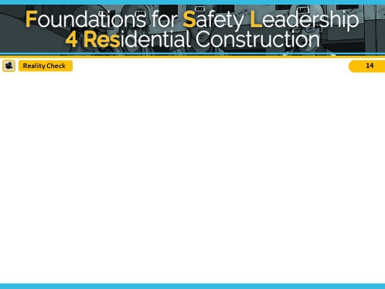
NOTES FOR SLIDE 14
VIDEO WILL START AUTOMATICALLY

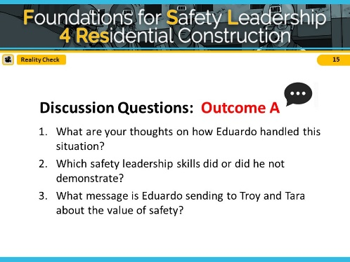
NOTES FOR SLIDE 15
Reveal the discussion questions and/or use the Scenario Leadership Checklist to go through skills.
Try not to spend too much time on Outcome A so you have time for both outcomes.
In Outcome A, Eduardo did not use any safety leadership skills and missed opportunities to utilize the leadership skills and promote a safe worksite.
ASK CLASS: What leadership skills could he have used in this scenario? [Short Discussion]

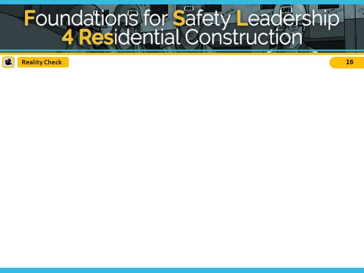
NOTES FOR SLIDE 16
VIDEO WILL START AUTOMATICALLY

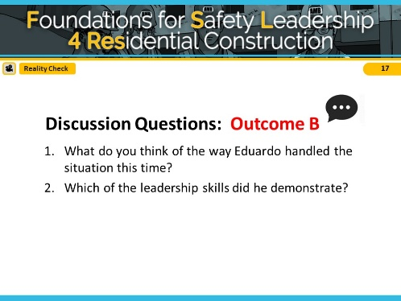
NOTES FOR SLIDE 17
Reveal the discussion questions and/or use the Scenario Leadership Checklist to go through skills.

The first leadership skill Eduardo demonstrated was that he actively listened to how Troy and Tara responded and sensed that they might not actually know how to check the rigging. Then, rather than demanding they check it themselves; he led by example by talking to the foreman Foster and offered to go check it with them. Foster was able to develop the three workers by using his teaching and coaching skills. He used his 3-way communication skills by asking them to reiterate what he had told them. Lastly, he demonstrated his ability to give positive feedback by telling them how glad he was that they admitted not knowing about rigging and recognized them for being good team members and valued workers.

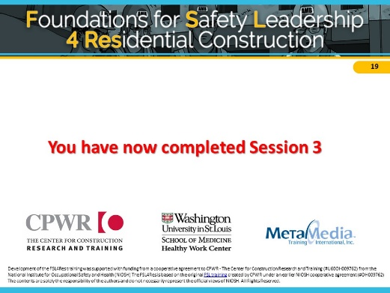
NOTES FOR SLIDE 18
This ends session 3.

Before next session, choose one or more of the leadership skills to practice by our next session. Make sure to note your experience(s), such as how easy was it to use and how did your crew respond. Please bring these experiences to the next session.

Read Mode

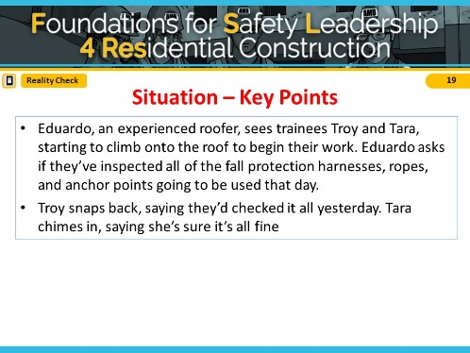
NOTES FOR SLIDE 19
Refer students to page 19 in the student guide.

Read out loud or ask students to read the situation in the “Reality Check” script.

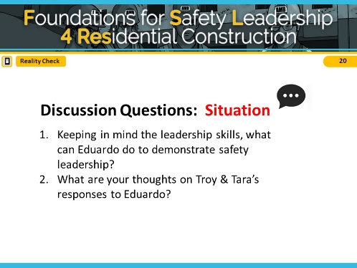
NOTES FOR SLIDE 20
Reveal the discussion questions and/or use the Scenario Leadership Checklist to go through skills.

Try not to spend too much time on the situation so you have time for both outcomes.

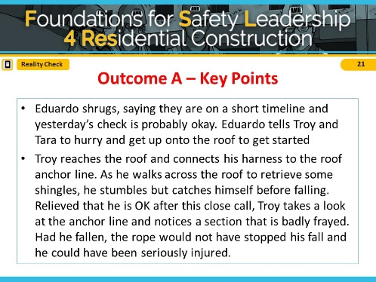
NOTES FOR SLIDE 21
Read out loud or have students read Outcome A in “Reality Check” script.

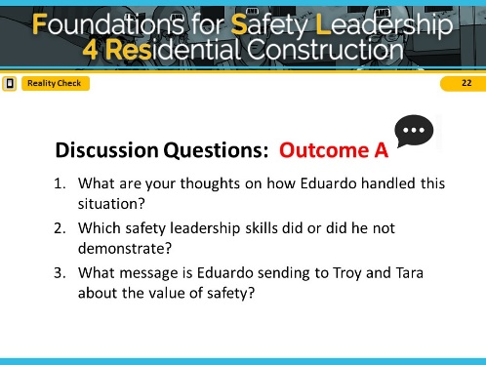
NOTES FOR SLIDE 22
Reveal the discussion questions and/or use the Scenario Leadership Checklist to go through skills.
Try not to spend too much time on Outcome A so you have time for both outcomes.
In Outcome A, Eduardo did not use any safety leadership skills and missed opportunities to utilize the leadership skills and promote a safe worksite.
ASK CLASS: What leadership skills could he have used in this scenario? [Short Discussion]
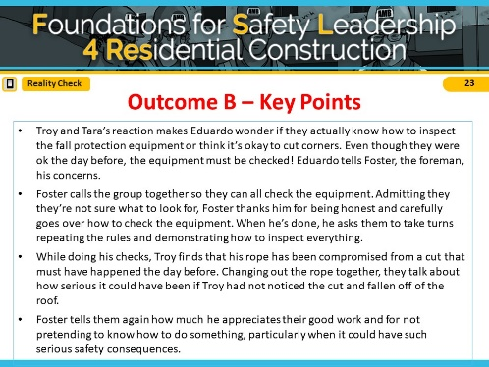

NOTES FOR SLIDE 23
Read out loud or have students read Outcome B in “Reality Check” script.

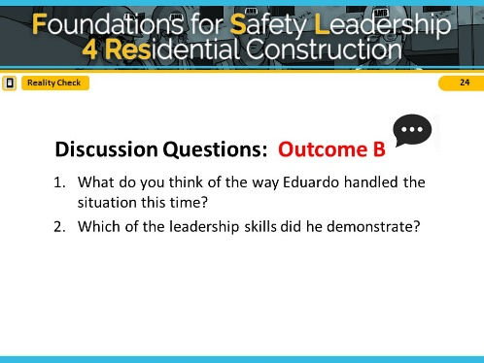
NOTES FOR SLIDE 24
Reveal the discussion questions and/or use the Scenario Leadership Checklist to go through skills.

The first leadership skill Eduardo demonstrated was that he actively listened to how Troy and Tara responded and sensed that they might not actually know how to check the rigging. Then, rather than demanding they check it themselves; he led
by example by talking to the foreman Foster and offered to go check it with them. Foster was able to develop the three workers by using his teaching and coaching skills. He used his 3-way communication skills by asking them to reiterate what he had told them. Lastly, he demonstrated his ability to give positive feedback by telling them how glad he was that they admitted not knowing about rigging and recognized them for being good team members and valued workers.

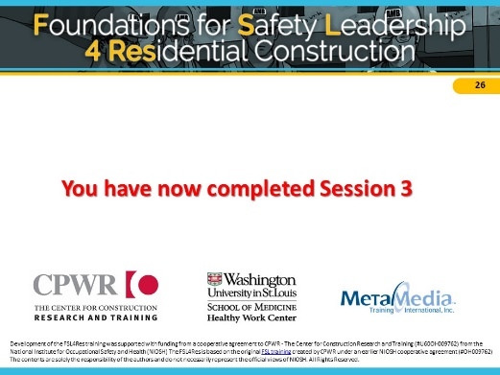
NOTES FOR SLIDE 25
This ends session 3.

Before next session, choose one or more of the leadership skills to practice by our next session. Make sure to note your experience(s), such as how easy was it to use and how did your crew respond. Please bring these experiences to the next session.

Session 4
Session 4 | 30 min total | Page # /  Slide # | Description
Welcome | 2 min | Page 44 / Slides 1-2 | - Introductions and session outline
Brief Skill Review | 5 min | Page 45 / Slide 3 | - Briefly list leadership skills and discuss real-world experiences.
“Cover Up” Scenario and discussion | 11 min | Pages 45-50 / Slides 4-17 | - Use the Read or Watch teaching mode to review “Cover Up” scenario and discuss the characters’ use or non-use of safety leadership skills.
“Don’t Shortcut Safety” Scenario and discussion | 12 min | Pages 50-55 / Slides 18-32 | - Use the Read or Watch teaching modes to review “Don’t Shortcut Safety” scenario and discuss the characters’ use or non-use of safety leadership skills.

Session Outline

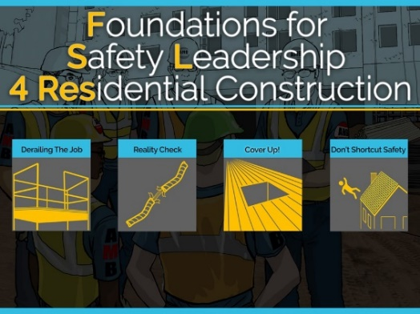
NOTES FOR SLIDE 1
Introductions (if needed)

You may refer to student handout to take notes. We’ll first be reviewing the leadership skills, which can be found starting on page 4.

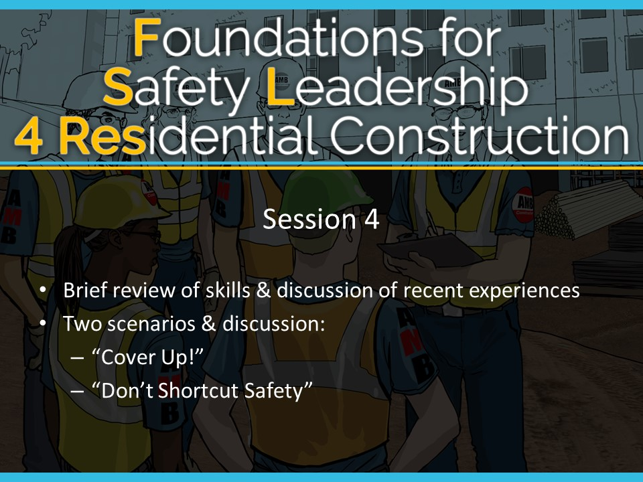NOTES FOR SLIDE 2
Today we will be briefly reviewing skills & having a discussion of recent experiences

Then we will work through two scenarios & discussions:
- “Cover Up”
- “Don’t Shortcut Safety”

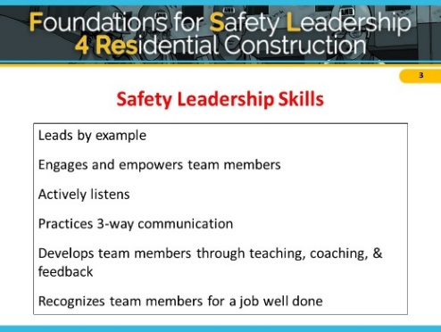
NOTES FOR SLIDE 3

Brief Skill Review
ASK CLASS: Can someone try to list all the safety leadership skills covered in the FSL4Res? [Reveal answers after giving students a chance to respond. For the sake of time, limit discussion and move through review quickly]
ASK CLASS: Have you started using any of the skills since our last session? What was the experience like? [Discuss]

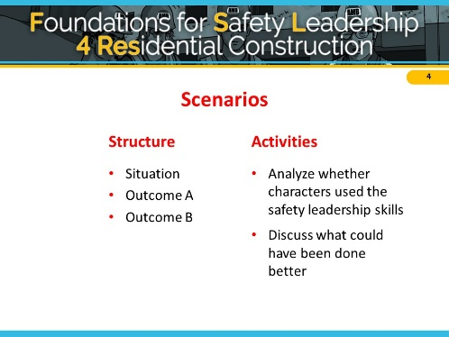
NOTES FOR SLIDE 4
We are going to work through two more scenarios using the same process as in the last two sessions.

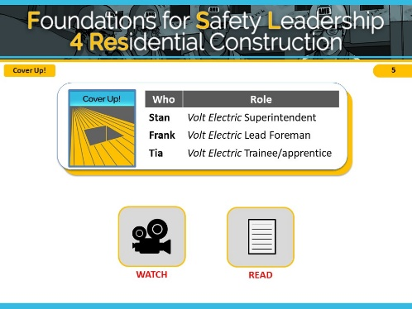

NOTES FOR SLIDE 5

Cover Up Scenario
The key safety leadership moment illustrated in “Cover Up” is how a safety leader can effectively communicate with a team member about how and why to carry out a safety-related task.
This scenario takes place on a mixed commercial-residential jobsite where there’s a large hole in the sub-floor floor creating a fall hazard.
Remember that these scenarios are meant to illustrate how the safety leadership skills you’ve learned can be used to address a safety situation.
This scenario is designed to illustrate the following safety leadership skills:
- Practicing 3-way communication
- Recognizing team members for a job well done
CLICK ON DESIRED TEACHING MODE…

Scenario Script

Cover Up
Stan – Volt Electric Superintendent
Frank – Volt Electric Lead Foreman
Tia – Volt Electric Trainee/Apprentice

Situation
To perform her tasks, Tia, a trainee with Volt Electric, has to walk by a large hole in the floor where some damaged plywood needs to be replaced. Stan, Volt’s superintendent, knows it’s a serious fall hazard that needs to be addressed immediately. The GC has been slow to respond to safety requests, so he asks his lead foreman, Frank, to take care of it.
Outcome A
Frank tells Tia she needs to cover the hole in the floor. Tia nods and decides she’ll take care of it in 15 minutes when she’s done securing the electrical wire to the stud. She knows Frank hates it when one person holds up someone else’s work. Meanwhile, two drywall installers don’t see the hole until the last minute when a nearby worker yells, “Stop!” which gives them just enough time to avoid it.
Frank gets word of this, goes back over to Tia, and yells at her for not covering the hole immediately. He adds that if the worker had stepped into the hole, she would have been seriously injured, or maybe worse, and points out that this isn’t the first time she’s ignored his instructions. Tia, feeling humiliated, apologizes and explains that she didn’t realize he wanted her to drop everything.
Outcome B
Frank tells Tia she needs to cover the hole in the floor immediately because it’s a serious fall hazard. He tells her to stop what she’s doing, get a piece of plywood, secure it over the hole, and spray paint the word “hole” on it. He reminds her to tie off, so she won’t become a victim while fixing the problem.
When he’s finished, he asks her to repeat his instructions to make sure they’re on the same page. Tia repeats Frank’s instructions word for word and Frank gives her the thumbs-up.
When she’s done covering the hole, Tia thinks how glad she is Frank asked her to confirm what he wanted her to do and by when he wanted it done because there have been times when she hasn’t understood exactly what other foremen she’s worked with were asking her to do. A few minutes later, when Frank comes by to thank Tia for removing the fall hazard, two drywall installers walk across the piece of plywood she just put down.

Watch Mode

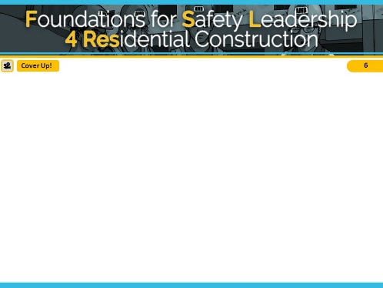
NOTES FOR SLIDE 6
VIDEO WILL START AUTOMATICALLY

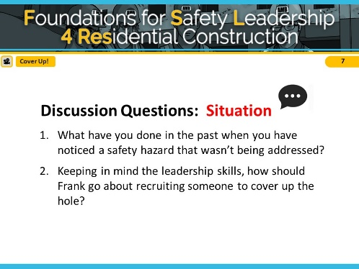
NOTES FOR SLIDE 7
Reveal the discussion questions and/or use the Scenario Leadership Checklist to go through skills.

Try not to spend too much time on the situation so you have time for both outcomes.

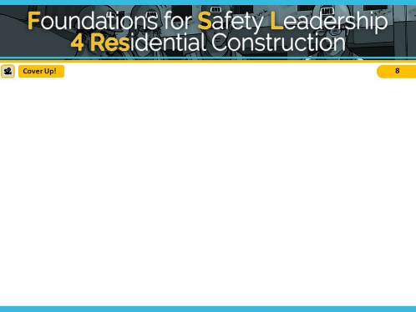
NOTES FOR SLIDE 8
VIDEO WILL START AUTOMATICALLY

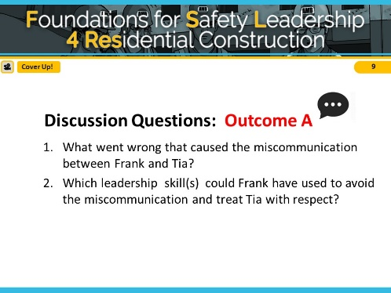
NOTES FOR SLIDE 9
Reveal the discussion questions and/or use the Scenario Leadership Checklist to go through skills.
Try not to spend too much time on Outcome A so you have time for both outcomes.
In Outcome A, Frank did not use any safety leadership skills and missed opportunities to utilize the leadership skills and promote a safe worksite.
ASK CLASS: What leadership skills could he have used in this scenario? [Discuss]

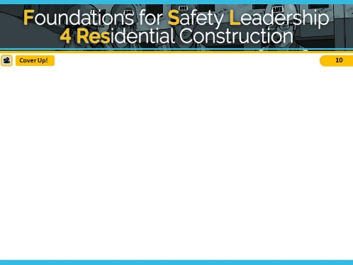
NOTES FOR SLIDE 10
VIDEO WILL START AUTOMATICALLY

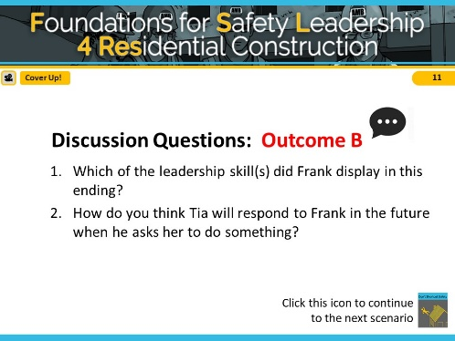
NOTES FOR SLIDE 11
Reveal the discussion questions and/or use the Scenario Leadership Checklist to go through skills.
To recap our conversation: In Outcome B, Frank did practice 3-way communication. This ensured that Tia understands exactly what Frank wanted and by when he wanted it done. The 2 minutes that it took for Frank to do this helped prevent Tia from being humiliated and also prevented the drywall installers from getting hurt. By recognizing Tia for doing a good job carrying out his instructions, Frank made Tia feel valued, and she is likely to be even more safety-conscious in the future.

<<Click on the “Don’t Shortcut Safety” icon in the bottom right corner to move to the final scenario slides>>

Read Mode

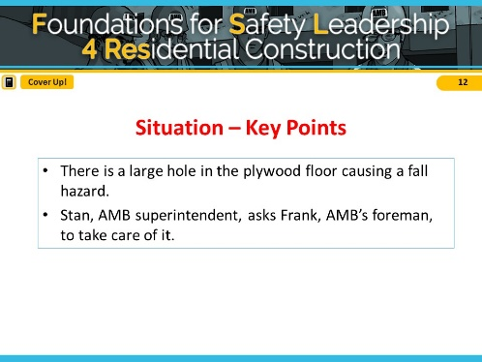
NOTES FOR SLIDE 12
Refer students to page 20 in the student guide.

Read out loud or ask students to read the situation in the “Cover Up” script.

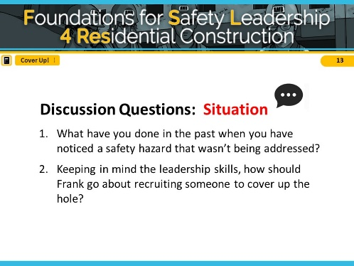
NOTES FOR SLIDE 13
Reveal the discussion questions and/or use the Scenario Leadership Checklist to go through skills.

Try not to spend too much time on the situation so you have time for both outcomes.

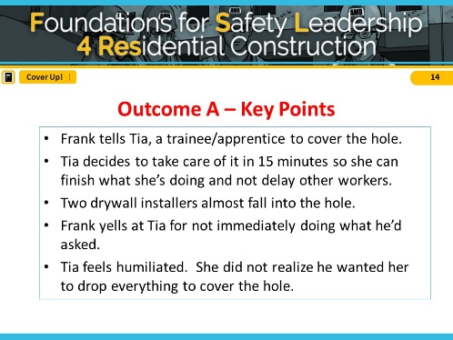
NOTES FOR SLIDE 14
Read out loud or have students read Outcome A in “Cover Up” script.

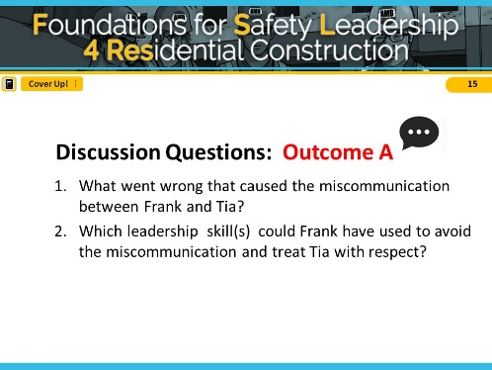
NOTES FOR SLIDE 15
Reveal the discussion questions and/or use the Scenario Leadership Checklist to go through skills.
Try not to spend too much time on Outcome A so you have time for both outcomes.
In Outcome A, Frank did not use any safety leadership skills and missed opportunities to utilize the leadership skills and promote a safe worksite.
ASK CLASS: What leadership skills could he have used in this scenario? [Short Discussion]

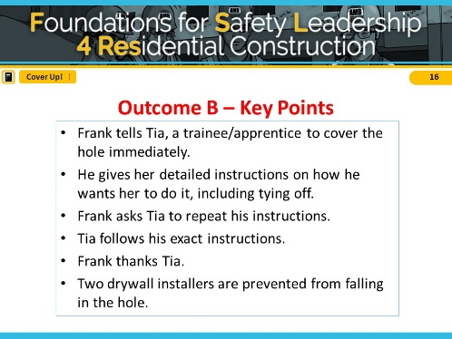
NOTES FOR SLIDE 16
Read aloud or have students read Outcome B in “Cover Up” script.

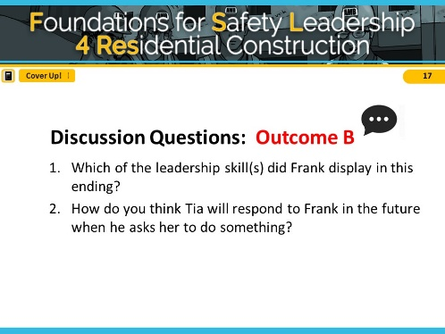
NOTES FOR SLIDE 17
Reveal the discussion questions and/or use the Scenario Leadership Checklist to go through skills.
To recap our conversation: In Outcome B, Frank did practice 3-way communication. This ensured that Tia understands exactly what Frank wanted and by when he wanted it done. The 2 minutes that it took for Frank to do this helped prevent Tia from being humiliated and also prevented the drywall installers from getting hurt. By recognizing Tia for doing a good job carrying out his instructions, Frank made Tia feel valued, and she is likely to be even more safety-conscious in the future.

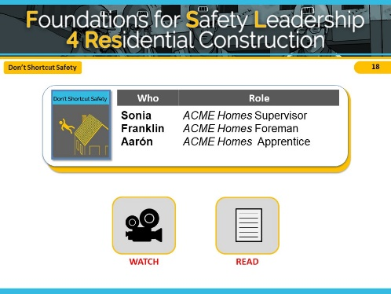

NOTES FOR SLIDE 18

Don’t Shortcut Safety Scenario
The final scenario is called “Don’t Shortcut Safety.”
It shows a residential worksite where shutters need to be installed before the homeowners come by in a few hours for a final walk through.

This scenario is designed to illustrate the following safety leadership skills:
- Leads by example
- Develop team members
- Recognizes team members

CLICK ON DESIRED TEACHING MODE…

Scenario Script

Don’t Shortcut Safety
Sonia – ACME Homes Supervisor
Franklin – ACME Homes Foreman
Aarón – ACME Homes Apprentice
Situation
Sonia, the superintendent from ACME homes, has a final walk through coming in just a few hours and she is scrambling to get the home completed. The shutters for the home have been on back order for weeks and just arrived this morning. There are no exterior trim workers on site, but her company’s framing crew is working on a nearby house.
Sonia asks Franklin, the foreman of the framing crew, if someone from his crew can install the shutters on two upper floor windows to complete the house. Franklin knows that this will be an easy task since the worker will be able to stand on the porch roof below the windows to get the job done, and not have to use a ladder. Franklin agrees to send Aarón, the apprentice, to do the job since he just had training on exterior trim work last week.
Outcome A
Franklin tells Aarón to stop what he’s doing and to go install the shutters on the other house saying that it should only take a few minutes. Franklin instructs Aarón to remember what he learned in school last week about how to do exterior trim work. Franklin then turns to Sonia to talk about some other issues on the site.
Aarón gets his screw gun, heads down to the house and goes to work. Once he installs the last shutter, he steps back to make sure the shutters are even and look good. As Aarón steps back to get a better view, he steps on the gutter, loses his balance, and falls to the ground.
Outcome B
Franklin introduces Aarón to Sonia and tells him about the missing shutters. Franklin asks if Aarón remembers his training and can install the shutters to help out the superintendent. Aarón nods, grabs his screw gun, and heads toward the other house.
Franklin did not see Aarón grab any equipment other than the screw gun and wonders how Aarón is going to do the job safely. Franklin wants to speak with Sonia about some other issues but decides it can wait and follows Aarón down the street.
As Aarón steps out of the window onto the porch roof, Franklin notices that he’s not tied off and shouts to him to stop immediately.
Franklin gathers his entire crew and grabs some fall protection equipment from his truck for demonstration. He reminds the crew that they must always use fall protection when working at heights, even for tasks they can get done quickly. Franklin shows them how to create a secure tie-off point so they can use a harness and a lanyard. He also takes the time to show the crew members how to use a new window frame anchorage device that the company just purchased.
While the task didn’t go as quickly as Sonia had hoped, she was pleased that Franklin took time with his crew to emphasize the importance of always using fall protection when working at heights, and to demonstrate how to do it properly. To show her appreciation, Sonia nominated Franklin for employee of the month and wrote up the story for the company newsletter.

Watch Mode

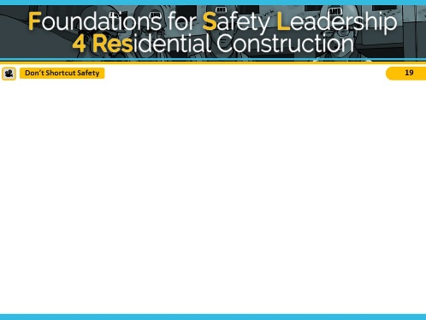
NOTES FOR SLIDE 19
VIDEO WILL START AUTOMATICALLY

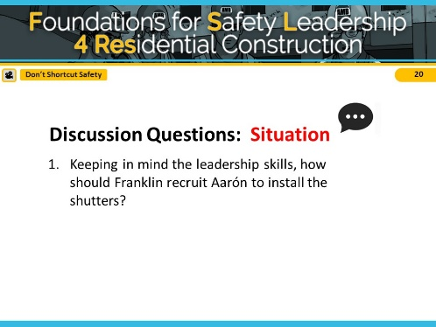
NOTES FOR SLIDE 20
Reveal the discussion questions and/or use the Scenario Leadership Checklist to go through skills.

Try not to spend too much time on the situation so you have time for both outcomes.

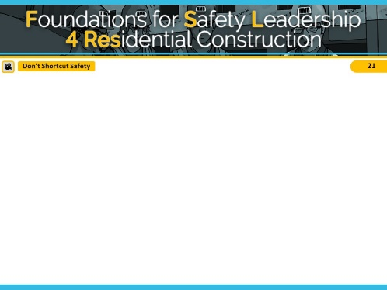
NOTES FOR SLIDE 21
VIDEO WILL START AUTOMATICALLY

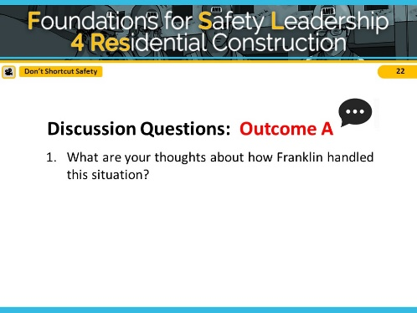
NOTES FOR SLIDE 22
Reveal the discussion questions and/or use the Scenario Leadership Checklist to go through skills.
Try not to spend too much time on Outcome A so you have time for both outcomes.

In Outcome A, Franklin did not use any safety leadership skills and missed opportunities to utilize the leadership skills and promote a safe worksite.
ASK CLASS: What leadership skills could he have used in this scenario? [Short Discussion]

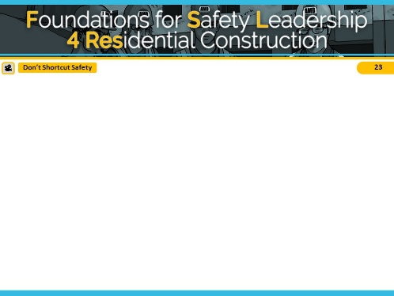
NOTES FOR SLIDE 23
VIDEO WILL START AUTOMATICALLY

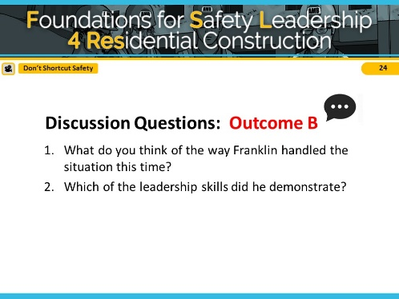
NOTES FOR SLIDE 24
Reveal the discussion questions and/or use the Scenario Leadership Checklist to go through skills.

To recap our conversation: In this scenario outcome, Franklin did lead by example when he stops work as he sees Aarón performing the job in an unsafe manner. He developed his team members by calling them together to teach them about the various methods they can and must use to safely complete the task. His company leadership also recognized Franklin’s effort in the newsletter for going above and beyond for safety.

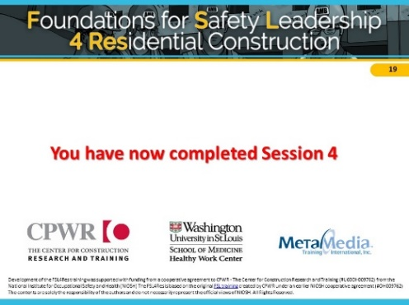
NOTES FOR SLIDE 25
This ends session 4.

I hope you have the opportunity to practice the skills between now and the final session so we can talk about how you used them and if you had any challenges.

Read Mode

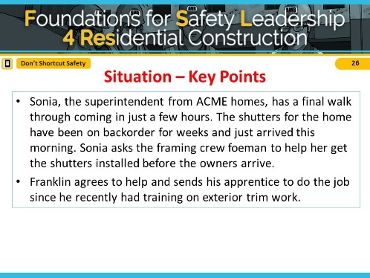
NOTES FOR SLIDE 26
Refer students to page 21 in the student guide.

Read out loud or ask students to read the situation in the “Don’t Shortcut Safety” script.

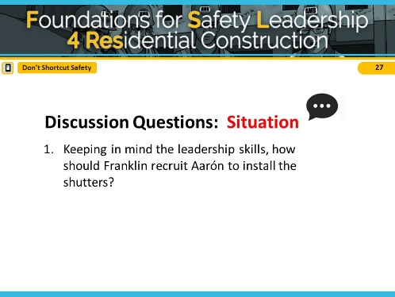
NOTES FOR SLIDE 27
Reveal the discussion questions and/or use the Scenario Leadership Checklist to go through skills.

Try not to spend too much time on the situation so you have time for both outcomes.

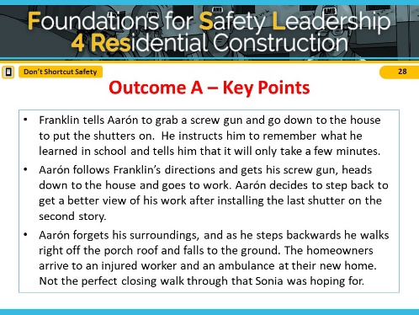
NOTES FOR SLIDE 28
Read out loud or have students read Outcome A in “Don’t Shortcut Safety” script.

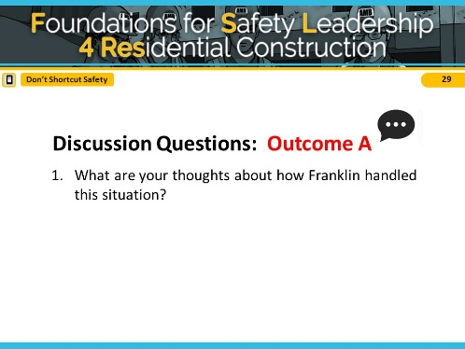
NOTES FOR SLIDE 29
Reveal the discussion questions and/or use the Scenario Leadership Checklist to go through skills.
Try not to spend too much time on Outcome A so you have time for both outcomes.
In Outcome A, Franklin did not use any safety leadership skills and missed opportunities to utilize the leadership skills and promote a safe worksite.
ASK CLASS: What leadership skills could he have used in this scenario? [Short Discussion]

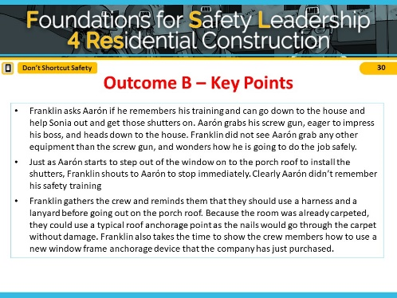
NOTES FOR SLIDE 30
Read out loud or have students read Outcome B in “Don’t Shortcut Safety” script.

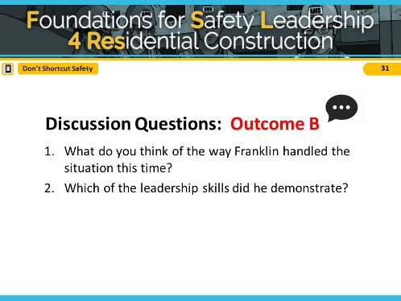
NOTES FOR SLIDE 31
Reveal the discussion questions and/or use the Scenario Leadership Checklist to go through skills.

To recap our conversation: In this scenario outcome, Franklin did lead by example when he stops work as he sees Aarón performing the job in an unsafe manner. He developed his team members by calling them together to teach them about the various methods they can and must use to safely complete the task. His company leadership also recognized Franklin’s effort in the newsletter for going above and beyond for safety.

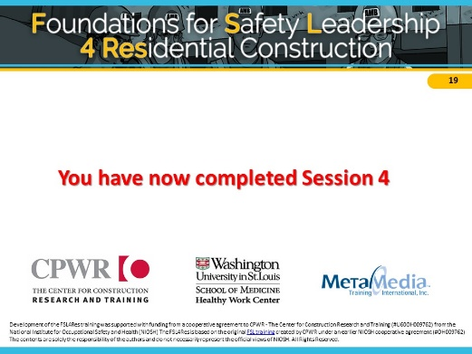
NOTES FOR SLIDE 32
This ends session 4.

I hope you have the opportunity to practice the skills between now and the final session so we can talk about how you used them and if you had any challenges.

Booster Session

Session Outline
Booster Session | 30 min total | Page # /  Slide # | Description
Welcome | 2 min | Page 58 / Slides 1-2 | - Introductions and session outline
Self-Assessment | 5 min | Page 58 / Slides 3-4 | - Use the self-assessment to discuss how they used the skills on the jobsite.
Taking it Back to the Jobsite | 5 min | Page 58 / Slide 5 | - Discuss ideas and tips for continuing to use skills in the real world.
Additional FSL4Res Resources | 3 min | Page 59 /  Slide 6 | - Review TBT’s and other training tools.
Take Aways | 2 min | Page 59 / Slide 7-8 | - Review key concepts from FSL4Res course

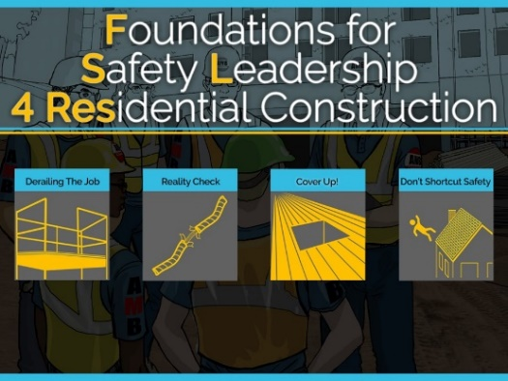
NOTES FOR SLIDE 1

Welcome
Introductions (if needed)

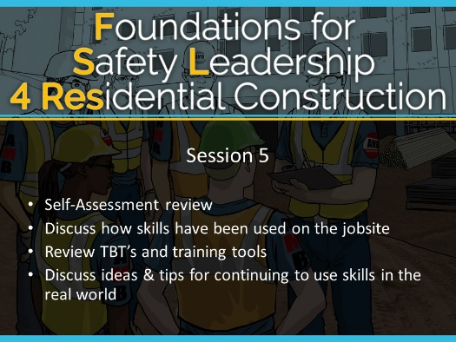
NOTES FOR SLIDE 2
Today we will be:
- Reviewing your Self-Assessment
- Discussing how skills have been used on the jobsite
- Reviewing TBT’s and training tools
- Discussing ideas & tips for continuing to use skills in the real world

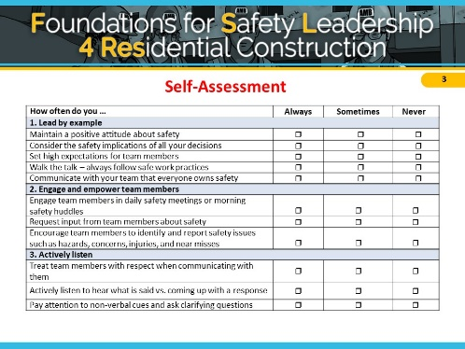
NOTES FOR SLIDE 3

Self-Assessment
As a final exercise, we’re going walk through it and discuss if and how you’ve been able to practice the skills on the jobsite.
ASK CLASS: Did anyone practice…
- Lead by Example, Engage and Empower Team Members or Actively Listen?
[IF YES] – Tell us about your experience. How did it go?

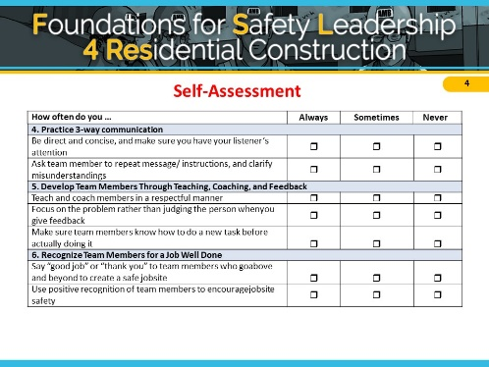
NOTES FOR SLIDE 4
ASK CLASS: Did anyone practice…
- Practice 3-way Communication, Develop Team Members through Teaching, Coaching, and Feedback, or Recognize Team Members for a Job Well Done?
[IF YES] - Tell us about your experience. How did it go?
- If you were to complete this assessment again, would your answers change? Are there specific skills you plan to work on?

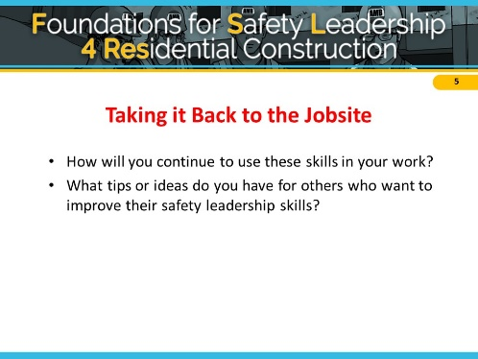
NOTES FOR SLIDE 5

Taking it Back to the Jobsite
ASK CLASS:
- How will you continue to use these skills on the jobsite?
- What tips or ideas do you have for others who want to improve their safety leadership skills?

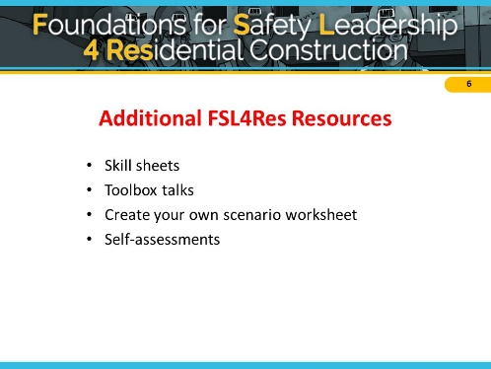
NOTES FOR SLIDE 6

Additional FSL4Res Resources
At CPWR.com, you can find a number of different resources to use as you continue practicing the skills on the jobsite. If you would like to reference the information you have learned in this training, there are skill sheets, toolbox talks, and self-assessments on the website, along with other materials you may find helpful.

You may provide class with printout of materials or review materials by going to CPWR.com if you have time.

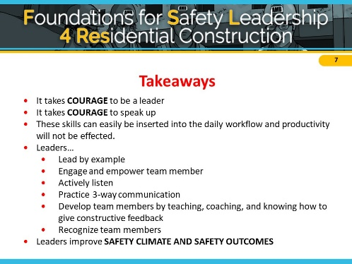
NOTES FOR SLIDE 7

Takeaways
We’ve come to the end of the FSL4Res course, and we’ve covered a lot. So, here are the key points I hope you will take away from this training and put into practice on the jobsite:

- It takes COURAGE to be a leader. It takes COURAGE to speak up.
- These skills can easily be inserted into the daily workflow and productivity will not be affected.
- Leaders…
  - Lead by Example
  - Engage and Empower team members
  - Actively listen
  - Practice 3-way communication
  - Develop team members by teaching, coaching, and knowing how to give constructive feedback
  - Recognize team members for going above and beyond for safety
- And finally, if you use these skills on the jobsite and become a true safety leader, you can improve both jobsite SAFETY CLIMATE and SAFETY OUTCOMES.

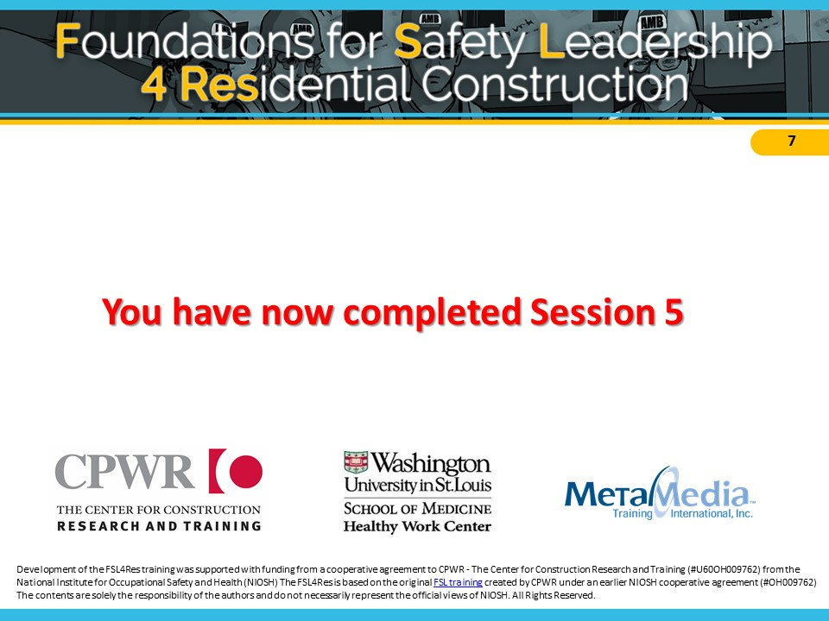NOTES FOR SLIDE 8
Congratulations! You have officially completed the FSL4Res training course

