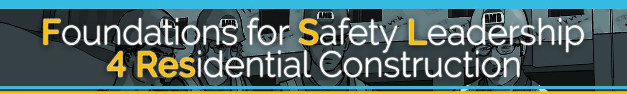

Instructor Teaching Guide For Additional Scenarios

The Foundations for Safety Leadership 4 Residential Construction (FSL4Res) course was developed collaboratively by

Development of the FSL4Res training was supported with funding from a cooperative agreement to CPWR - The Center for Construction Research and Training (#U60OH009762) from the National Institute for Occupational Safety and Health (NIOSH) The FSL4Res is based on the original FSL training created by CPWR under an earlier NIOSH cooperative agreement (#OH009762) The contents are solely the responsibility of the authors and do not necessarily represent the official views of NIOSH. All Rights Reserved.

TABLE OF CONTENTS

Additional Scenarios Main Menu 4
- FRITZ TAKES A SHORTCUT 5
WATCH 7
READ 9
- STORMY WEATHER 12
WATCH 14
READ 16
- OH SOLAR MIO 19
WATCH 21
READ 23
- IT’S TOO HOT 25
WATCH 27
READ 29

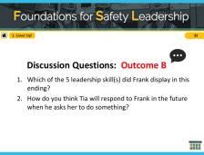
Applying Leadership Skills in Real World Scenarios
This guide contains the information instructors/trainers need if they want to use any of the four additional scenarios when teaching the scenario portion of the FSL4Res training. To get the full PowerPoint and instructor guide containing all other teaching material go to https://www.cpwr.com/foundations-safety- leadership-fsl.

Additional Scenarios Main Menu

NOTES FOR SLIDE 1 SLIDE 1
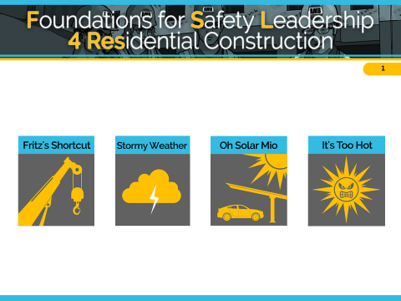
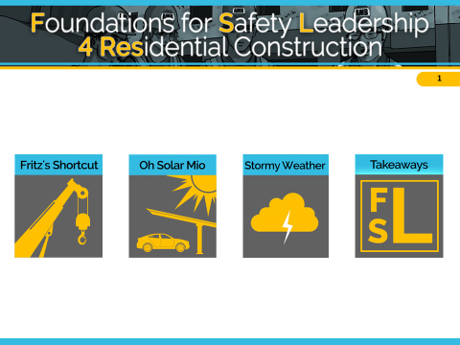
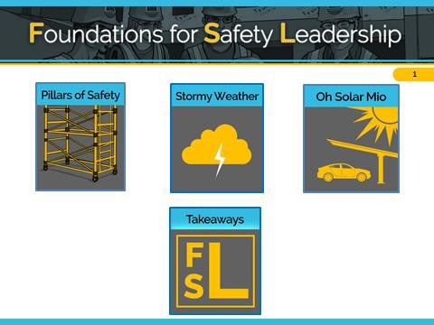
We’re going to work through [list the scenarios you’ve picked].

CLICK THE ICON OF THE SCENARIO YOU WISH TO USE

Additional Instructor Notes

Clicking on any of the first 4 icons on Slide 1 will take you to the introductory slide of that scenario.

Whenever you want to return to Slide 1, you can click on the home icon located in the bottom right corner of other slides.

1. FRITZ TAKES A SHORTCUT

Fritz – Mighty Mechanical Foreman –Sheet Metal Subcontractor Elliot – Mighty Mechanical Experienced worker

Situation
The crane operator gave Fritz, Mighty Mechanical’s foreman the wire rope slings and shackles they will need to lift 2 HVAC units to the roof and Fritz gave them to Elliot, an experienced worker.
While inspecting the equipment, Elliot notices that one sling is severely kinked and a shackle is damaged. So he tells Fritz they should ask the crane operator for replacements.
Fritz knows that getting replacements would take hours and earlier he caught hell from the GC about the tight timeline. So he tells Elliot to go with what they have.
Elliot tells Fritz that he is not comfortable with the decision to proceed with the current rigging equipment because it will create a really unsafe situation. Fritz reminds him that as his foreman Elliot just needs to do what he says.
As one of the units is lifted, the kinked sling abruptly stretches, one end of the unit drops 6 inches, and the damaged shackle breaks open….causing the unit to fall to the ground severely damaging it and nearly crushing a worker.
Outcome A
Later, Fritz tells Elliot not to mention the damaged rigging equipment to anyone.
Elliot is angry about Fritz’s request, but he wants to keep his job.
Outcome B
Later, Fritz tells Elliot he was right to question his decision and says he did it because the GC has been pressuring him. But if that worker had been crushed because of his bad decision he couldn’t have lived with himself.
Fritz calls for a safety stand-down. He repeats to the crew what he told Elliot adding that from now on he’s going to hold a daily safety huddle to discuss the day’s tasks and how to eliminate hazards that may come-up.
He says he has learned the hard way to listen to his crew's safety concerns and expects everyone to report unsafe situations. Fritz ends by saying that he doesn’t want to lose any of them due to poor decisions, pride or ego … some of the bad behaviors he displayed today.

NOTES FOR SLIDE 2 SLIDE 2
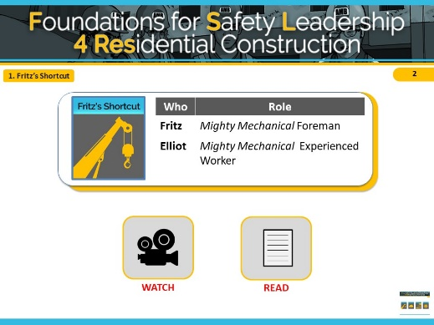
The key safety leadership moment in “Fritz Takes a Shortcut” is how a leader handles a near miss incident created because he made a decision to put productivity before safety.
This safety scenario shows a commercial construction setting, however it is also relevant to residential construction, as performing safety inspections and replacing damaged equipment are key to ensuring a job is done safely on any construction site. In this scenario, you will see a free-standing, six-story building in North Carolina with commercial offices on the first floor and residential housing on the upper five floors. The crew is using a crane to move two HVAC units to the roof of the building. While watching this scenario, imagine that the crane is instead being used to place roof trusses on a new residential build.
Remember that these scenarios are meant to illustrate key safety leadership skills. Focus on how a safety leader would communicate the needs of the task while prioritizing safety

The major safety hazards in this scenario are struck by and caught in-between.
INSTRUCTOR INFORMATION - This scenario is designed to illustrate the following safety leadership skills:
- Lead by example
- Engage team members
- Actively listen
- Recognize team members for a job well done

CLICK ON DESIRED TEACHING MODE…

WATCH

NOTES FOR SLIDE 3 SLIDE 3
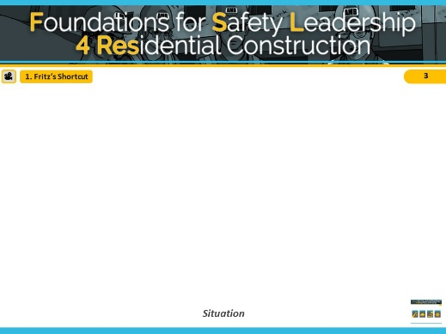
VIDEO WILL START AUTOMATICALLY

ADVANCE SLIDE

NOTES FOR SLIDE 4 SLIDE 4
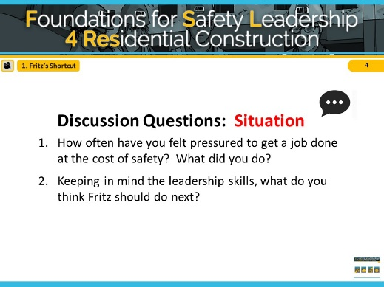
Reveal the discussion questions and/or use the facilitation table to go through skills.

ADVANCE SLIDE

NOTES FOR SLIDE 5 SLIDE 5
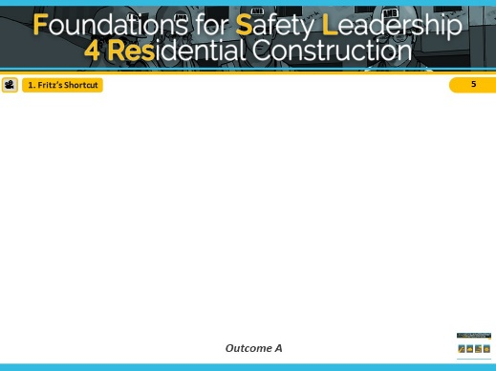
VIDEO WILL START AUTOMATICALLY

ADVANCE SLIDE

NOTES FOR SLIDE 6 SLIDE 6
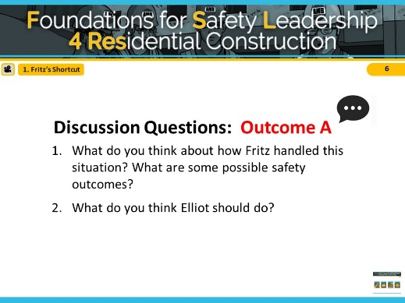
Reveal the discussion questions and/or use the facilitation table to go through skills.

Fritz displayed very poor leadership skills. He definitely did NOT lead by example. He did NOT actively listen to Elliot, nor did he engage and empower him to identify and report hazards and unsafe situations.

ADVANCE SLIDE

NOTES FOR SLIDE 7 SLIDE 7
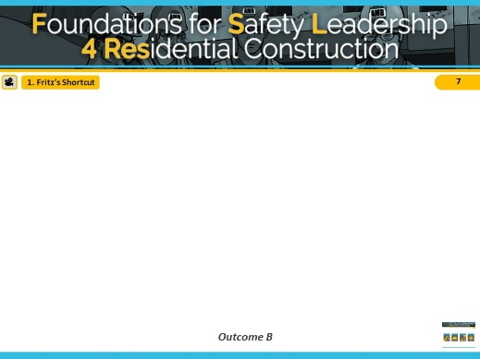
VIDEO WILL START AUTOMATICALLY

ADVANCE SLIDE

NOTES FOR SLIDE 8 SLIDE 8
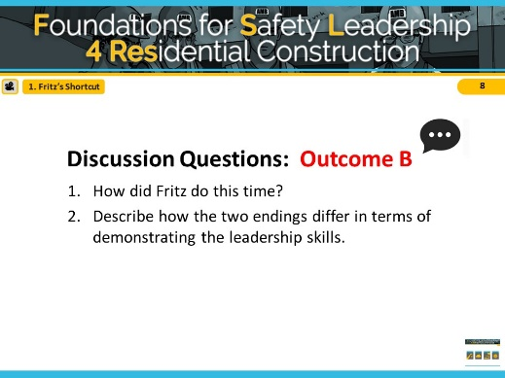
Reveal the discussion questions and/or use the facilitation table to go through skills.

In outcome B, Fritz did lead by example by letting his guard down and sharing with his crew that he too can be negatively influenced by pride and ego, which can cause him to make poor safety-related decisions. He recognized Elliot for identifying and trying to prevent an unsafe situation. He then engaged his team by initiating a daily safety huddle and empowered them by creating the expectation that everyone is to report hazardous conditions and near misses. Fritz promises that in the future he will actively listen to their ideas and feedback.

CLICK SCENARIO MENU ICON TO RETURN TO MAIN MENU
READ

NOTES FOR SLIDE 9 SLIDE 9

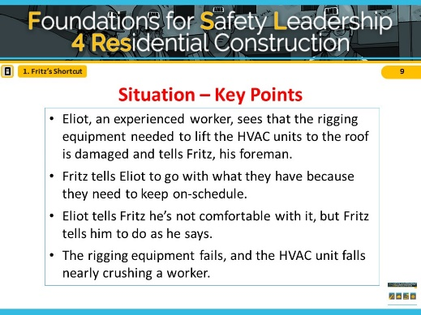
Refer students to page 5 in the student handout

Read/Have students read the situation in the “Fritz
takes a shortcut” script (or instructor reads aloud).

ADVANCE SLIDE

NOTES FOR SLIDE 10 SLIDE 10
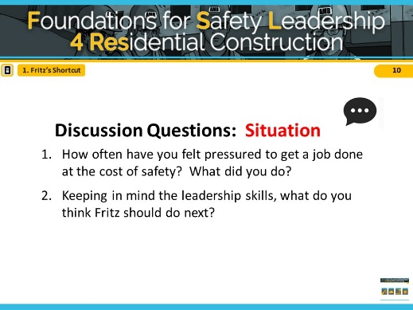
Reveal the discussion questions and/or use the facilitation table to go through skills.

ADVANCE SLIDE

NOTES FOR SLIDE 11 SLIDE 11
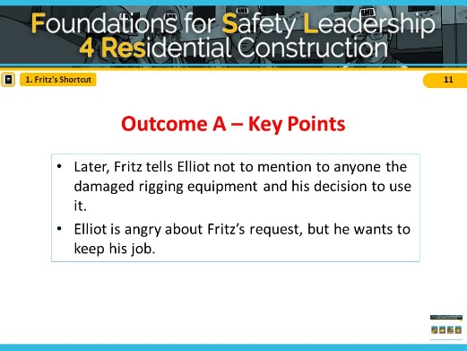
Read/have students read outcome A in “Fritz takes a shortcut” script (or instructor reads aloud).

ADVANCE SLIDE

NOTES FOR SLIDE 12 SLIDE 12
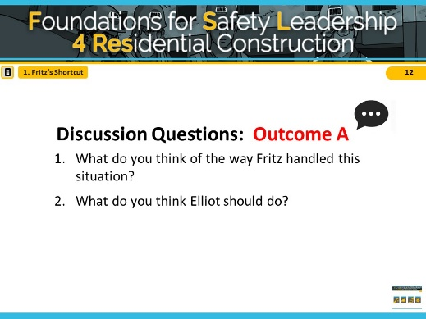
Reveal the discussion questions and/or use the facilitation table to go through skills.

Fritz is displayed very poor leadership skills. He definitely did NOT leading by example. He did NOT actively listen to Elliot, nor did he engage and empower him to identify and report hazards and unsafe situations.

ADVANCE SLIDE

NOTES FOR SLIDE 13 SLIDE 13
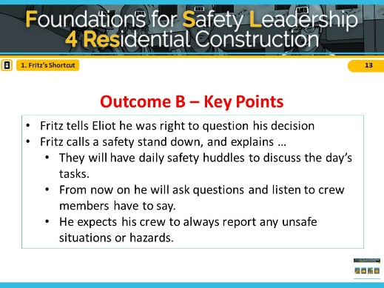
Read/have students read outcome B in “Fritz takes a shortcut” script (or instructor reads aloud).

ADVANCE SLIDE

NOTES FOR SLIDE 14 SLIDE 14
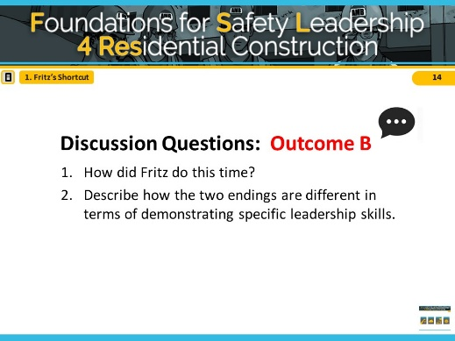
Reveal the discussion questions or use the facilitation table to go through skills.

In outcome B, Fritz did lead by example by letting his guard down and sharing with his crew that he too can be negatively influenced by pride and ego, which can cause him to make poor safety-related decisions. He recognized Elliot for identifying and trying to prevent an unsafe situation. He then engaged his team by initiating a daily safety huddle and empowered them by creating the expectation that everyone is to report hazardous conditions and near misses. Fritz promises that in the future he will actively listen to their ideas and feedback.

CLICK SCENARIO MENU ICON TO RETURN TO MAIN MENU

2. STORMY WEATHER
Sam – AMB, Inc. Superintendent
Francis – Aiden’s Carpentry Foreman
Evan – Aiden’s Carpentry Experienced worker
Filip – Parson’s Sheet Metal Foreman
Elaine – Parson’s Sheet Metal Experienced worker
Tad – Parson’s Sheet Metal Trainee

Situation
At the morning huddle, AMB’s superintendent, Sam, tells the sheet metal and carpentry crews that today’s biggest task is to prepare the roof for the HVAC systems. After they discuss the steps involved and the potential hazards that may come up, Sam adds that they need to get started because the afternoon weather forecast is calling for severe thunderstorms with a chance of lightening.
Once on the roof, Francis and Evan from Aiden’s Carpentry cut two holes for the sheet metal workers to install the HVAC duct work. Since they won’t be starting the installation until after lunch, Francis and Evan screw down pieces of plywood over the holes and put out a few safety cones.
Outcome A
After lunch, as Parson’s sheet metal crew is getting ready to start work, Filip, the foreman at Parson’s Sheet Metal, notices dark clouds coming in. At the same time, Elaine, an experienced sheet metal worker, realizes that she’s the only one who has fall protection, which they will need when they remove the plywood that’s covering the holes. She calls to the trainee Tad to hold-up for a minute.
As she’s telling Tad that everyone needs to be wearing fall protection before they can start their work, Filip interrupts her saying that it’s going to start raining really soon and they can’t waste any time going to get getting fall protection. And besides, he says, there’s really no risk of falling since they’re not working at the edge of the building and the hole won’t be open for that long before they install the duct work.
As Elaine starts to explain that the holes in the roof present a fall risk no matter how long they are open, she notices that Filip is glaring at her, so she stops talking. Tad is pleased because it means he won’t have to trudge down to the trailer to get the fall protection equipment.
Outcome B
After lunch, as Parson’s Sheet Metal crew is getting ready to start work, Filip, the foreman, notices dark clouds coming in. At the same time Elaine, an experienced sheet metal worker, realizes that she’s the only one who has fall protection, which they will need when they remove the plywood that’s covering the holes. She calls to the trainee Tad to hold-up for a minute.
As she’s telling Tad that everyone needs to be wearing fall protection before they can start their work, Filip starts to interrupt her but stops.
While he would really like to get started before the storm, he realizes the situation gives him an opportunity to recognize Elaine for taking ownership of safety and for demonstrating good safety behavior in front of Tad. So he lets Elaine continue explaining why it’s important they all should be wearing fall protection.
After she’s done, Filip thanks her for being a good role model and asks Tad to go down and get the fall protection equipment. He adds that if the stormy weather starts, they’ll just have to wait it out and maybe even finish-up tomorrow.

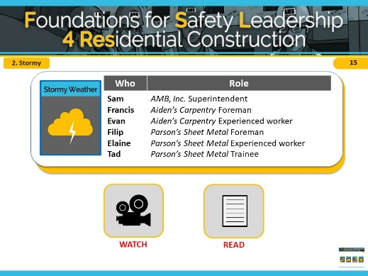
NOTES FOR SLIDE 15 SLIDE 15
The primary safety leadership moment illustrated in “Stormy Weather” is how to encourage others to use safety leadership skills.
This scenario shows a commercial worksite, however it is also relevant to residential construction, as wearing fall protection gear is an important safety precaution on many different construction sites. In this scenario, you will see a free-standing, six-story building with commercial offices on the first floor and residential housing on the upper floors. A crew of sheet metal workers are trying to remove plywood covers on the roof of the building in order to install HVAC units before a storm comes in, but only one worker has the proper fall protection gear. While watching this scenario, imagine instead that the workers are trying to finish installing roof sheathing without proper fall gear on a residential build.
Remember that these scenarios are meant to illustrate key safety leadership skills. Focus on how a safety leader would communicate the needs of the task while prioritizing safety

The safety hazards in this scenario are falls and bad weather.
INSTRUCTOR INFORMATION - It is designed to illustrate the following safety leadership skills:
- Lead by example
- Engage and empower team members
- Develop team members through teaching, coaching, and feedback
- Recognize team members for a job well done

CLICK ON DESIRED TEACHING MODE…

WATCH

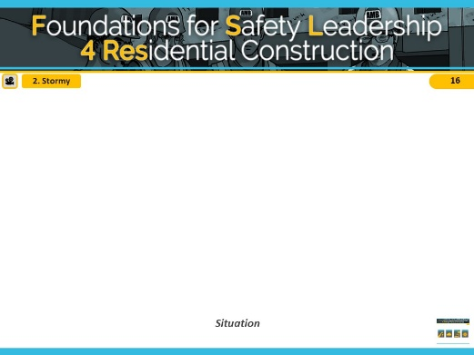
NOTES FOR SLIDE 16 SLIDE 16
VIDEO WILL START AUTOMATICALLY

ADVANCE SLIDE

NOTES FOR SLIDE 17 SLIDE 17
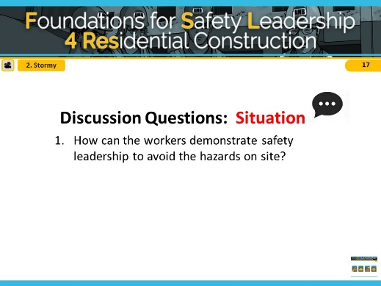
Reveal the discussion questions and/or use the facilitation table to go through skills. Spend a few minutes getting students’ ideas and then say, Ok, let’s see how your ideas match the two alternative endings we came up with.

ADVANCE SLIDE

NOTES FOR SLIDE 18 SLIDE 18
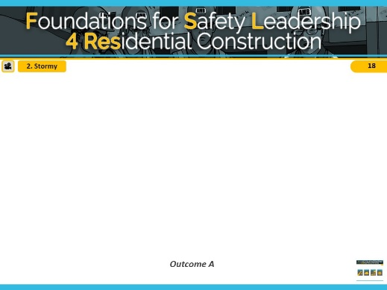
VIDEO WILL START AUTOMATICALLY

ADVANCE SLIDE

NOTES FOR SLIDE 19 SLIDE 19
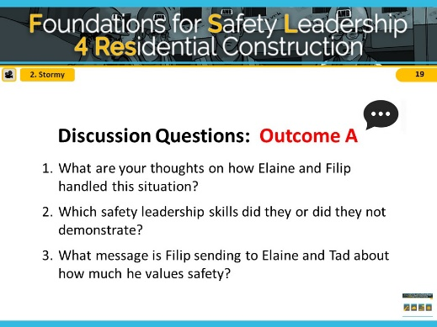
Reveal the discussion questions and/or use the facilitation table to go through skills.

In outcome A, Elaine did lead by example and developed her team member, Tad, when she started teaching him that the hole in the roof presents a fall hazard and that they should all be wearing fall protection. Filip on the other hand did not lead by example when he interrupted her and gave reasons why they didn’t have to worry about the fall
protection. He undercut Elaine’s authority as an experienced worker and sent a message to Tad that in the future he need not pay attention to what she asks him to do in terms of jobsite safety.

ADVANCE SLIDE

NOTES FOR SLIDE 20 SLIDE 20
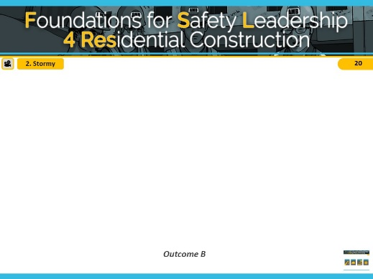
VIDEO WILL START AUTOMATICALLY

ADVANCE SLIDE

NOTES FOR SLIDE 21 SLIDE 21
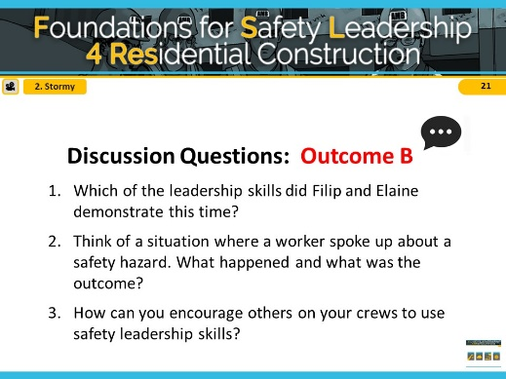
Reveal the discussion questions and/or use the facilitation table to go through skills.

In outcome B, Elaine did lead example and developed her team member, Tad, when she started explaining that the hole in the roof presents a fall hazard and that they should all be wearing fall protection. This time, Filip did lead example and empowered Elaine by giving her the time to explain the fall hazard to Tad despite the impending storm. Filip also recognized
Elaine by thanking her for being a good role model to Tad.

CLICK THE SCENARIO MENU ICON TO RETURN TO MAIN MENU

READ

NOTES FOR SLIDE 22 SLIDE 22
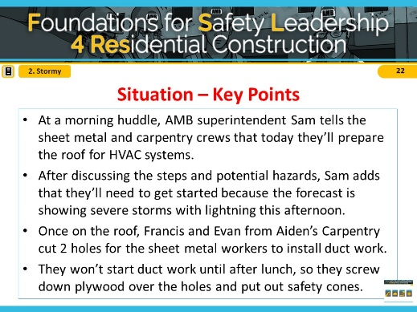
Refer students to page 6 in the student handout

Ask students to read the situation for “Stormy Weather” (or instructor reads it aloud).

ADVANCE SLIDE

NOTES FOR SLIDE 23 SLIDE 23
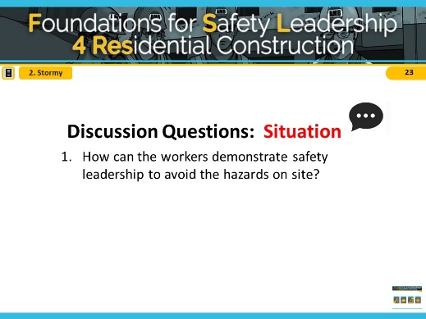
Reveal the discussion questions and/or use the facilitation table to go through skills.

ADVANCE SLIDE

NOTES FOR SLIDE 24 SLIDE 24
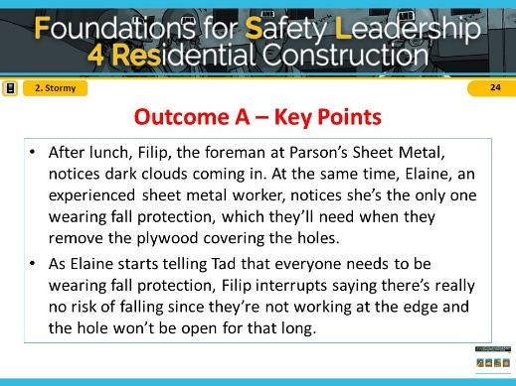
Ask students to read outcome A for “Stormy Weather” (or instructor reads it aloud).

ADVANCE SLIDE

NOTES FOR SLIDE 25 SLIDE 25
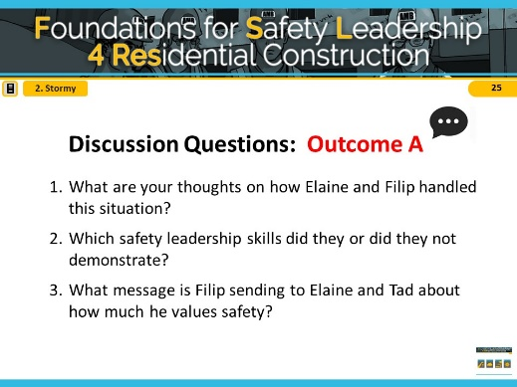
Reveal the discussion questions and/or use the facilitation table to go through skills.

In outcome A, Elaine did lead by example and developed her team member, Tad, when she started teaching him that the hole in the roof presents a fall hazard and that they should all be wearing fall protection. Filip, on the other hand, did not lead by example when he interrupted her and gave reasons why they didn’t have to worry about the fall protection. He undercut Elaine’s authority as an experienced worker and sent a message to Tad that in the future he need not pay attention to what she asks him to do for safety.

ADVANCE SLIDE

NOTES FOR SLIDE 26 SLIDE 26
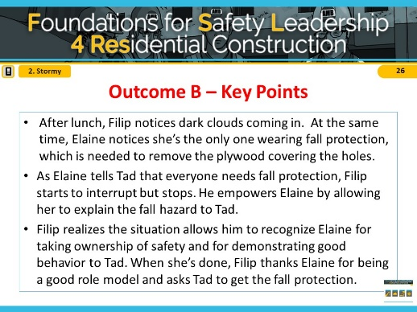
Ask students to read outcome B for “Stormy Weather” (or instructor reads it aloud).

ADVANCE SLIDE

NOTES FOR SLIDE 27 SLIDE 27
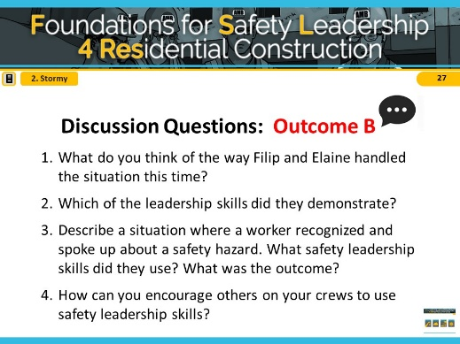
Reveal the discussion questions and/or use the facilitation table to go through skills.

In outcome B, Elaine did lead by example and developed her team member, Tad, when she started explaining that the hole in the roof presents a fall hazard and that they should all be wearing fall protection. This time Filip did lead by example and empowered Elaine by giving her the time to explain the fall hazard to Tad despite the impending storm. Filip also recognized Elaine by thanking her for being a good role model to Tad.

CLICK THE SCENARIO MENU ICON TO RETURN TO MAIN MENU

Ferris – Alan’s Operators Foreman
3. OH SOLAR MIO
Ethan – Alan’s Operators Experienced worker
Emily – Alan’s Operators Experienced worker

Situation
It’s 7 am. Operating engineers Ethan, Emily, their foremen Ferris, and a few ironworkers are in The Cain Building parking lot checking out the flatbed trailer that’s loaded with mounting structures needed to build solar carports.
Earlier that week, Ferris had developed a lift plan that took into account the size and weight of the materials, the ground conditions, and the crane’s load and lift capacity. However, late yesterday afternoon the GC needed the larger crane at a different job site and the only one that was available to rent was smaller with less capacity.
In the past, Ferris has had the GC’s superintendent make the go/no-go decision, particularly when a change could delay the schedule. Unfortunately, AMB’s superintendent isn’t at the jobsite yet, so Ferris must decide whether or not to do the lift using the smaller crane.
As Ferris considers what to do, one of the iron workers starts pressuring him to begin hoisting the steel mounts immediately, reminding him that the carport installation is behind schedule and the GC is already ticked-off. The ironworker’s pushing and the fact that they are behind schedule lead Ferris to put his concerns aside and go ahead with the lift.
Outcome A
Ferris asks Ethan and Emily to get the slings and attach them to the first structure. Emily is worried about the size of the crane and tells Ferris that she’s concerned the crane may be too small to do the lift safely. Ferris responds defensively, saying that he’s sure it will be okay to do the lift.
Ethan and Emily look at each other before they reluctantly get the slings. As Ferris lifts the load and extends the boom, he feels the bed of the crane begin to shift and the outrigger starts to lift off the ground. Luckily, he is able to retract the boom just in time to prevent a possible disaster.
Outcome B
Ferris asks Ethan and Emily to get the slings and attach them to the first structure. Emily is worried about the size of the crane and tells Ferris that she’s concerned the crane may be too small to do the lift safely.
Ferris hears what Emily is saying and in the back of his mind he recognizes that she’s right. He also realizes that if ignores her comment, then all his talk about expecting his crew to openly voice jobsite safety concerns is meaningless, and that his role as a safety leader will be greatly weakened.
So, instead of going ahead with the lift, Ferris brings everyone together and tells them that even though
the GC may not be happy about it, he is taking Emily’s concern seriously and is going to postpone the lift. He goes on to say that he’ll let AMB’s superintendent know what’s going on as soon as he gets to the jobsite and work with him to find a larger crane they can use, hopefully by the end of the day.
Before he starts discussing alternative job assignments, Ferris turns to Emily and, in front of everyone, thanks her for having the courage to speak up and question his decision about the smaller crane, adding that he appreciates it when she and others on the jobsite take their role as a safety leader seriously.

NOTES FOR SLIDE 28 SLIDE 28
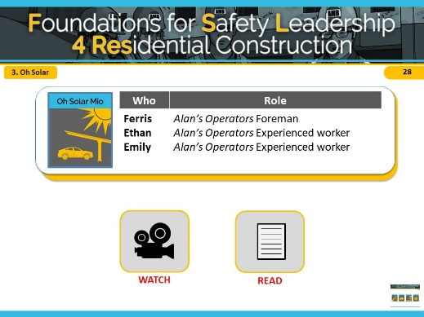
The key safety leadership moment in “Oh Solar Mio” is what can happen when production and scheduling are prioritized over safety.
This scenario shows a commercial worksite, however it is also relevant to residential construction as assuring a crane has the right load and lift capacity for the task at hand is important for completing a lift job on many different types of construction sites. In this scenario, you will see a free-standing, six-story building with commercial offices on the first floor and residential housing on the upper floors. The crew is getting ready to lift mounting structures for solar carports, however the larger crane they had planned to use is not available. While watching this scenario, imagine that instead of lifting mounting structures for solar carports, the workers need to place a beam on top of the foundation of a residential build using a crane.
Remember that these scenarios are meant to illustrate key safety leadership skills. Focus on how a safety leader would communicate the needs of the task while prioritizing safety

The safety hazard in this scenario is use of proper equipment.
INSTRUCTOR INFORMATION - It is designed to illustrate the following safety leadership skills:
- Lead by example
- Actively listen
- Practice 3-way communication
- Engage and empower team members
- Recognize team members for a job well done

CLICK ON DESIRED TEACHING MODE…

WATCH

NOTES FOR SLIDE 29 SLIDE 29
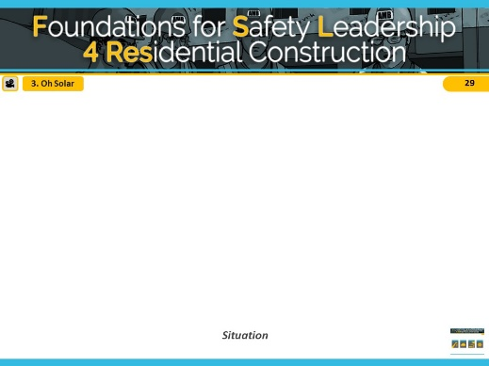
VIDEO WILL START AUTOMATICALLY

ADVANCE SLIDE

NOTES FOR SLIDE 30 SLIDE 30
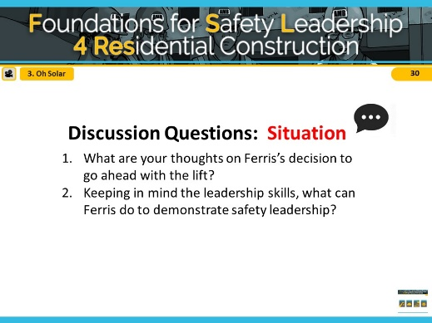
Reveal the discussion questions and/or use the facilitation table to go through skills. Spend a few minutes getting students’ ideas and then say, Ok, let’s see how your ideas match the two alternative endings we came up with.

ADVANCE SLIDE

NOTES FOR SLIDE 31 SLIDE 31
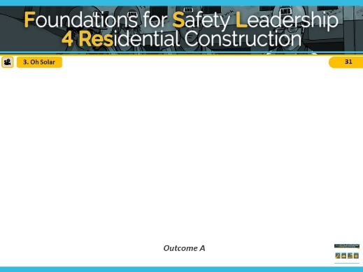
VIDEO WILL START AUTOMATICALLY

ADVANCE SLIDE

NOTES FOR SLIDE 32 SLIDE 32
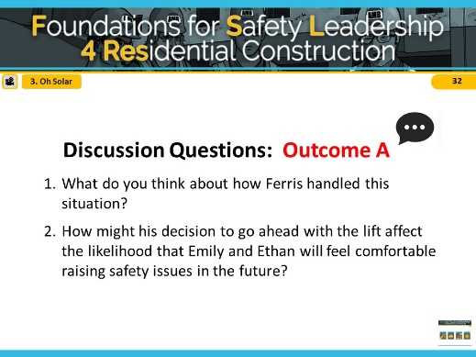
Reveal the discussion questions and/or use the facilitation table to go through skills.

In outcome A, Ferris did not use any safety leadership skills. He didn’t lead by example when he decided to go ahead with the lift even though he knew he didn’t have the right equipment. He didn’t engage his crew in the safety decision-making process and he also didn’t listen to Emily when she voiced her concern.

ADVANCE SLIDE

NOTES FOR SLIDE 33 SLIDE 33
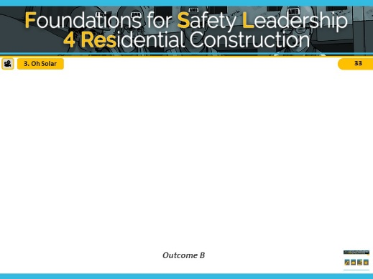
VIDEO WILL START AUTOMATICALLY

ADVANCE SLIDE

NOTES FOR SLIDE 34 SLIDE 34
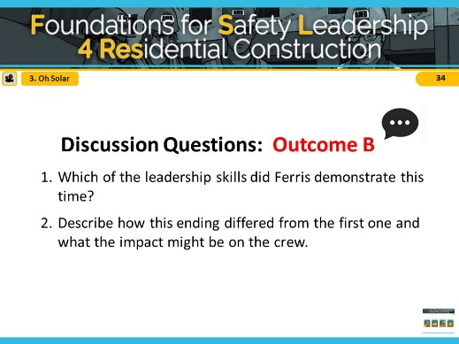
Reveal the discussion questions and/or use the facilitation table to go through skills.

In outcome B, Ferris did lead by example, actively listened to Emily’s concerns, and empowered her when he decides to stop the job until the proper equipment is available. He also recognized Emily for having the courage to speak up and for being a valuable team member.

CLICK THE SCENARIO MENU ICON TO RETURN TO MAIN MENU

READ

NOTES FOR SLIDE 35 SLIDE 35
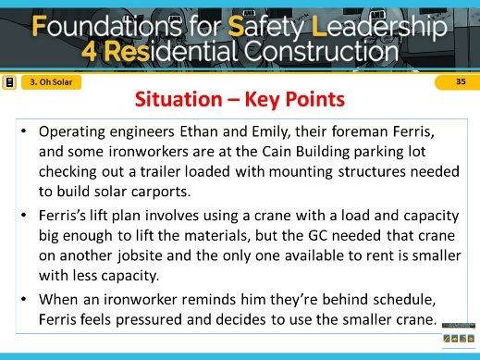
Refer students to page 8 in the student handout

Ask students to read the situation for “Oh Solar Mio” (or instructor reads it aloud).

ADVANCE SLIDE

NOTES FOR SLIDE 36 SLIDE 36
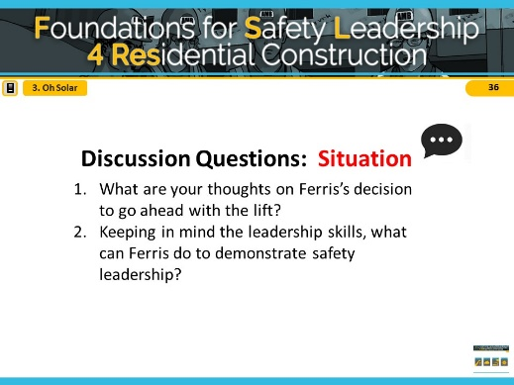
Reveal the discussion questions and/or use the facilitation table to go through skills.
Spend a few minutes getting students’ ideas and then say, Ok, let’s see how your ideas match the two alternative endings we came up with.

ADVANCE SLIDE

NOTES FOR SLIDE 37 SLIDE 37
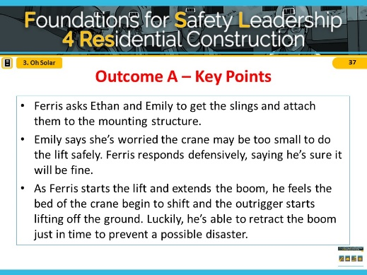
Ask students to read outcome A for “Oh Solar Mio” (or instructor reads it aloud).

ADVANCE SLIDE

NOTES FOR SLIDE 38 SLIDE 38
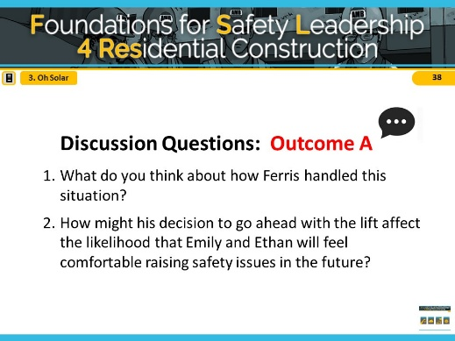
Reveal the discussion questions and/or use the facilitation table to go through skills.

In outcome A, Ferris did not use any safety leadership skills. He didn’t lead by example when he decided to go ahead with the lift even though he knew he didn’t have the right equipment. He didn’t engage his crew in the safety decision-making process and he also didn’t listen to Emily when she voiced her concern.

ADVANCE SLIDE

NOTES FOR SLIDE 39 SLIDE 39
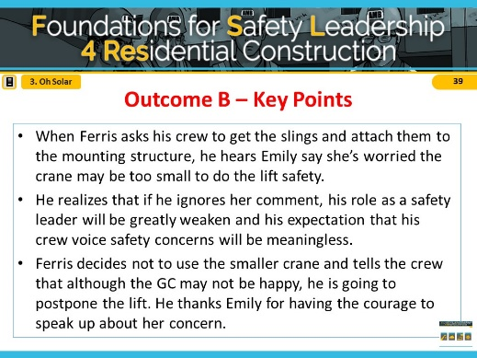
Ask students to read outcome B for “Oh Solar Mio” (or instructor reads it aloud).

ADVANCE SLIDE

NOTES FOR SLIDE 40 SLIDE 40
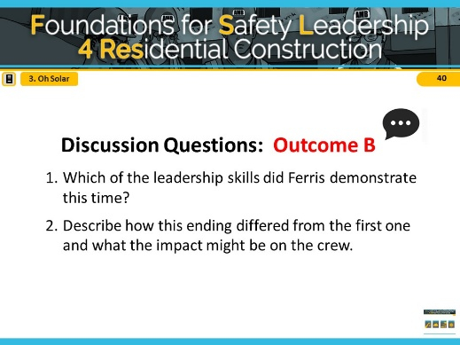
Reveal the discussion questions and/or use the facilitation table to go through skills.

In outcome B, Ferris did lead by example, actively listened to Emily’s concerns, and empowered her when he decides to stop the job until the proper equipment is available. He also recognized Emily for having the courage to speak up and for being a valuable team member.

CLICK THE SCENARIO MENU ICON TO RETURN TO MAIN MENU

4. IT’S TOO HOT, TOO HOT, TOO HOT BABY…

Franco – AMB, Inc. Foreman
Emilio – AMB, Inc. Experienced Carpenter

Situation
Late one afternoon, Franco, a foreman for AMB, notices Emilio, an experienced carpenter, pouring a jug of water over his head. Franco suspects heat exhaustion.
He shouts to Emilio that he’ll be right down to walk him to the trailer where it’s cool, so he can rest, get something to eat and drink, and stay inside, out of the sun, until quitting time.
Emilio responds that he’s fine, except for a slight head and stomachache. But agrees to go to the trailer.
Outcome A
After guzzling a sports drink and eating some peanuts, Emilio notices it’s 2:00 and thinks if he gets back to work soon, he can finish what he was doing before the day ends. So, he leaves the trailer to go back to work.
The sweltering heat hits him as he leaves and soon he is overcome with nausea. He gets a leg cramp, his knee buckles, and he drops to the ground. Franco sees this and runs over to see if he’s ok.
Emilio's wave of nausea subsides and he tells Franco not to worry, it was "just a little cramp." Franco tells Emilio his instructions were very clear to sit out the rest of the day and that he should have listened to him.
Outcome B
Franco asks Emilio to tell him exactly what he’s going to do once he gets into the trailer. Emilio repeats Franco’s instructions, but leaves out the part about stopping work for the day.
Franco corrects him and emphasizes that he expects him to stay and rest in the trailer until quitting time. Emilio frowns, saying it will only take him a few minutes to finish what he was doing.
Franco tells Emilio that the only job he has left to do today is to get better for tomorrow and that another crew member will be able to finish up for him. Emilio knows that Franco is doing this because he’s concerned, so he explains what’s left to do, and heads to the trailer.

NOTES FOR SLIDE 41 SLIDE 41

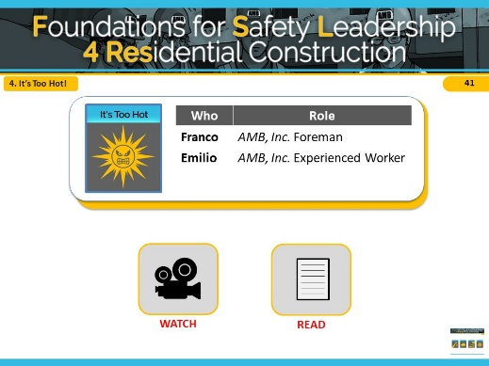
The primary safety leadership moment illustrated in “It’s too hot, too hot, too hot baby” is how a safety leader approaches a team member who may be facing a potentially serious health risk.

This safety scenario shows a commercial worksite, however it is also relevant to residential construction, as heat exhaustion is a serious health issue that can happen on any type of construction site. In this scenario, you will see a free-standing, six-story building in North Carolina with commercial offices on the first floor and residential housing on the upper five floors. While working on site a worker experiences heat exhaustion and his supervisor tells him to cool off in the trailer for the rest of the day. While watching this scenario, imagine instead that the supervisor sends the worker to his car to cool off for the rest of the day instead of the trailer.

Remember that these scenarios are meant to illustrate key safety leadership skills. Focus on how a safety leader would communicate the needs of the task while prioritizing safety.

The safety hazard in this scenario is heat stress.
INSTRUCTOR INFORMATION - It is designed to illustrate the following safety leadership skills:
- Lead by example
- Practice 3-way communication
- Engage and empower workers

CLICK ON DESIRED TEACHING MODE…

WATCH

NOTES FOR SLIDE 42 SLIDE 42
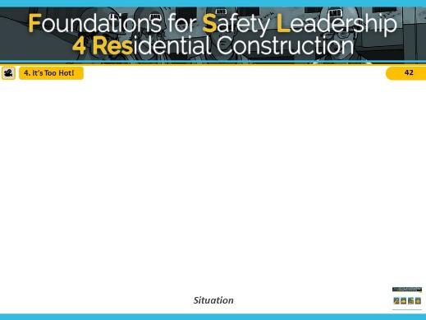
VIDEO WILL START AUTOMATICALLY

ADVANCE SLIDE

NOTES FOR SLIDE 43 SLIDE 43
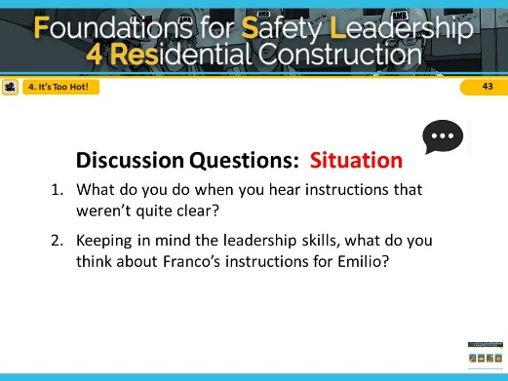
Reveal the discussion questions and/or
use the facilitation table to go through skills.

ADVANCE SLIDE

NOTES FOR SLIDE 44 SLIDE 44
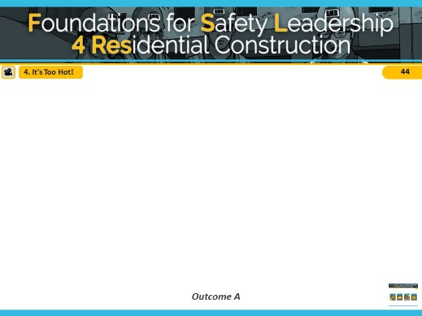
VIDEO WILL START AUTOMATICALLY

ADVANCE SLIDE

NOTES FOR SLIDE 45 SLIDE 45
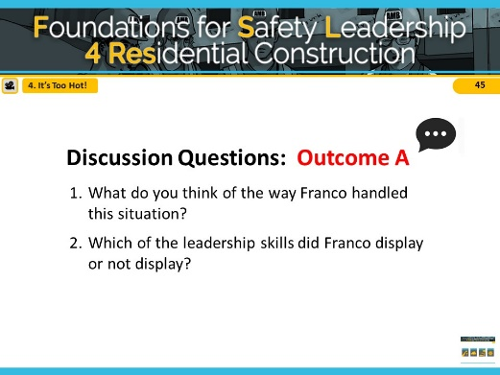
Reveal the discussion questions and/or use the facilitation table to go through skills.

Franco led by example by putting safety ahead of productivity when he asked Emilio to go to the trailer and rest. Unfortunately, Franco did not practice 3- way communication skill, which resulted in Emilio not understanding that Franco wanted him to not only to rest, but also to stop work for the day.

ADVANCE SLIDE

NOTES FOR SLIDE 46 SLIDE 46
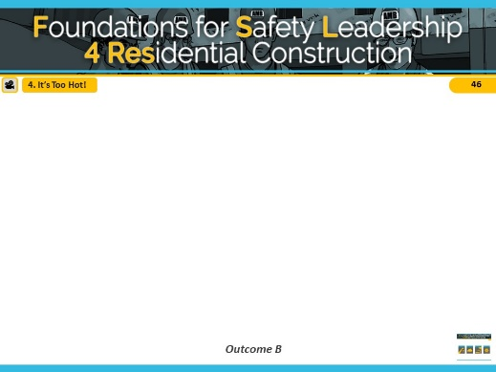
VIDEO WILL START AUTOMATICALLY

ADVANCE SLIDE

NOTES FOR SLIDE 47 SLIDE 47
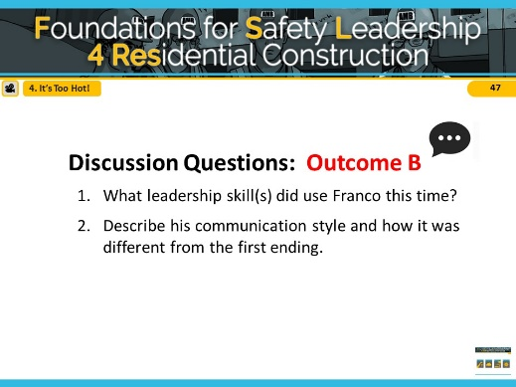
Reveal the discussion questions and/or use the facilitation table to go through skills.

In addition to leading by example as in outcome A, Franco engaged in 3-way communication with Emilio. This allowed both of them to understand and agree that Emilio should go to the trailer where it’s cool, drink fluids, eat a snack and not return to work that day. He also led by example and engaged Emilio by offering to get one of the other guys to finish what Emilio had started. This let Emilio know that he is valued and he can focus on getting better.

CLICK THE SCENARIO MENU ICON TO RETURN TO MAIN MENU

READ

NOTES FOR SLIDE 48 SLIDE 48

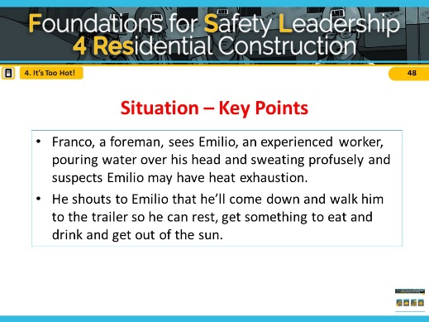
Refer students to page 10 in the student handout

Ask students to read the situation for “It’s too hot…” (or instructor reads it aloud).

ADVANCE SLIDE

NOTES FOR SLIDE 49 SLIDE 49
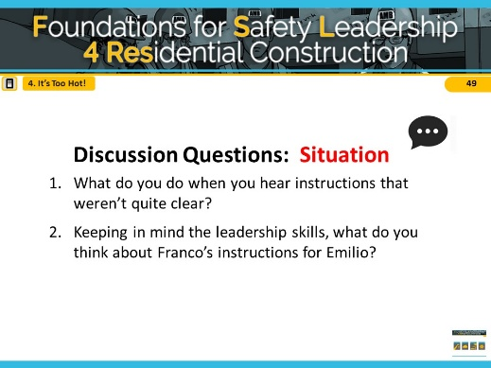
Reveal the discussion questions and/or use the facilitation table to go through skills.

ADVANCE SLIDE

NOTES FOR SLIDE 50 SLIDE 50
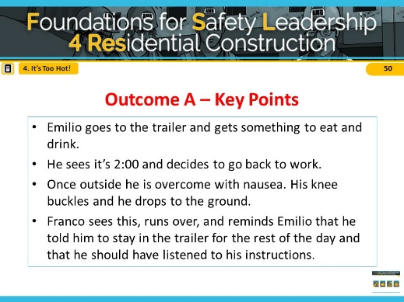
Ask students to read outcome A for “It’s too hot…” (or instructor reads it aloud).

ADVANCE SLIDE

NOTES FOR SLIDE 51 SLIDE 51
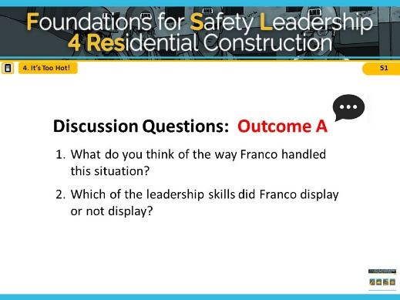
Reveal the discussion questions and/or use the facilitation table to go through skills.

Franco led by example by putting safety ahead of productivity when he asked Emilio to go to the trailer and rest. Unfortunately, Franco did not practice 3- way communication skills, which resulted in Emilio not understanding that Franco wanted him to not only to rest, but also to stop work for the day.

ADVANCE SLIDE

NOTES FOR SLIDE 52 SLIDE 52
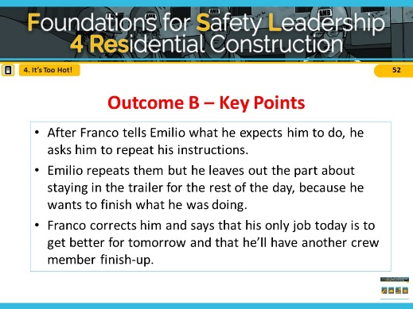
Ask students to read outcome B for “It’s too hot…” (or instructor reads it aloud).

ADVANCE SLIDE

NOTES FOR SLIDE 53 SLIDE 53
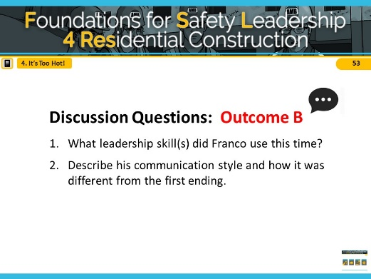
Reveal the discussion questions and/or use the facilitation table to go through skills.

In addition to leading by example as in outcome A, Franco engaged in 3-way communication with Emilio. This allowed both of them to understand and agree that Emilio should go to the trailer where it’s cool, drink fluids, eat a snack, and not return to work that day. He also led by example and engaged Emilio by offering to get one of the other guys to finish what Emilio had started. This let Emilio know that he is valued and he can focus on getting better.

CLICK THE SCENARIO MENU ICON TO RETURN TO MAIN MENU

NOTES FOR SLIDE 54 SLIDE 54
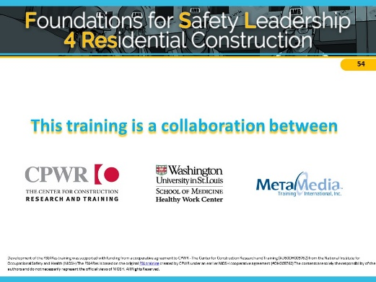
Credits

