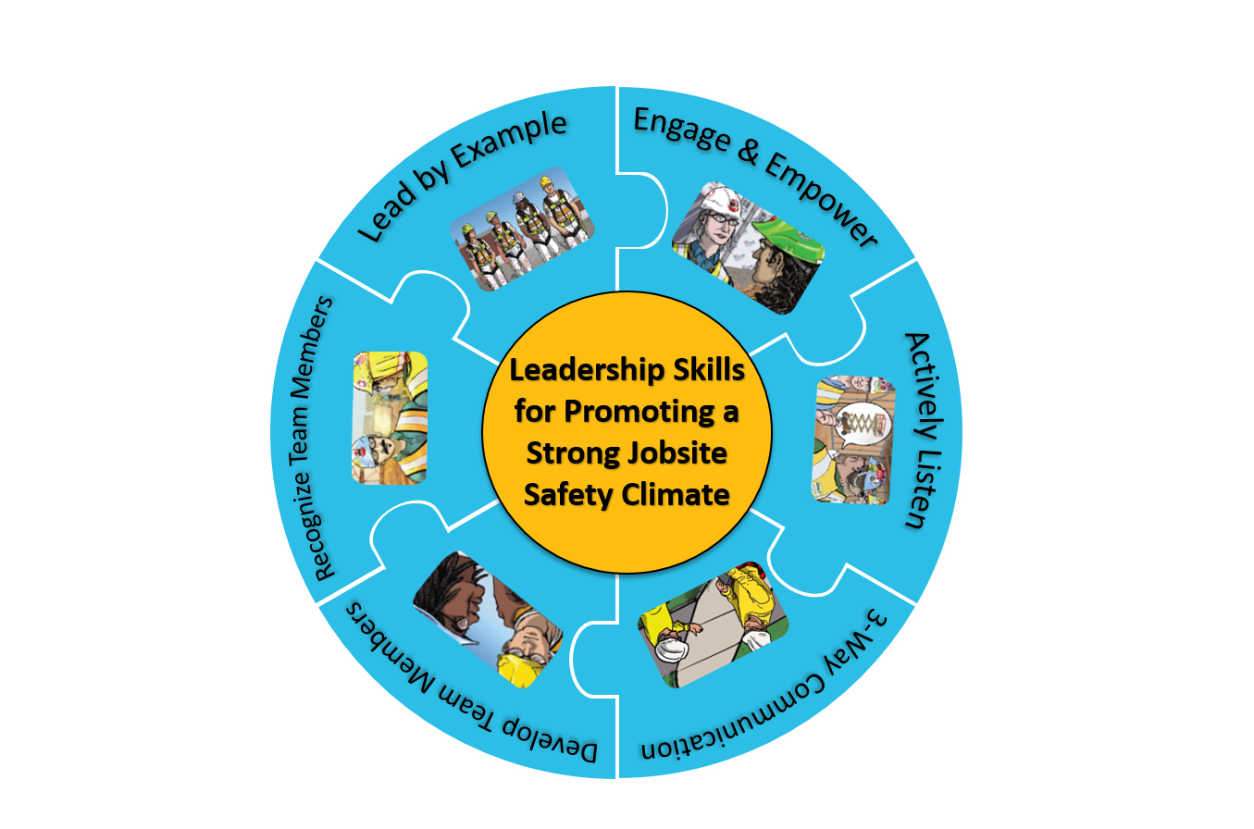
Leadership Self-Assessment & Personal Action Plan

SELF-ASSESSMENT ON THE 6 LEADERSHIP SKILLS
How often do you….
 | Always | Sometimes | Never
1. Lead by example
Maintain a positive attitude about safety | ❒ | ❒ | ❒
Consider the safety implications of all your decisions | ❒ | ❒ | ❒
Set high expectations for team members | ❒ | ❒ | ❒
Walk the talk – always follow safe work practices | ❒ | ❒ | ❒
Communicate with your team that everyone owns safety | ❒ | ❒ | ❒
2. Engage and empower team members
Engage team members in daily safety meetings or morning safety huddles | ❒ | ❒ | ❒
Request input from team members about safety | ❒ | ❒ | ❒
Encourage team members to identify and report safety issues such as hazards, concerns, injuries, and near misses | ❒ | ❒ | ❒
3. Actively listen
Treat team members with respect when communicating with them | ❒ | ❒ | ❒
Actively listen to hear what is said vs. coming up with a response | ❒ | ❒ | ❒
Pay attention to non-verbal cues and ask clarifying questions | ❒ | ❒ | ❒
4. Practice 3-way communication
Be direct and concise, and make sure you have your listener’s attention | ❒ | ❒ | ❒
Ask team member to repeat message/ instructions, and clarify misunderstandings | ❒ | ❒ | ❒
5. Develop Team Members Through Teaching, Coaching, and Feedback
Teach and coach members in a respectful manner | ❒ | ❒ | ❒
Focus on the problem rather than judging the person when you give feedback | ❒ | ❒ | ❒
Make sure team members know how to do a new task before actually doing it | ❒ | ❒ | ❒
6. Recognize Team Members for a Job Well Done
Say “good job” or “thank you” to team members who go above and beyond to create a safe jobsite | ❒ | ❒ | ❒
Use positive recognition of team members to encourage jobsite safety | ❒ | ❒ | ❒
Total number of checks for each column

ACTION PLAN

Based on your self-assessment and your knowledge of the safety leadership skills, answer the questions below to create your action plan – what steps will you take in the next few months to further develop your skills as a safety leader? Be specific.

- In which of the skill areas are you doing very well? (Checked “Always” for the majority of the questions)

- Which skill areas do you need to work on or improve? (Checked “Sometimes” or “Never” for the majority of the questions)

- Which skill area(s) will you work on first, in the next 3 months, and what steps will you take?

- Which skill area(s) will you work on next, in 3 – 6 months, and what steps will you take?

Follow up and track your progress:
At the 3-month and 6-month point, check to see if you have taken the steps to becoming a more effective safety leader. Ask yourself:

- What is working well?
- If you haven’t taken the steps, what is preventing you from doing so?
- Who can help you or give you the support you need?

Check your success
You can check to see how well you are doing at putting the skills into action by paying attention to how often your team members are:

- Following safety procedures
- Helping each other be safe
- Reporting any hazards they see and making suggestions for solutions
- Reporting near misses when they occur
- Reporting injuries when they occur

The more they are doing these things and others like them, the more likely it is that you are being an effective safety leader and are creating a strong jobsite safety climate!

Good luck on your leadership journey!

Development of the FSL4Res training was supported with funding from a cooperative agreement to CPWR - The Center for Construction Research and Training (#U60OH009762) from the National Institute for Occupational Safety and Health (NIOSH) The FSL4Res is based on the original FSL training created by CPWR under an earlier NIOSH cooperative agreement (#OH009762) The contents are solely the responsibility of the authors and do not necessarily represent the official views of NIOSH. All Rights Reserved.

