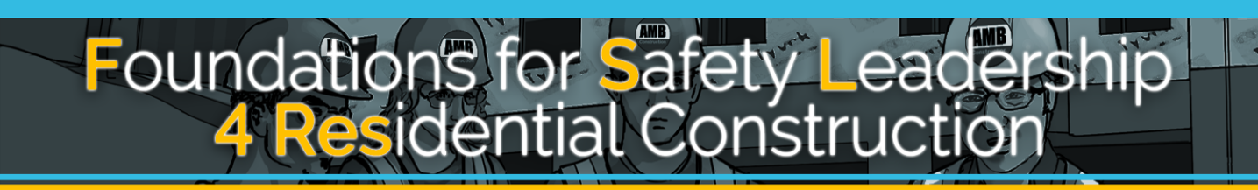

Single-Session Student Handout

The Foundations for Safety Leadership 4 Residential Construction (FSL4Res) course was developed collaboratively by

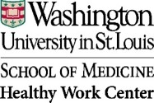

Development of the FSL4Res training was supported with funding from a cooperative agreement to CPWR - The Center for Construction Research and Training (#U60OH009762) from the National Institute for Occupational Safety and Health (NIOSH) The FSL4Res is based on the original FSL training created by CPWR under an earlier NIOSH cooperative agreement (#OH009762) The contents are solely the responsibility of the authors and do not necessarily represent the official views of NIOSH. All Rights Reserved.
TABLE OF CONTENTS

Foundational Material 4
Safety Leadership Skills 7
Leads by Example 8
Engages and Empowers Team Members 9
Actively Listens 10
Practices 3-Way Communication 11
Develops Team Members through Teaching, Coaching, and Feedback 12
Recognizes Team Members for a Job Well Done 14
Applying Leadership Skills In Real World Scenarios 15
Leadership Skills and Action Checklist 17
- Derailing the Job 18
- Reality Check… 19
- Cover Up!… 20
- Don’t Shortcut Safety 21
- It’s Too Hot, Too Hot, Too Hot Baby 22
Takeaways 23

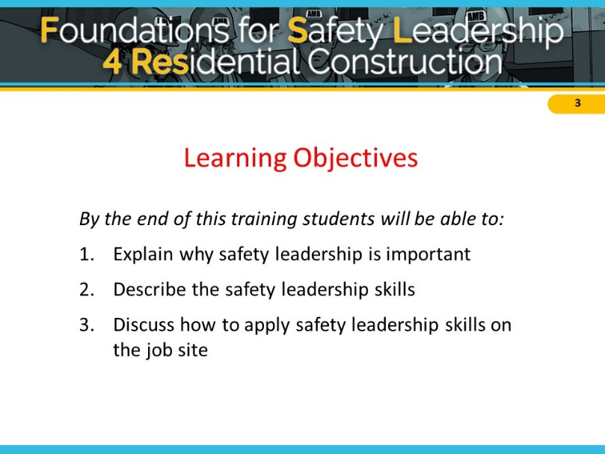
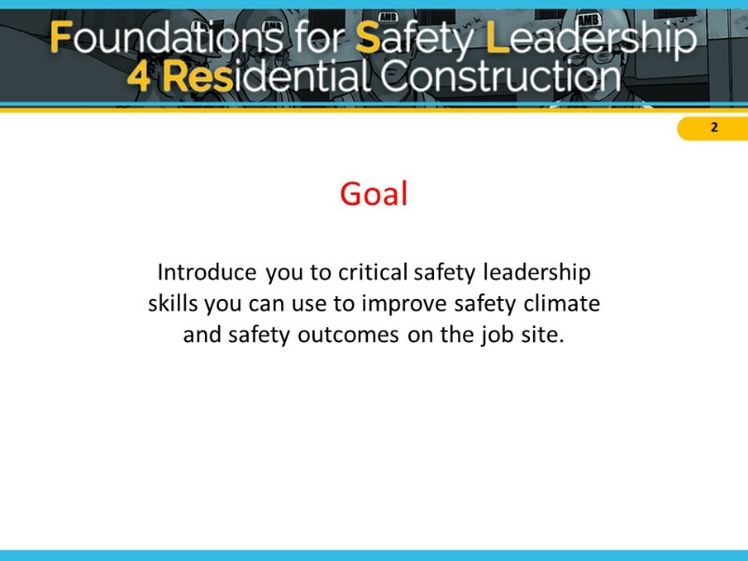
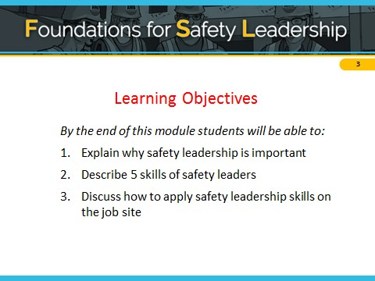
FOUNDATIONAL MATERIAL

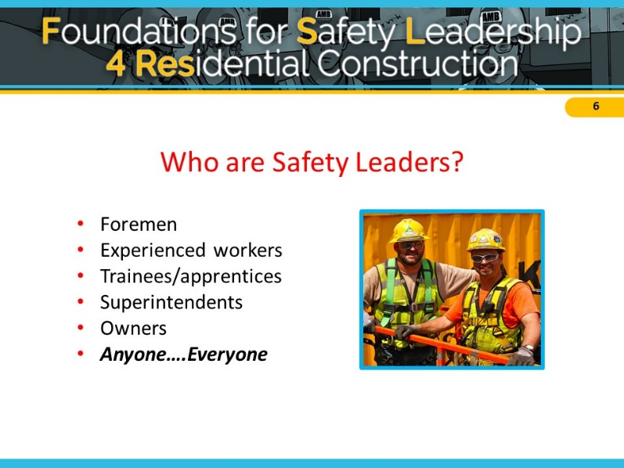
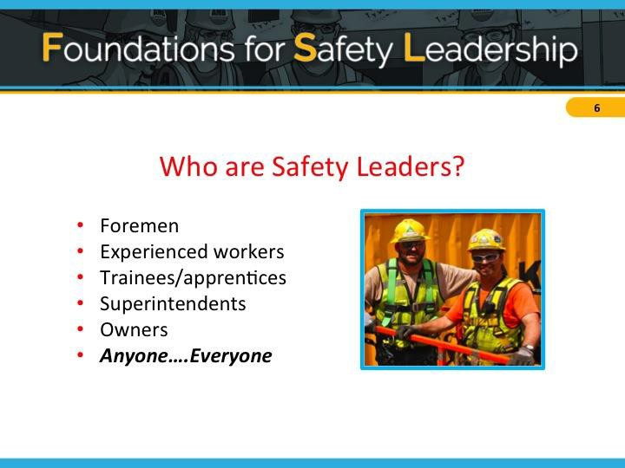
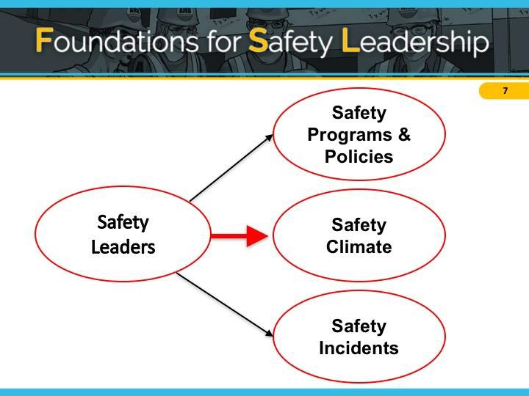

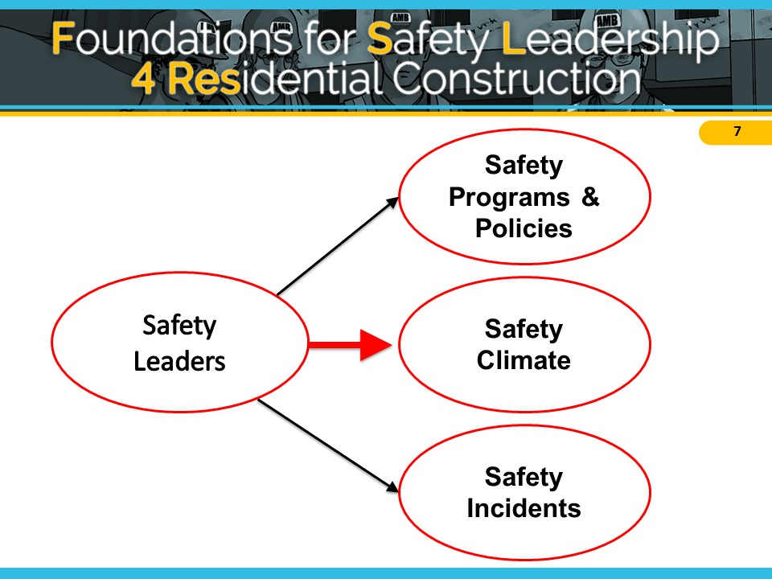

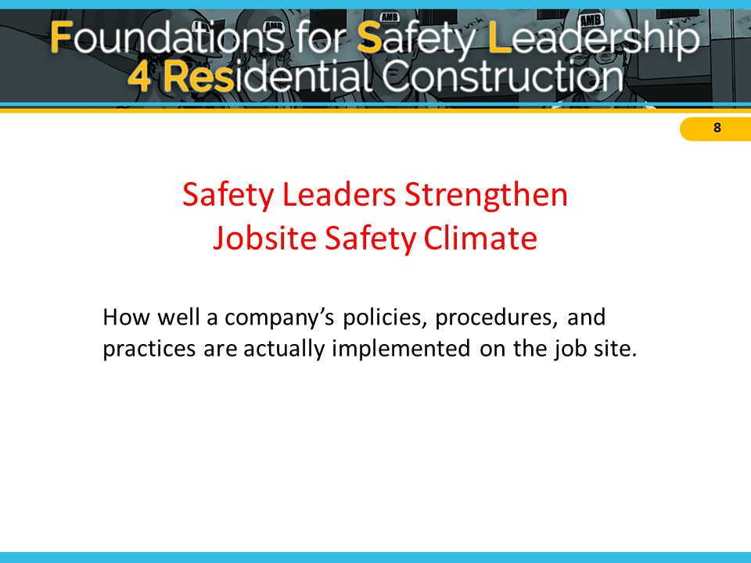
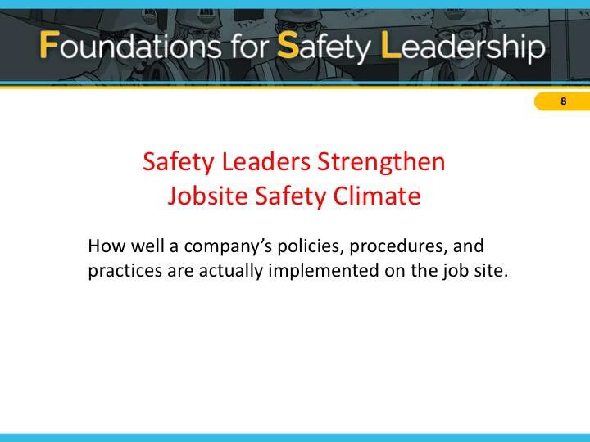

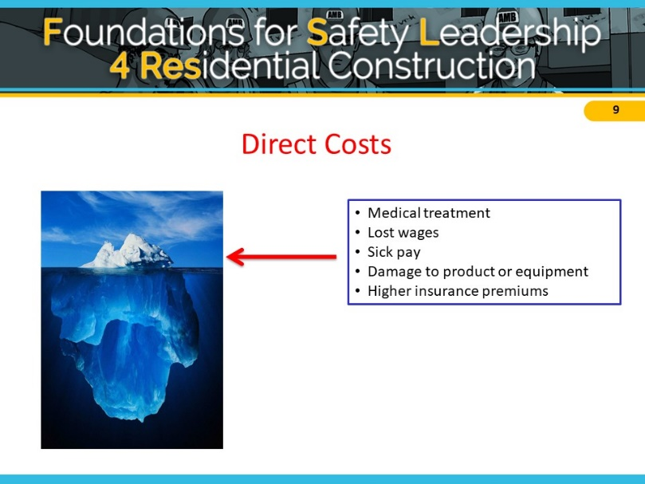
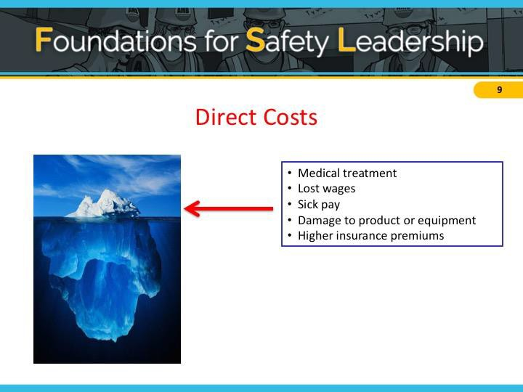

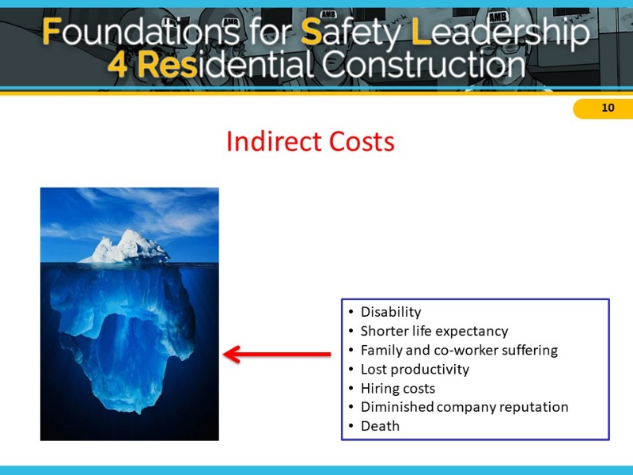
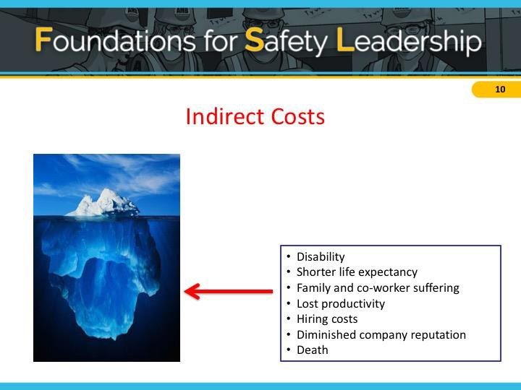

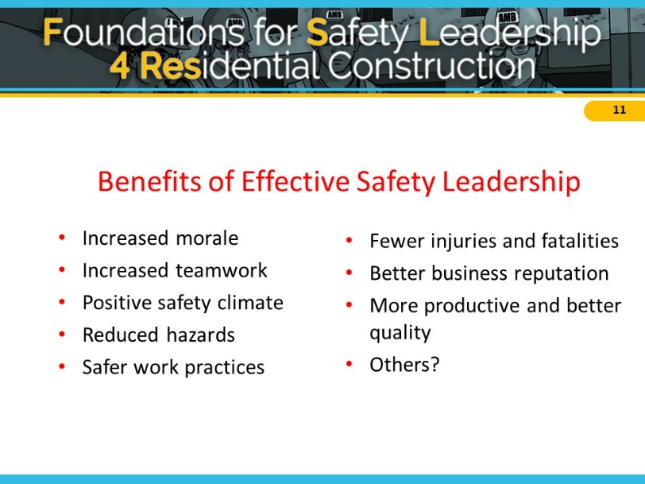

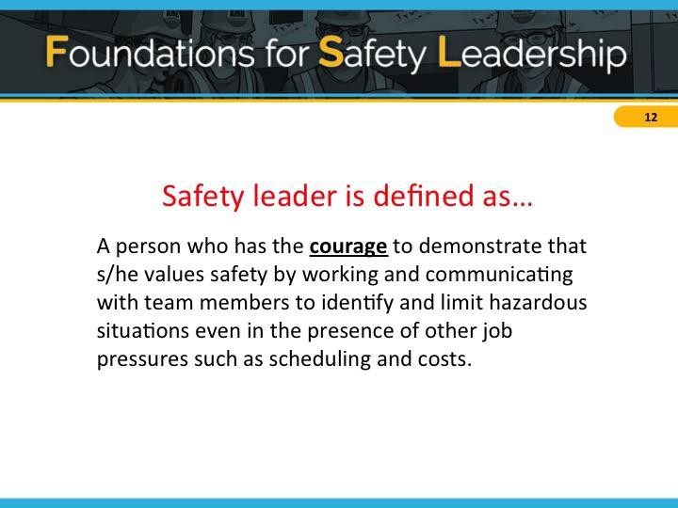
Safety Leadership Skills

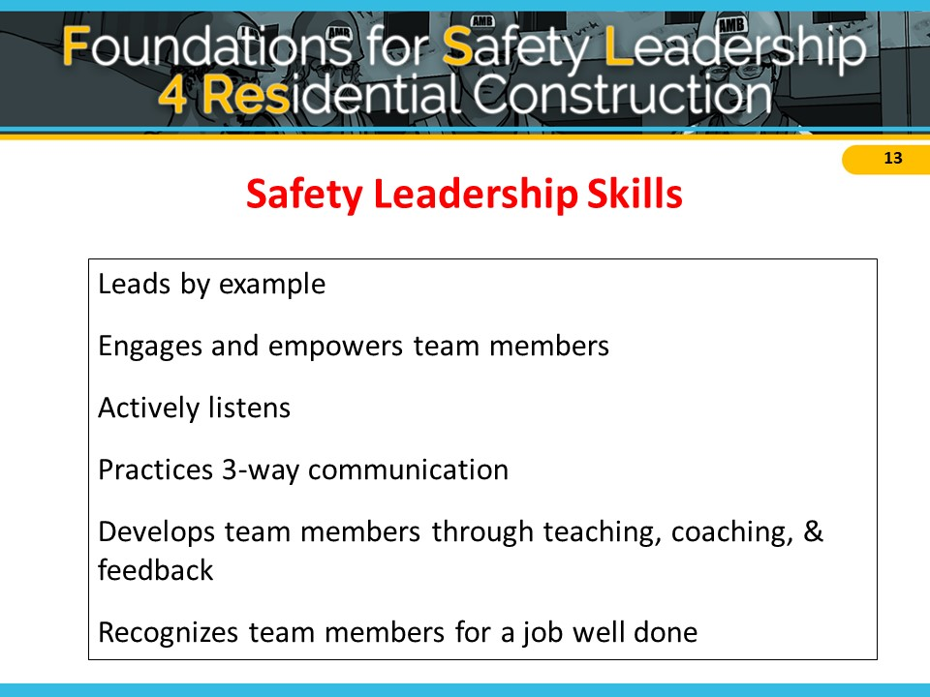

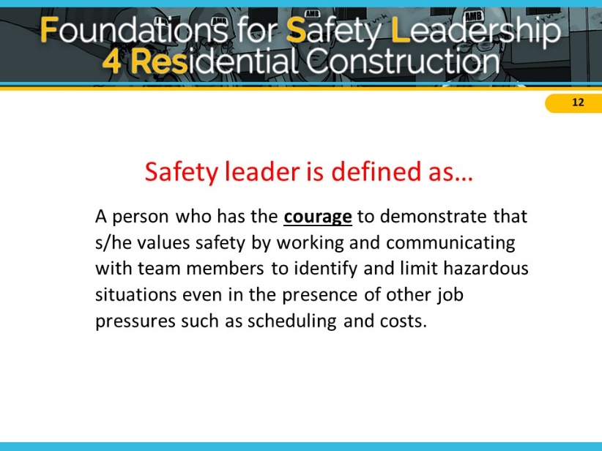

Leads by Example

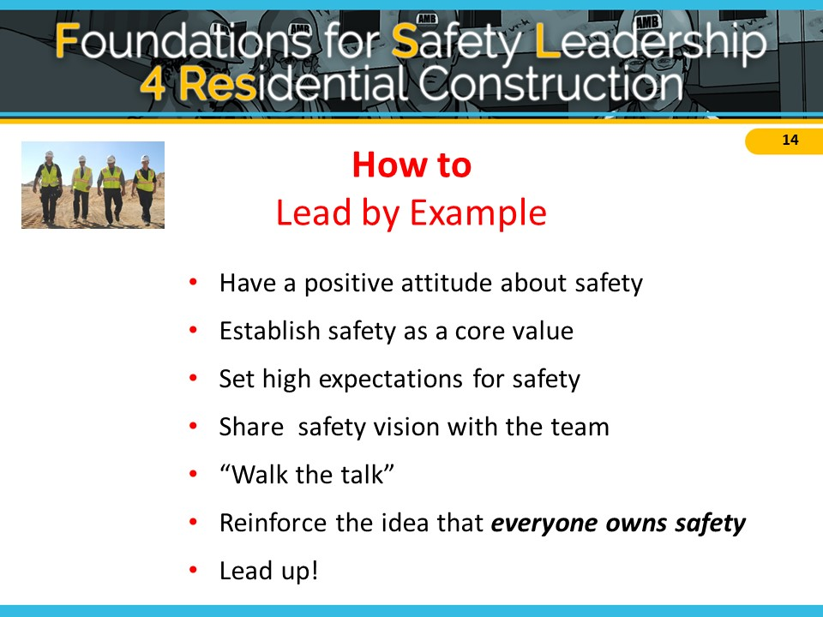
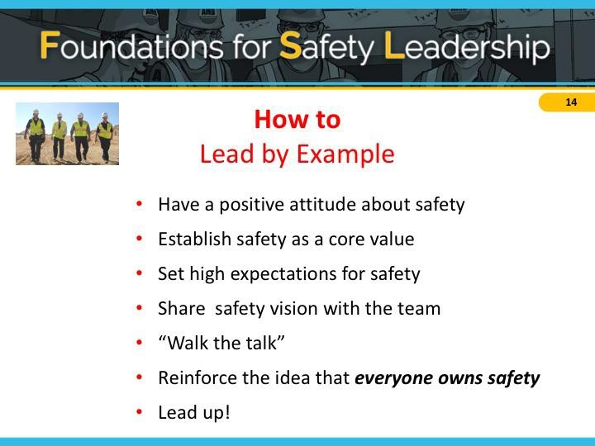

Engages and Empowers Team Members

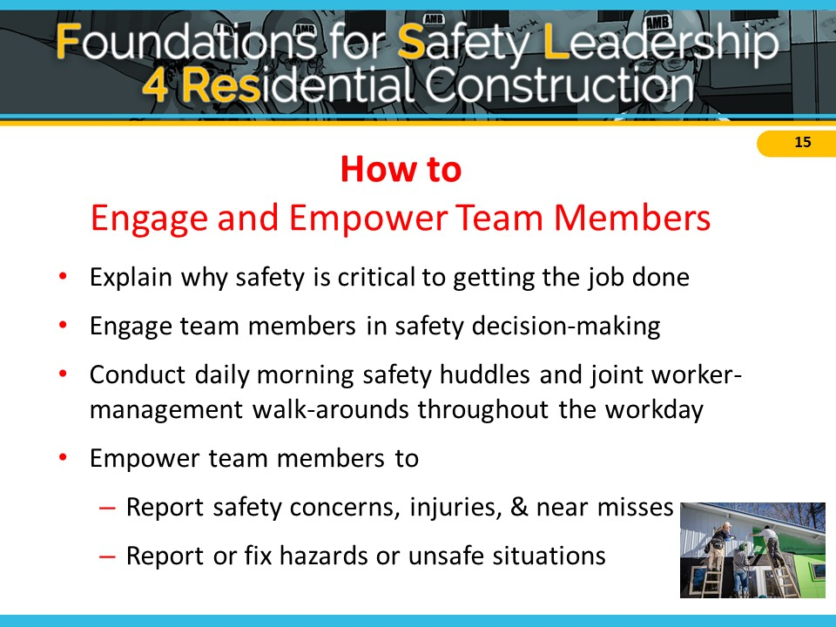
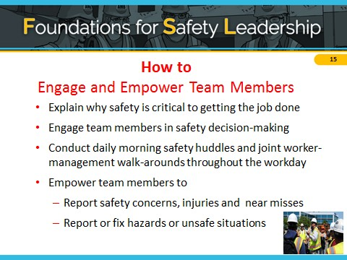

Actively Listens

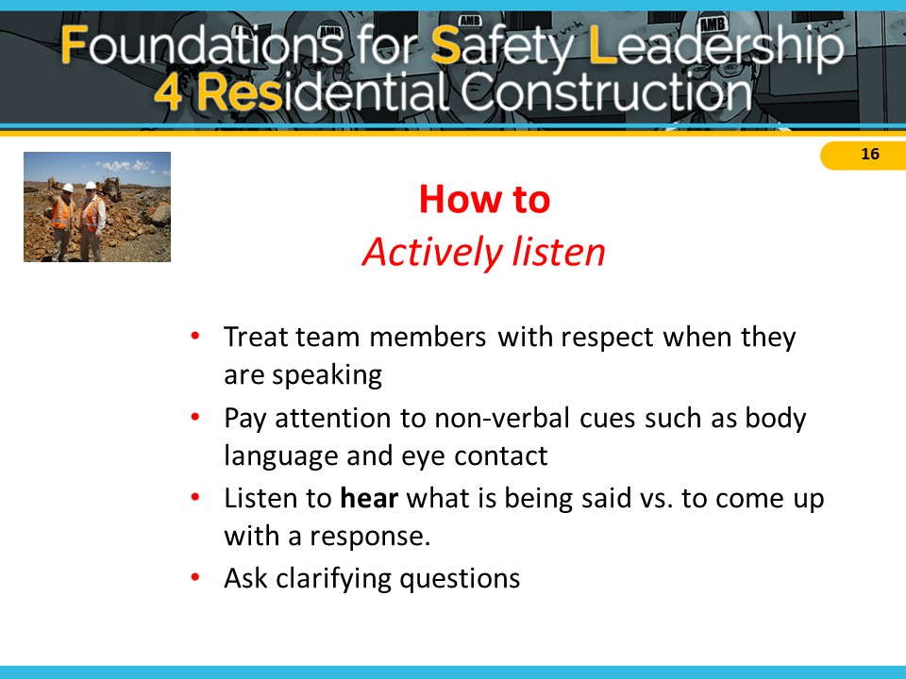
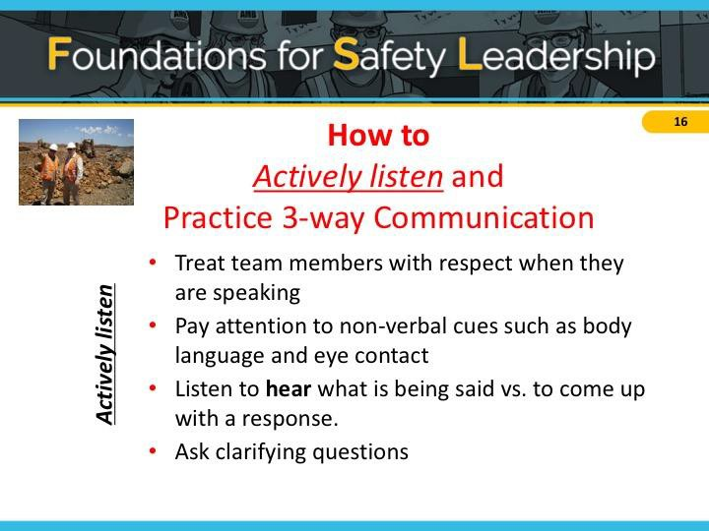

Practices 3-Way Communication

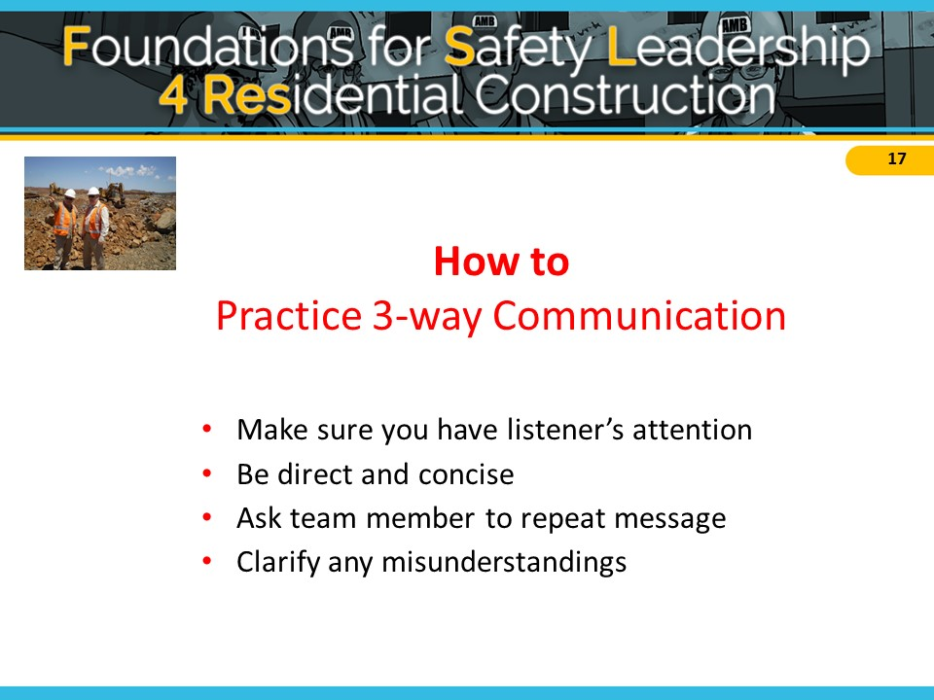

Develops Team Members through Teaching, Coaching, and Feedback

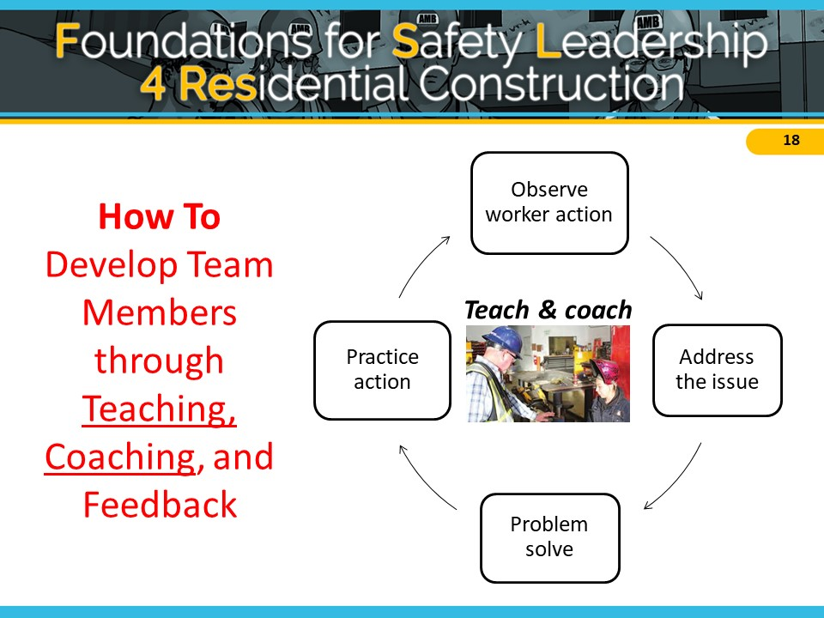
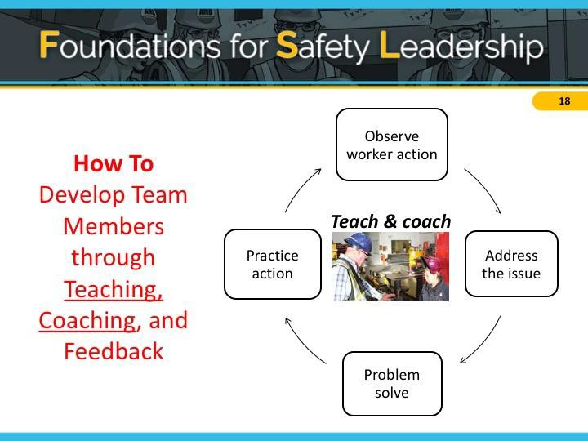

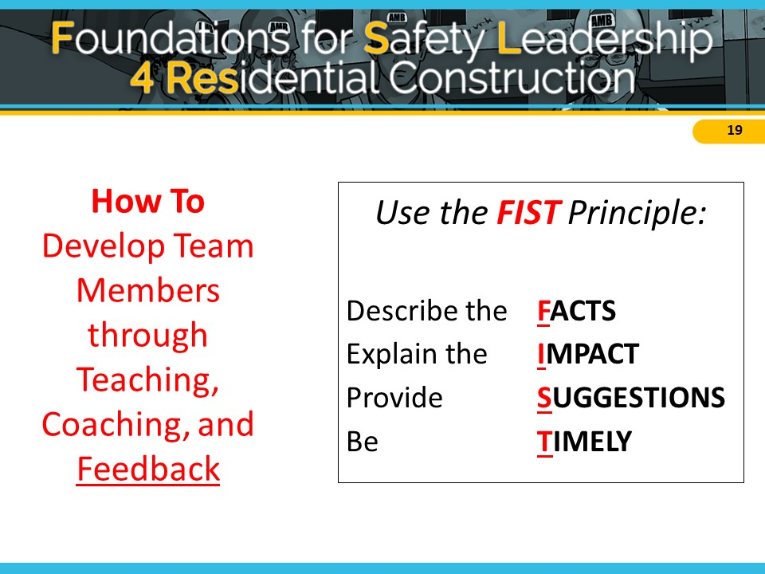
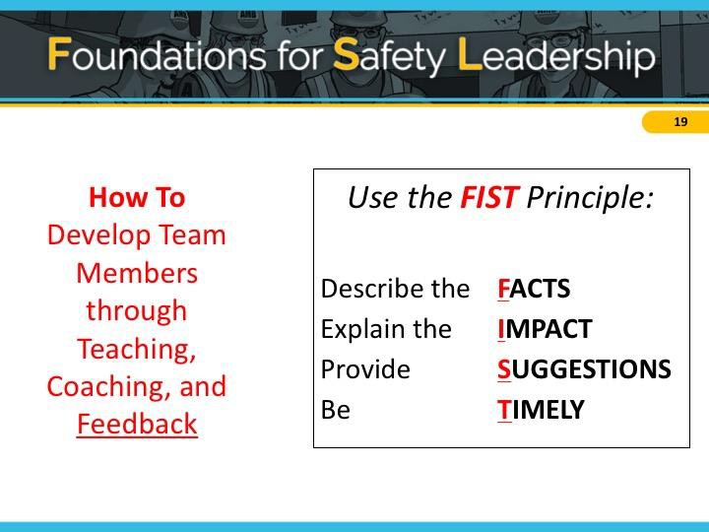

Recognizes Team Members for a Job Well Done

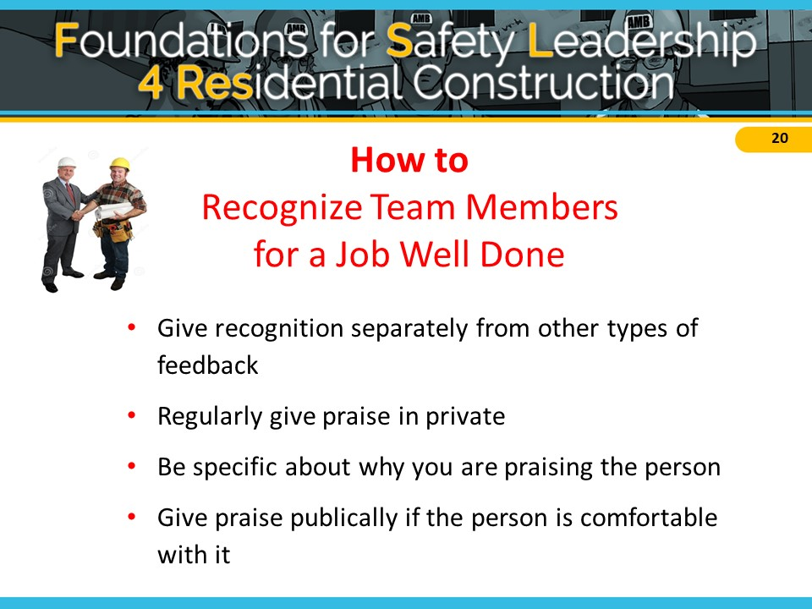
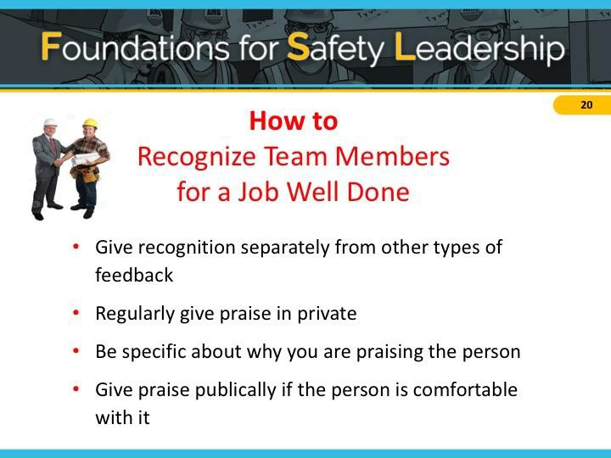

Applying Leadership Skills in Real World Scenarios
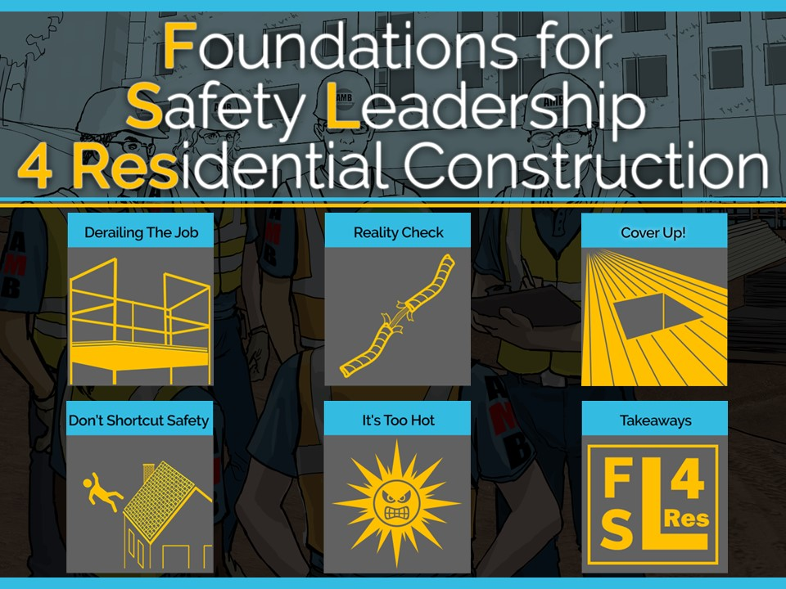
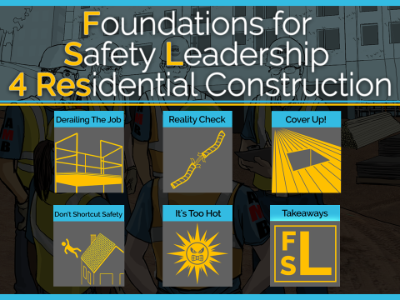
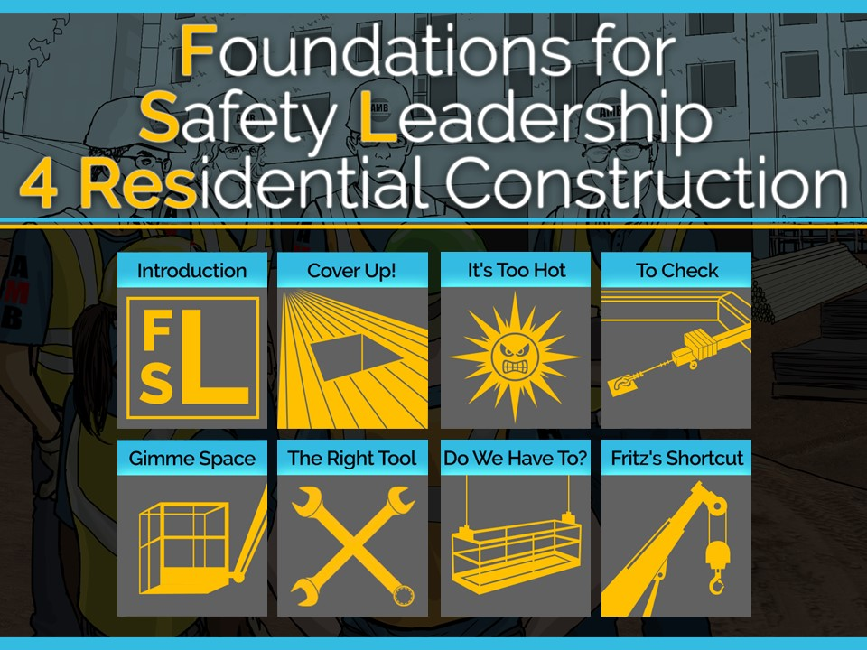
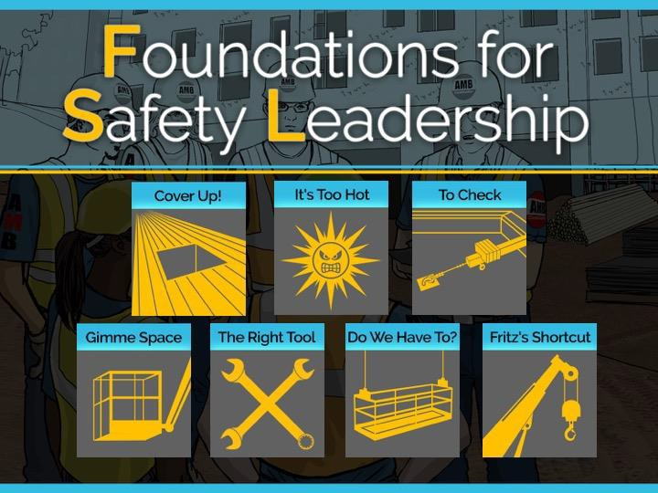

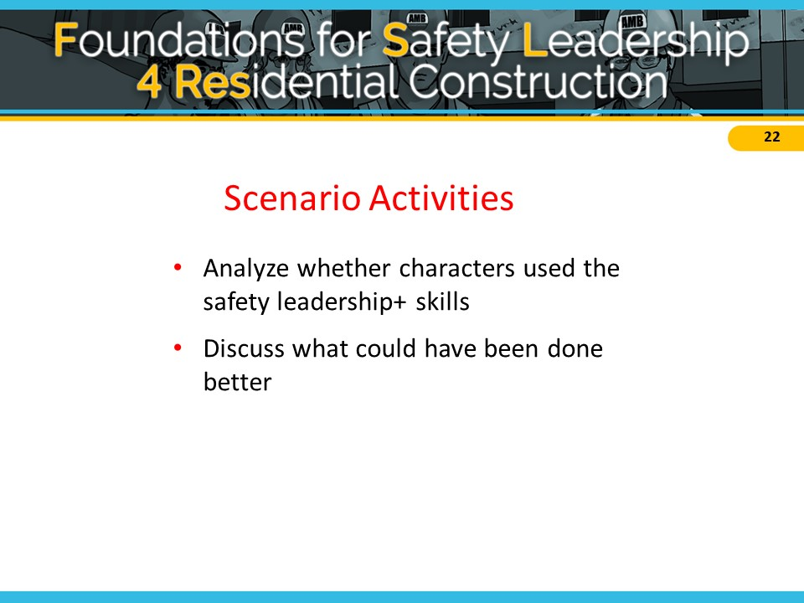
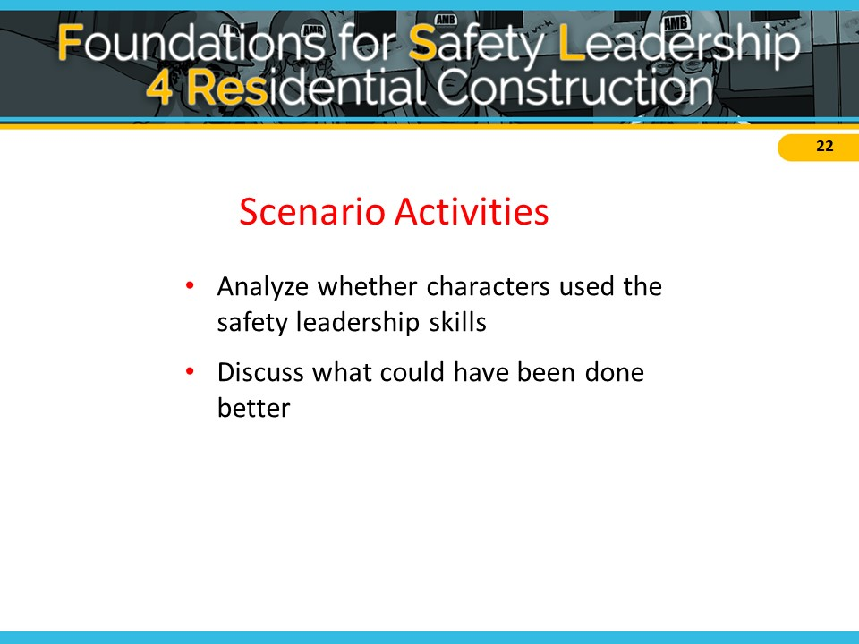

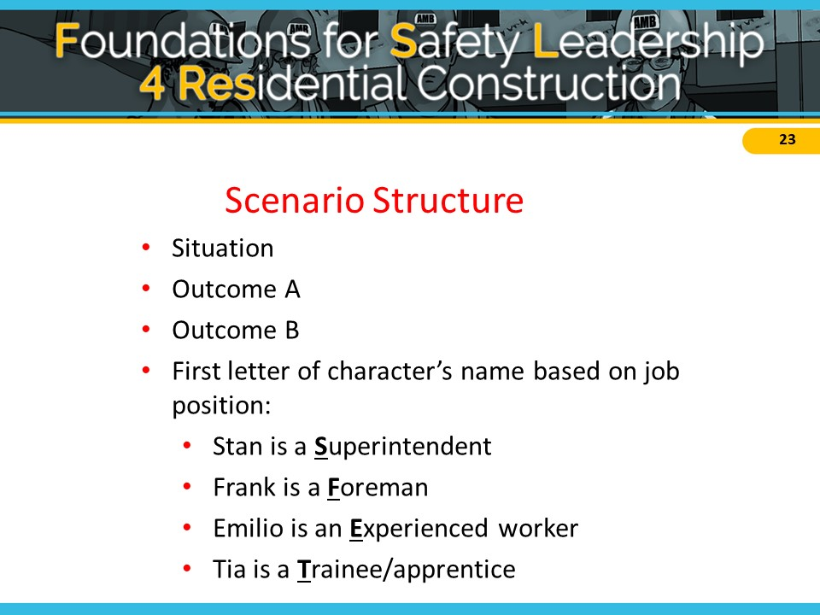
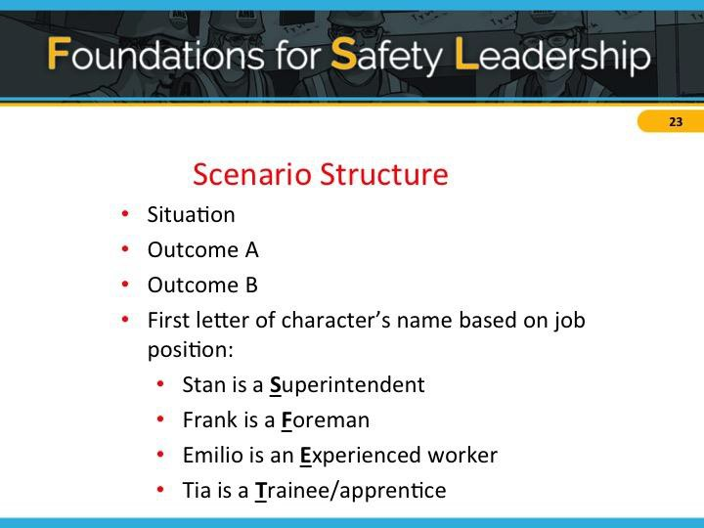

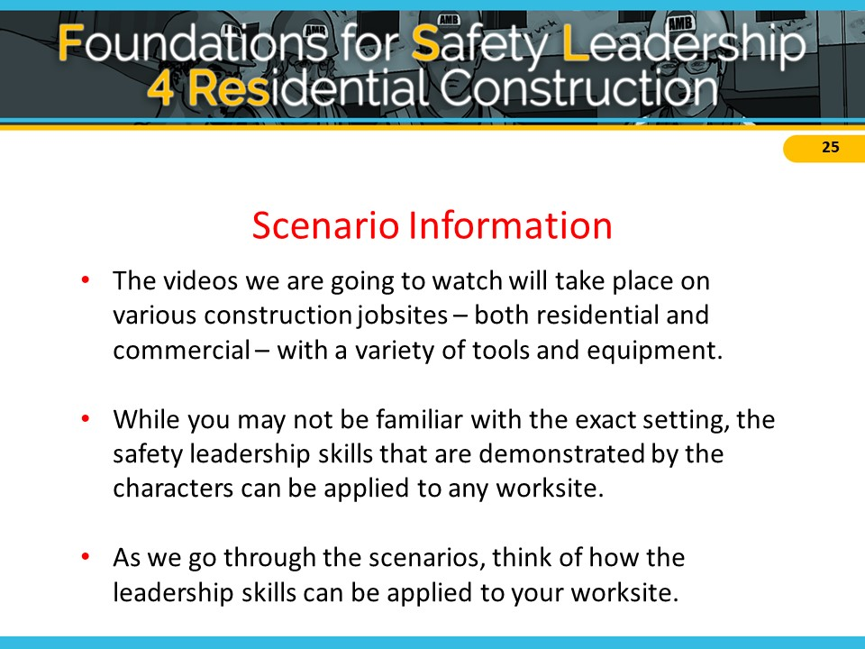

Leadership Skills and Action Checklist

Skills | Actions
Leads by Example | - Establishes safety expectations as a core value  - Shares safety vision with team members  - Demonstrates a positive attitude about safety  - Walks the Talk  - Leads up
Engages and Empowers Team Members | Engages, encourages, and empowers team members to  identify and act upon unsafe situations by…  - Reporting hazards and safety concerns  - Providing solutions  - Reporting near misses  - Stopping work if necessary
Actively Listens | - Actively listens to hear what team members are saying  - Treat team members with respect when they are speaking and listen to hear what is said vs. coming up with a response  - Pay attention to non-verbal cues and ask clarifying questions
Practices 3-way Communication | - Is direct and concise, and makes sure s/he has the listener’s attention  - Asks team member to repeat message and clarify misunderstandings
Develops Team Members Through Teaching, Coaching, and Feedback | - Respectfully teaches and coaches workers  - Watches the learner fix the hazardous situation or perform the task to make sure it's done correctly  - Focuses on potential consequences rather than on the team member  - Uses the FIST principle: Facts, Impact, Suggestions, Timely
Recognizes Team Members for a Job Well Done | - Privately and/or publicly acknowledges team members for going above and beyond when it comes to safety

1. DERAILING THE JOB

Tomas – Derby Drywall Trainee
Steve –Derby Drywall Supervisor
Felix – Haglin Homebuilding Foreman
Trevor – Haglin Homebuilding Trainee
Ellen – Haglin Homebuilding Experienced Carpenter

Situation
A crew from the Derby Drywall company is trying to finish taping the drywall in a two-story residential home. Their supervisor, Steve, told them earlier that the job must be completed by the end of the day because they have another job starting tomorrow.
Tomas, a trainee, is unable to finish his taping work on the stairwell because one of the scaffold guardrails is in his way. Keeping in mind what Steve said, Tomas removes the guardrail and finishes taping, but forgets to reinstall the guardrail before leaving for the day.
When the Haglin Homebuilding carpentry crew arrives to begin installing the crown molding, Trevor, a trainee, notices the missing guardrail and tells Felix, his foreman, about it.
Outcome A
Felix thanks Trevor for letting him know and tells him to “deal with it.” Trevor isn’t sure if he should put the guardrail back up since Felix didn’t tell him to but decides it’s better to be safe than sorry.
Later, Felix notices that the guardrail is up, but doesn’t say anything to Trevor or any other crew members.
Outcome B
Felix is surprised and asks if this has happened before. The workers nod and Ellen says she noticed the same thing last week, but she put it back up without saying anything.
Felix reminds the crew that if the guardrails aren’t attached, someone could fall and get seriously injured. He thanks Trevor and Ellen for paying attention to hazards and for speaking up. Felix says he’s going to talk to the drywall company supervisor.
Later that day, Steve, the Derby Drywall supervisor, stops by the site. Felix calls over Trevor and Ellen and tells Steve about the guardrail being removed. Steve gets defensive, exclaiming that he and his crew always put safety first! He also admits that he’s under pressure from the owner because another job started today.
In a stern voice, Felix says to Steve that Derby’s actions are putting workers at risk of falling. Steve agrees but points out that his crew is unable to work easily or quickly around guardrails. Felix and Steve then work together to develop a process for ensuring that guardrails are in place at all times.

2. REALITY CHECK

Foster – Five Star Roofing Foreman
Eduardo – Five Star Roofing Experienced worker
Troy – Five Star Roofing Trainee
Tara – Five Star Roofing Trainee

Situation
As Eduardo, an experienced roofer, arrives at the worksite, he sees trainees Troy and Tara start to climb onto the roof to begin their work. Eduardo asks if they’ve secured the ladder and inspected all of the fall protection harnesses, anchor points, and lines they’ll be using.
Troy snaps back, saying they’d just put the ladder up and the rest of the equipment was checked yesterday. Tara chimes in, saying she’s sure it’s all fine.
Outcome A
Eduardo shrugs. The job has a short timeline and yesterday’s check is probably okay. He
tells Troy and Tara to get up on the roof and get started.
Troy reaches the roof and connects his harness to the roof anchor line. As he walks across the roof to retrieve some shingles, he stumbles, but catches himself before falling. Relieved that he is OK after this close call, Troy inspects the anchor line and notices a section that is badly frayed. He realizes that if he had fallen, the anchor line might have snapped and he could have been seriously injured.
Outcome B
Troy and Tara’s reaction makes Eduardo wonder if they actually know how to inspect the fall protection equipment. Or worse, maybe they think it’s okay to cut corners. He tells them that even though they checked the harnesses, anchor points, and lines the day before, their company requires them to be checked every day, since their fall protection equipment is what keeps them from being injured. Eduardo tells Foster, the foreman, his concerns and suggests it might be a good time to have a huddle to discuss procedures and expectations.
Foster agrees, calls the crew together, and asks them to bring their fall protection equipment with them. He asks Tara and Troy to explain the process for checking the harnesses, anchor points and lines. After a minute or so, Troy admits that they’re not 100% sure what to look for because they’ve always trusted others to check. Rather than being angry, Foster thanks him for being honest and then carefully goes over the OSHA rules and manufacturer's recommendations for checking equipment. When he’s done, he asks Troy and Tara to take turns repeating the rules and demonstrating how to inspect everything.
While doing his checks, Troy finds that part of his anchor line is frayed and shows everyone. As a group, they discuss why this is dangerous and how it reinforces why all equipment must be inspected daily. Foster then watches Troy inspect a new anchor line and properly connect it.
Foster tells them again how much he appreciates their good work, and for admitting when they didn’t know how to do something, particularly when it could have such serious safety consequences. Then Tara surprises Foster by thanking him for recognizing their value as team members, and for saying so.

3. COVER UP!

Stan – Volt Electric Superintendent
Frank – Volt Electric Lead Foreman
Tia/Tio – Volt Electric Trainee/Apprentice

Situation
To perform her tasks, Tia, a trainee with Volt Electric, has to walk by a large hole in the floor where some damaged plywood needs to be replaced. Stan, Volt’s superintendent, knows it’s a serious fall hazard that needs to be addressed immediately. The GC has been slow to respond to safety requests, so he asks his lead foreman, Frank, to take care of it.
Outcome A
Frank tells Tia she needs to cover the hole in the floor. Tia nods and decides she’ll take care of it in 15 minutes when she’s done securing the electrical wire to the stud. She knows Frank hates it when one person holds up someone else’s work.
Meanwhile, two drywall installers don’t see the hole until the last minute when a nearby worker yells, “Stop!” which gives them just enough time to avoid it.
Frank gets word of this, goes back over to Tia, and yells at her for not covering the hole immediately. He adds that if the worker had stepped into the hole, she would have been seriously injured, or maybe worse, and points out that this isn’t the first time she’s ignored his instructions. Tia, feeling humiliated, apologizes and explains that she didn’t realize he wanted her to drop everything.
Outcome B
Frank tells Tia she needs to cover the hole in the floor immediately because it’s a serious fall hazard. He tells her to stop what she’s doing, get a piece of plywood, secure it over the hole, and spray paint the word “hole” on it. He reminds her to tie off so she won’t become a victim while fixing the problem.
When he’s finished, he asks her to repeat his instructions to make sure they’re on the same page. Tia repeats Frank’s instructions word for word and Frank gives her the thumbs-up.
When she’s done covering the hole, Tia thinks how glad she is Frank asked her to confirm what he wanted her to do and by when he wanted it done because there have been times when she hasn’t understood exactly what other foremen she’s worked with were asking her to do.
A few minutes later, when Frank comes by to thank Tia for removing the fall hazard, two drywall installers walk across the piece of plywood she just put down.

4. DON’T SHORTCUT SAFETY
Sonia – ACME Homes Supervisor
Franklin – ACME Homes Foreman
Aaron – ACME Homes Apprentice

Situation
Sonia, the superintendent from ACME homes, has a final walk through coming in just a few hours and she is scrambling to get the home completed. The shutters for the home have been on backorder for weeks and just arrived this morning. There are no exterior trim workers on site, but her company’s framing crew is working on a nearby house.
Sonia asks Franklin, the foreman of the framing crew, if someone from his crew can install the shutters on two upper floor windows to complete the house. Franklin knows that this will be an easy task since the worker will be able to stand on the porch roof below the windows to get the job done, and not have to use a ladder. Franklin agrees to send Aarón, the apprentice, to do the job since he just had training on exterior trim work last week.
Outcome A
Franklin tells Aarón to stop what he’s doing and to go install the shutters on the other house saying that it should only take a few minutes. Franklin instructs Aarón to remember what he learned in school last week about how to do exterior trim work. Franklin then turns to Sonia to talk about some other issues on the site.
Aarón gets his screw gun, heads down to the house and goes to work. Once he installs the last shutter, he steps back to make sure the shutters are even and look good.
As Aarón steps back to get a better view, he steps on the gutter, loses his balance, and falls to the ground.
Outcome B
Franklin introduces Aarón to Sonia and tells him about the missing shutters. Franklin asks if Aarón remembers his training and can install the shutters to help out the superintendent. Aarón nods, grabs his screw gun, and heads toward the other house.
Franklin did not see Aarón grab any equipment other than the screw gun and wonders how Aarón is going to do the job safely. Franklin wants to speak with Sonia about some other issues but decides it can wait and follows Aarón down the street.
As Aarón steps out of the window onto the porch roof, Franklin notices that he’s not tied off and shouts to him to stop immediately.
Franklin gathers his entire crew and grabs some fall protection equipment from his truck for demonstration. He reminds the crew that they must always use fall protection when working at heights, even for tasks they can get done quickly. Franklin shows them how to create a secure tie-off point so they can use a harness and a lanyard. He also takes the time to show the crew members how to use a new window frame anchorage device that the company just purchased.
While the task didn’t go as quickly as Sonia had hoped, she was pleased that Franklin took time with his crew to emphasize the importance of always using fall protection when working at heights, and to demonstrate how to do it properly. To show her appreciation, Sonia nominated Franklin for employee of the month and wrote up the story for the company newsletter.

5. IT’S TOO HOT, TOO HOT, TOO HOT BABY…

Franco – AMB, Inc. Foreman
Emilio – AMB, Inc. Experienced Carpenter
Situation
Late one afternoon, Franco, a foreman for AMB, notices Emilio, an experienced carpenter, pouring a jug of water over his head. Franco suspects heat exhaustion.
He shouts to Emilio that he’ll be right down to walk him to the trailer where it’s cool, so he can rest, get something to eat and drink, and stay inside, out of the sun, until quitting time.
Emilio responds that he’s fine, except for a slight head and stomachache. But agrees to go to the trailer.
Outcome A
After guzzling a sports drink and eating some peanuts, Emilio notices it’s 2:00 and thinks if he gets back to work soon, he can finish what he was doing before the day ends. So, he leaves the trailer to go back to work.
The sweltering heat hits him as he leaves and soon he is overcome with nausea. He gets a leg cramp, his knee buckles, and he drops to the ground. Franco sees this and runs over to see if he’s ok.
Emilio's wave of nausea subsides and he tells Franco not to worry, it was "just a little cramp." Franco tells Emilio his instructions were very clear to sit out the rest of the day and that he should have listened to him.
Outcome B
Franco asks Emilio to tell him exactly what he’s going to do once he gets into the trailer. Emilio repeats Franco’s instructions, but leaves out the part about stopping work for the day.
Franco corrects him and emphasizes that he expects him to stay and rest in the trailer until quitting time. Emilio frowns, saying it will only take him a few minutes to finish what he was doing.
Franco tells Emilio that the only job he has left to do today is to get better for tomorrow and that another crew member will be able to finish up for him. Emilio knows that Franco is doing this because he’s concerned, so he explains what’s left to do, and heads to the trailer.

TAKEAWAYS

