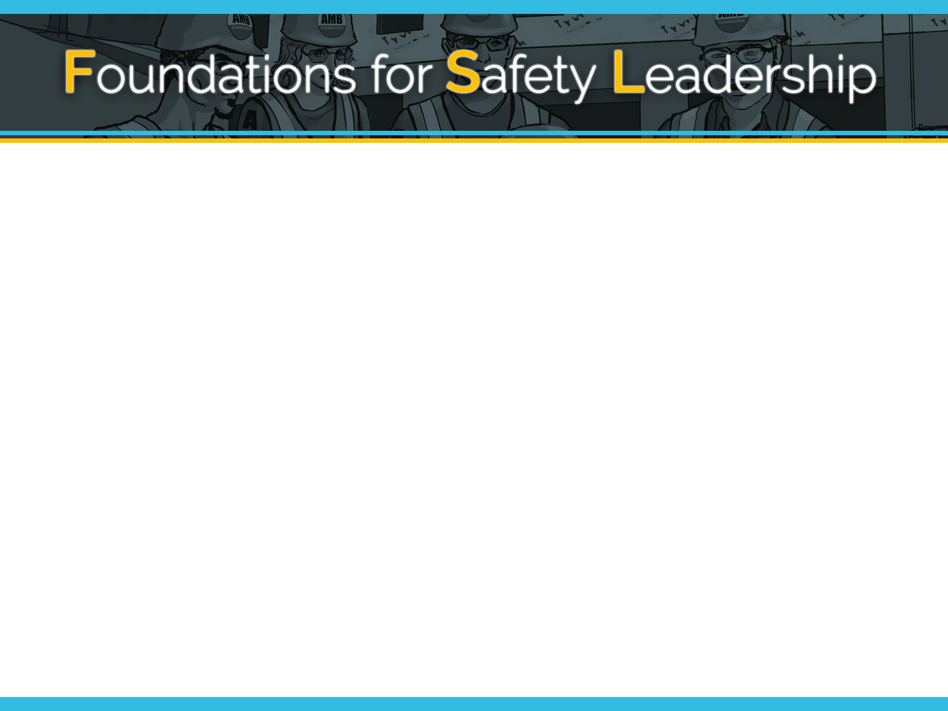

This certificate hereby acknowledges that

participated in and completed the
Foundations for Safety Leadership
4 Residential Construction training course

Provided by On

