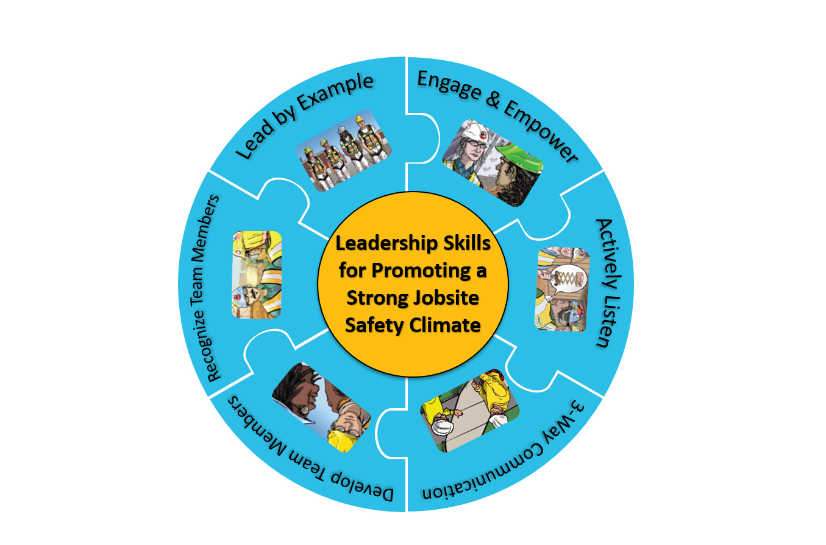

An Introductory Handbook to the Foundations for Safety Leadership 4 Residential Construction Course

About the handbook:
This handbook provides a brief introduction to the leadership skills covered in the Foundations for Safety Leadership 4 Residential Construction (FSL4Res) course that construction foremen, frontline supervisors, and others with supervisory responsibilities can take to learn how to become more effective safety leaders. The handbook can be distributed to students at the end of the FSL4Res course, used in conjunction with the FSL4Res toolbox talks, or used to introduce construction industry stakeholders to the leadership skills covered in the FSL4Res which are:
Lead by example
Engage and empower team members
Actively listen
Practice 3-way communication
Develop team members through teaching, coaching, & feedback
Recognize team members for going above and beyond for safety
There’s a brief self-assessment and action plan worksheet at the end of the handbook that gives readers the opportunity to think about how well they are currently practicing the leadership skills and steps they could take to become a more effective safety leader.

About the Foundations for Safety Leadership 4 Residential Construction (FSL4Res) course:
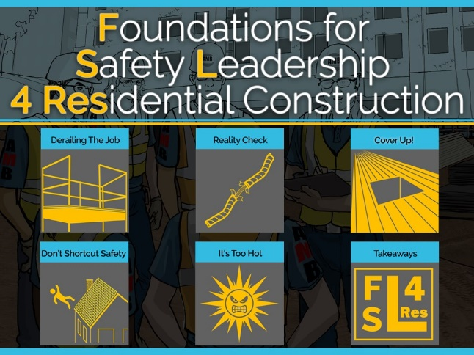
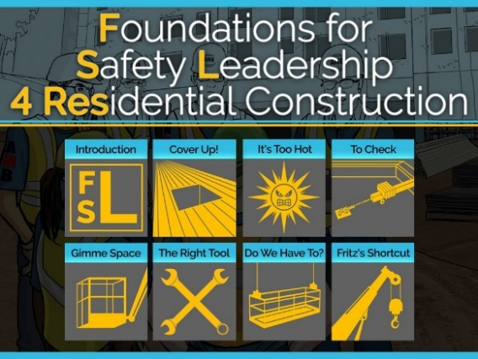
The FSL4Res was developed by the Healthy Work Center at Washington University School of Medicine in St. Louis and CPWR-The Center for Construction Research and Training in partnership with many construction stakeholders and subject matter experts and includes teaching materials such as a PowerPoint presentation, instructor and student guides, hard hat stickers, toolbox talks, posters/ infographics, assessment sheets, create your own scenario sheets, and wallet cards. All FSL4Res teaching materials can be downloaded free of charge at http://www.cpwr.com/foundations- safety-leadership-fsl.
SAFETY LEADERSHIP IN CONSTRUCTION

Health and safety injuries in construction are costly. In 2015, one in five worker deaths occurred in the construction industry; a construction worker has a 78% chance of getting injured at work. The cost of these injuries to workers, contractors, and the industry as a whole is over $11 billion per year or about $27,000 per injured worker.1,2 Those are only the direct costs that include things like medical treatment, lost wages, sick pay, damage to work product or equipment, and increased insurance premiums.

The costs are actually much greater when you include indirect costs such as family and co-worker suffering, lost productivity due to investigations and work stoppage, hiring costs to replace an injured worker, and the company’s reduced ability to win bids due to their diminished public reputation.
Leaders play a part in whether or not companies experience injury-related costs.

Leaders can improve if, and how well, a company’s safety policies, procedures, and practices are implemented on the jobsite – also called jobsite safety climate. By practicing safety leadership skills, you, as a safety leader, can help create a strong jobsite safety climate where everyone works safely, efficiently, and productively.
- CPWR: The Center for Construction Research and Training. 2013. The construction chart book: The U.S. construction industry and its workers. Silver Springs, MD. 5th Edition
- Waehrer GM1, Dong XS, Miller T, Haile E, Men Y Costs of occupational injuries in construction in the United States. Accid Anal Prev. 2007 Nov; 39(6): 1258-66.

WHO IS A SAFETY LEADER?

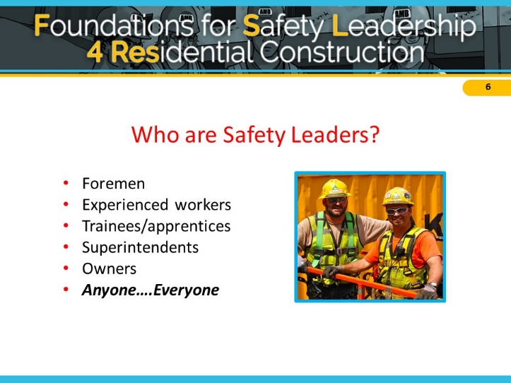

A safety leader is a person who has the courage to demonstrate that s/he values safety, by working and communicating with team members to identify and limit hazardous situations, even in the presence of other job pressures such as scheduling and costs.
Safety leaders work at all levels of a company.
Anyone, regardless of title or role, who values his
or her own well-being and that of fellow workers,
is responsible for being an effective safety leader.

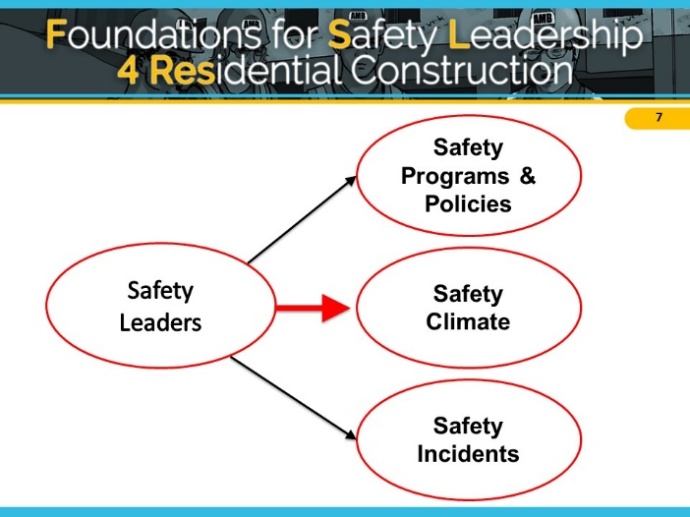

At the highest levels, leaders develop safety programs and policies to protect their workers and their company. When it comes to reducing safety incidents on the jobsite, everyone is a leader. However, it is the frontline supervisors and foremen who create a strong jobsite safety climate by making sure safety programs and policies are implemented and enforced on the jobsite.

Leaders interact with their crew/team members in ways that can either negatively or positively affect safety climate. As you look over the table below, think about “leaders” you have worked with. What behaviors did they display? How did they communicate? Were they good or bad role models? Consider how their actions might have affected safety climate and safety outcomes.

Ineffective Actions | Effective Actions
Harmful Behaviors ….  - Lies to protect him/herself  - Withholds information  - Blames worker or others for problems  - Reacts angrily to a problem without addressing it or seeking solutions  - Becomes defensive when an issue is brought up | Helpful Behaviors….  - Doesn’t go back on his/her word  - Tells the truth  - Works hard  - Is fair
Poor Communication….  - Yells  - Doesn’t listen to or ignores worker ideas  - Threatens retaliation | Good Communication….  - Listens to hear what others are saying vs. listens to speak
Lack of teamwork….  - Says things like, “I’m in charge here and you’ll do as I say.” “You don’t need to ask someone else for their opinion.” “I’ll tell you when something is risky.”  - Doesn’t engage or empower workers to be part of the safety solution | Sense of teamwork…  - Makes sure team members know each other  - Highlights the importance of working together as a team to improve safety  - Asks team members for input on how to best carry out their tasks safely
Poor role model….  - Has team members wear personal protective equipment (PPE) and demands safety from them, but doesn’t ‘walk the talk’  - Thinks having weekly toolbox talks is all that’s needed for safety | Leads by example….  - Provides needed safety resources  - Always wears PPE  - Never takes or encourages others to take shortcuts  - Conducts daily safety huddles  - Holds everyone accountable for being safe

There are many benefits of putting the leadership skills covered in the FSL4Res into practice on the jobsite including:

  - Creating a strong safety climate
- Fewer injuries and fatalities
- Reduced hazards
- Safer work practices
  - Increased team morale
- Increased teamwork
  - More productive, better quality
- Better company reputation

As you will see in the following sections, using these skills is not time-consuming and can be easily inserted into daily workflow, and is likely to improve productivity.

SAFETY LEADERSHIP SKILLS
Lead by Example
At our morning huddle, we discuss what we are going to be doing that day and what safety issues may come up. For example, the other day we were going to frame a roof and the safety rep. talked about how to lift and carry the rafters in order to avoid hurting our backs or shoulders. When we got to the jobsite, our foreman said that he wanted us to use the lifting equipment as much as possible because the last thing he wants is any more back strains.

Leading by example is the most important safety leadership skill. Team members learn from their leaders. They notice when leaders cut corners, don’t follow safety policies or procedures, or give inconsistent safety messages. Leaders who practice the following actions send the message that safety is an integral part of work, and not just a way to avoid safety violations.

Tips for how to lead by example
- Have a positive attitude about safety and establish it as a core value by considering the safety implications of all your decisions. Share these with your team members.
- Set high expectations for every team member by letting them know on a regular basis that you expect them to always use safe work practices and ensure that other team members do too. Provide constructive feedback in a timely manner. Ask that team members immediately report hazardous conditions and all injuries or near misses.
- Share your safety vision with your team members by talking about the importance of safety for you and for them. You can talk about the direct and indirect costs of injuries and emphasize that safe work goes hand-in- hand with productive and quality work.
“Walk the talk.” Always follow safe work procedures and implement safe practices. This shows your commitment and belief in the importance of the safety policies.
- Reinforce the idea that everyone owns safety and that it’s not just the foreman’s or safety person’s responsibility. It’s up to everyone to keep the jobsite safe for themselves and others.
- Lead up by working to persuade individuals like company owners and others in supervisory positions to improve jobsite safety and health. Present your suggestions for solutions and get support from others, including workers and foremen, to help you convey your message.

Engage and Empower Team Members

Our crew was supposed to insulate copper wires in a ceiling. Simon the superintendent came by to see how we were doing and asked us to walk him through our plans. At first, we did not say anything about our concern with using ladders to access the wires. But then Fred, our foreman, spoke up and said the pipes were in a tight space close to electrical wires, so we couldn’t set up the ladders correctly and we’d have to work in awkward postures. Simon thanked him for identifying the problems ahead of time rather than starting work and getting in a bind. He asked us to think about equipment other than ladders that might work better. After some discussion, we all decided a one-man lift would be best for the job. Luckily, there was one on the jobsite that we could use.

If you really want to create a strong jobsite safety climate, it’s critical that you learn how to engage and empower their team members to participate in the safety process.

Tips for how to engage and empower team members
- Explain why safety is critical to getting the job done instead of just saying “be safe.”
- Involve team members in safety decision-making so they can see how they, too, own safety.
- Conduct daily morning safety huddles and joint worker-management walk-arounds throughout the workday. This lets the team know that safety is valued, that it is an essential aspect of how work gets done, and that they are a critical part of the overall safety effort.
Develop an “action list” to show how issues that are raised are addressed. Place this in a prominent place to ensure accountability and build trust.
- Encourage team members to:
  - report safety concerns, injuries and near misses, and
  - report or fix hazards or unsafe situations.
Make it clear they can do these things without negative consequences or retaliation.

Actively Listen

Simon, our superintendent, came to check in on us and ask how the project was going. We were all kind of avoiding eye contact and looking down at the floor, and eventually Ted said we were fine. Simon must’ve caught on to this body language and asked us to walk him through our plans – that’s when Fred explained that we couldn’t figure out how to set up the ladder to insulate the copper pipes in the ceiling.
Being able to communicate effectively is at the core of all the other safety leadership skills, and is critical to becoming an effective safety leader. Learning to be an active listener rather than a passive listener is a critical aspect to this skill.

Tips for how to actively listen
- Treat the team member with respect by giving him/her your full attention. Don’t check phones, emails, or read other materials when s/he is speaking.
- Pay attention to non-verbal cues such as body language and eye contact – both yours and those of the person you are speaking with. Maintain eye contact and avoid making negative facial expressions or raising your voice. If you’re feeling resentful or insulted, make an extra effort to maintain professional conduct.
- Listen to hear what is being said rather than listening just to come up with a response.
- Ask clarifying questions to ensure you understand what the person is saying.

Practice 3-Way Communication

We were working out in the sun and Emilio, a carpenter, was feeling really hot and had a slight headache and stomachache. Our foreman thought it might be heat exhaustion and told him to go rest in the trailer, get something to eat and drink, and stop work for the day. Our foreman then asked Emilio to tell him exactly what he was going to do once he got to the trailer. Emilio repeated his instructions, but left out the part about stopping for the day. Our foreman corrected him and emphasized why it was important for him to stay and rest in the trailer. He told Emilio his only job was to get better for tomorrow and not to worry about the task he hadn’t yet completed.

Practicing 3-way communication is vital to effective communication, and will reduce misunderstanding between you and the other person.

Tips for practicing 3-way communication
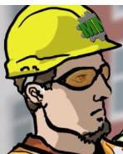
To ensure everyone understands the message or instructions you are giving:
- way communication:
  - Present instructions

  - Ask team member to repeat

  - Clarify if necessary
- Make sure you have the listener’s attention and be direct and concise.
- Have the listener repeat what you said to be sure the message was understood.
- Confirm to the listener that his/her interpretation is correct.

Develop Team Members through Teaching, Coaching, & Feedback

Our foreman Floyd asked two of our painters, Ed and Tom, if they had checked the rigging on the roof to make sure the scaffold was secure. They said that they were sure it was fine and it was too hot to get on the roof! Floyd thought that their overreaction to his question was odd. So he said that we all had to go to the roof and check the rigging since that is what keeps the scaffold and us from falling. Once on the roof, Ed admitted that he wasn’t sure what to look for. Floyd thanked him for being honest and carefully explained the rules and recommendations for securing the scaffold. Then he asked all of us to repeat his instructions and to demonstrate how to check the rigging. When we were done Floyd told us how much he appreciates our good work.
Effective safety leaders develop their team members by teaching and coaching them on how to do things correctly and safely on the jobsite. They also provide feedback to let them know how they are doing and if any changes are needed.

Tips for how to develop team members through teaching, coaching, and feedback
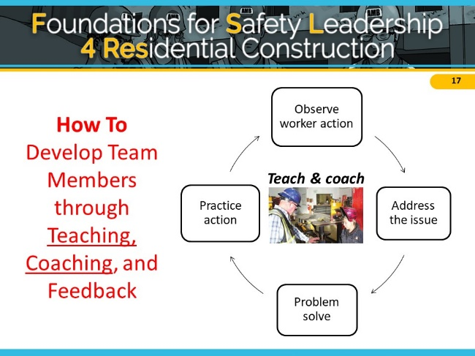
- Observe team member actions.
- Teach – Address the issue and problem solve. Respectfully ask questions to understand why s/he is doing it that way and then problem-solve together to find a better or safer approach to completing the task.
- Coach – Practice action. Show your team member how to perform the activity correctly then watch to be sure they’ve learned how to do it. If they need to be corrected, treat the person with respect.
- Provide constructive feedback using the FIST principle:
  - Describe the Facts: What is the situation or activity/behavior for which you are providing feedback? When and where did it occur? What were the circumstances?
  - Explain the Impact: What are the potential consequences that may result (good or bad)?
  - Offer Suggestions: Work together to problem-solve and come up with solutions. Think of ways team members might use the same approach in the future.
  - Be Timely: Don’t wait to provide feedback. It is more effective when you give it close to when the situation/behavior occurred.

Recognize Team Members for Going Above and Beyond for Safety
We have team members submit pictures to us when they see hazards on our job sites. We acknowledge these employees in front of everybody, or privately if they aren’t comfortable with that, and we give them a $20 gift card to Home Depot. We then give that information back to our general contractor to notify them that they have an issue on a job.

The final skill effective safety leaders display is recognizing their team members when they go above and beyond to maintain a strong positive jobsite safety climate. Showing your appreciation motivates and encourages team members to continue their efforts to maintain and improve the jobsite safety climate.

Tips for how to recognize team members for a job well done
- Give recognition separately from other types of feedback – do so in a timely manner and make sure it is sincere. It’s also important to separate this type of “way to go” or praise feedback from other types of feedback that involves evaluating performance.
- Regularly thank them in private.
- Be specific about why you are praising the person – know your team members as individuals so you can use praise and acknowledgement effectively.
It may be as simple as saying “good job,” giving a
handshake, or saying “thank you” for going the extra mile for safety or for something really well done.
- Thank them publically only if the person is comfortable with it – this can be a great way to show others that safety is valued. However, a person uncomfortable with public praise may be more embarrassed than pleased.

TO SUM UP…

Skills and Actions of an Effective Safety Leader
Leadership Skills | Good Leadership Actions
Leads by Example | - Establishes safety expectations as a core value  - Shares safety vision with team members  - Demonstrates a positive attitude about safety  - ‘Walks the Talk’  - Leads up by taking concerns to people at higher levels
Engages and Empowers Team Members | - Engages, encourages, and empowers team members to identify and act upon unsafe situations by…  - Reporting hazards and safety concerns  - Providing solutions  - Reporting near misses  - Stopping work if necessary
Actively Listens | - Actively listens to hear what team members are saying  - Treat team members with respect when they are speaking and listen to hear what is said vs coming up with a response  - Pay attention to non-verbal cues and ask clarifying questions
Practices 3-way communication | - Is direct and concise, and makes sure s/he has the listener’s attention  - Asks team member to repeat the message/ instructions and clarify misunderstandings
Develops Team Members Through Teaching, Coaching, and Feedback | - Respectfully teaches and coaches workers  - Watches the learner fix the hazardous situation or perform the task to make sure it's done correctly  - Focuses on potential consequences rather than on the team member’s behavior  - Uses the FIST principle for giving feedback: Facts, Impact, Suggestions, Timely
Recognizes Team Members for Going Above and Beyond for Safety | - Privately and/or publicly acknowledges team members for going above and beyond when it comes to safety

Next steps:

Now that you are familiar with the critical skills that you can use to become a more effective safety leader, it’s time to see how you’re doing and what you’d like to work on.

  - Use the self-assessment on the next page to identify which skills and practices you will work on.

  - Then, use the action plan to identify some specific steps you will take to improve those skills and practices. Set goals for the next 3 months and for 3 – 6 months.

  - Follow up and check on your progress.

PERSONAL ACTION PLAN
Self-assessment: How often do you….
 | Always | Sometimes | Never
Lead by example
Maintain a positive attitude about safety | ❒ | ❒ | ❒
Consider the safety implications of all your decisions | ❒ | ❒ | ❒
Set high expectations for team members | ❒ | ❒ | ❒
Walk the talk – always follow safe work practices | ❒ | ❒ | ❒
Communicate with your team that everyone owns safety | ❒ | ❒ | ❒
Engage and empower team members
Engage team members in daily safety meetings or morning safety huddles | ❒ | ❒ | ❒
Request input from team members about safety | ❒ | ❒ | ❒
Encourage team members to identify and report safety issues such as hazards, concerns, injuries, and near misses | ❒ | ❒ | ❒
Actively listen
Treat team members with respect when communicating with them | ❒ | ❒ | ❒
Actively listen to hear what is said vs. coming up with a response | ❒ | ❒ | ❒
Pay attention to non-verbal cues and ask clarifying questions | ❒ | ❒ | ❒
Practice 3-way communication
Be direct and concise, and make sure you have your listener’s attention | ❒ | ❒ | ❒
Ask team member to repeat message/ instructions, and clarify misunderstandings | ❒ | ❒ | ❒
Develop Team Members Through Teaching, Coaching, and Feedback
Teach and coach members in a respectful manner | ❒ | ❒ | ❒
Focus on the problem rather than judging the person when you give feedback | ❒ | ❒ | ❒
Make sure team members know how to do a new task before actually doing it | ❒ | ❒ | ❒
Recognize Team Members for a Job Well Done
Say “good job” or “thank you” to team members who go above and beyond to create a safe jobsite | ❒ | ❒ | ❒
Use positive recognition of team members to encourage jobsite safety | ❒ | ❒ | ❒
Total number of checks for each column

Action Plan:
Based on your self-assessment and your knowledge of the safety leadership skills, answer the questions below to create your action plan – what steps will you take in the next few months to further develop your skills as a safety leader? Be specific.

- In which of the skill areas are you doing very well? (Checked “Always” for the majority of the questions)

- Which skill areas do you need to work on or improve? (Checked “Sometimes” or “Never” for the majority of the questions)

- Which skill area(s) will you work on first, in the next 3 months, and what steps will you take?

- Which skill area(s) will you work on next, in 3 – 6 months, and what steps will you take?

Follow up and track your progress:
At the 3-month and 6-month point, check to see if you have taken the steps to becoming a more effective safety leader. Ask yourself:

- What is working well?
- If you haven’t taken the steps, what is preventing you from doing so?
- Who can help you or give you the support you need?

Check your success
You can check to see how well you are doing at putting the skills into action by paying attention to how often your team members are:

- Following safety procedures
- Helping each other be safe
- Reporting any hazards they see and making suggestions for solutions
- Reporting near misses when they occur
- Reporting injuries when they occur

The more they are doing these things and others like them, the more likely it is that you are being an effective safety leader and are creating a strong jobsite safety climate!

Good luck on your leadership journey!
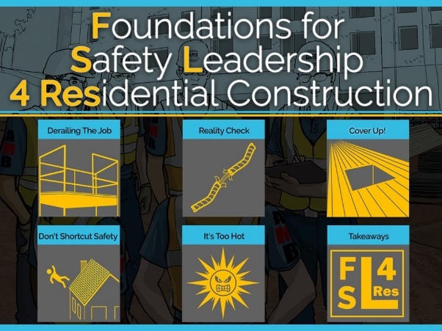
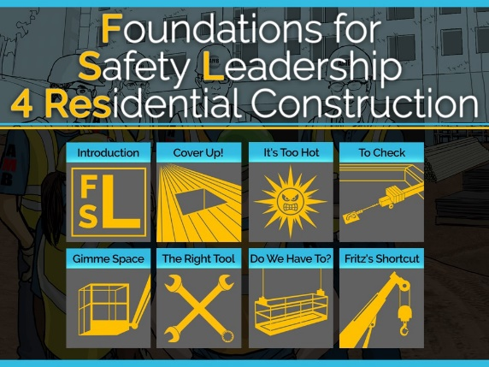

Development of the FSL4Res training was supported with funding from a cooperative agreement to CPWR - The Center for Construction Research and Training (#U60OH009762) from the National Institute for Occupational Safety and Health (NIOSH) The FSL4Res is based on the original FSL training created by CPWR under an earlier NIOSH cooperative agreement (#OH009762) The contents are solely the responsibility of the authors and do not necessarily represent the official views of NIOSH. All Rights Reserved.
15

