

**Single-Session Instructor Teaching Guide**



**The Foundations for Safety Leadership 4 Residential Construction (FSL4Res) course was developed collaboratively by**







Development of the FSL4Res training was supported with funding from a cooperative agreement to CPWR - The Center for Construction Research and Training (#U60OH009762) from the National Institute for Occupational Safety and Health (NIOSH) The FSL4Res is based on the original [FSL training](http://www.cpwr.com/research/training-and-awareness-programs-from-research-foundations-for-safety-leadership/) created by CPWR under an earlier NIOSH cooperative agreement (#OH009762) The contents are solely the responsibility of the authors and do not necessarily represent the official views of NIOSH. All Rights Reserved.

**Table of Contents**

**Introduction** **4**

**Information for Teaching the FSL4Res** **5**

Purpose of the Instructor Guide 6

Teaching Materials and Tips 6

Key Terms and Concepts 8

**Foundational Material** **9**

Welcome! 9

Goal of the FSL4Res Module 9

Learning Objectives 10

Characteristics of Effective and Ineffective Leaders 10

Importance of Safety Leadership – Safety Climate 12

Costs of Poor Safety Leadership 13

Benefits of Effective Leadership 14

**Safety Leadership Skills** **15**

Leads by Example 16

Engages and Empowers Team Members 17

Actively Listens 18 Practices 3-Way Communication 19

Develops Team Members through Teaching, Coaching, and Feedback 20

Recognizes Team Members for a Job Well Done 22

**Applying Leadership Skills in Real World Scenarios** **23**

Scenario Structure and Checklist 23

Overall Description of Jobsite 24

Scenario Main Menu 25

1. Derailing the Job 26

Watch 27

Read 30

1. Reality Check 33

Watch 34

Read 37

1. Cover Up! 40

Watch 41

Read 44

1. Don’t Shortcut Safety 46

Watch 47

Read 49

**Takeaways** **51**

**Short Quiz** **53**

**Reference List and Suggested Readings for More Information** **54**

# Introduction

Everyone, from the company owner to the experienced foreman and new trainee/apprentice, needs to own safety and be a safety leader. The Foundations for Safety Leadership 4 Residential Construction (FSL4Res) training module is designed to introduce construction workers, particularly those with supervisory responsibilities, to safety leadership principles and give them the skills to be a safety leader who can help create and sustain a safe and productive jobsite. The FSL4Res module was developed by a curriculum development team that included experienced OSHA 10 and 30-hour outreach trainers, construction workers, safety and health professionals from the construction industry, and safety, health, and leadership experts.

The first part of the FSL4Res module introduces foremen/workers to reasons why safety leadership is important and describes the safety leadership skills emphasized in the training. The remainder provides opportunities to work through real-world construction-based scenarios allowing students to think more about how to apply the safety leadership skills on the jobsite.

Goal of FSL4Res

Introduce you to critical safety leadership skills you can use to improve safety climate and safety outcomes on the job site.

Learning Objectives

*By the end of this training students will be able to:*

1. Explain why safety leadership is important
2. Describe critical safety leadership skills
3. Discuss how to apply safety leadership skills on the job site

# Information for Teaching the FSL4Res

**Purpose of the Instructor Guide**

This guide is designed to provide instructors/trainers with all the information and materials needed to successfully conduct the Foundations for Safety Leadership 4 Residential Construction (FSL4Res) training.

**Teaching Materials and Tips**

#### Instructor Guide - Includes:

* + Numbered thumbnails of PowerPoint slides
  + Instructor notes for each slide (also in the PowerPoint slides)
  + Questions to engage students in discussion
  + Written scenarios
  + Short quiz to use at the conclusion of training

#### Student Handout – Includes:

* + Foundational information on importance of safety leadership
  + Written scenarios
  + Leadership skills and action checklist

#### PowerPoint slides - Include:

* + Slides plus notes for all foundational material
  + Slides for each teaching mode for all four scenarios:
    - Watch - Animated videos and discussion questions
    - Read – Bullet points from script and discussion questions

It’s likely that you won’t have time to cover the foundational material AND work through all four scenarios. We suggest you review all the scenarios ahead of time and pick out the ones that you find most interesting and feel most comfortable teaching.

Next, you need to decide which teaching mode (Watch or Read) you would like to use or the ones you’ve picked. You might want to use different modes for each scenarios you will use during the training session.

Finally, rather than deleting the scenario slides you won’t be using, **HIDE** them so you have the flexibility to use them in the future. To **HIDE** slides, simply go to the Slide Show tab and click on HIDE SLIDE button. If you want to use the slide in the future, simply unclick the HIDE SLIDE button.

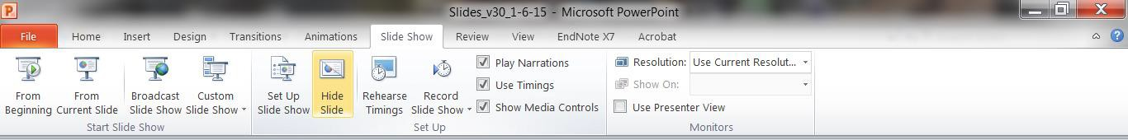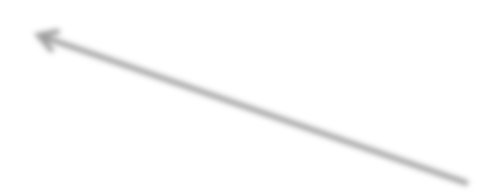

**Time Management -** It takes approximately 2.5-3 hours to complete the full FSL4Res training. Consider using the following as a general guide.

|  |  |  |  |  |
| --- | --- | --- | --- | --- |
| **Foundational Material (50-55 minutes)** | | | | |
| **Activity** | **Time** | **Page#/Slide#** | **Description** |
| Welcome, introductions, goals & learning objectives | 5 mins | Pages 9-10 / Slides 1-3 | Introductions and describe goals and learning objectives. |
| Characteristics of ineffective and effective leaders | 10 mins | Pages 10-11 / Slides 4-5 | Engage students in discussion of their experiences with ineffective and effective leaders. |
| Importance and benefits of effective safety leadership | 10 mins | Pages 12-14 / Slides 6-11 | Discuss the following points:   * Everyone is a safety leader * Safety leaders strengthen jobsite safety climate * Costs of poor safety leadership * Benefits of effective safety leadership |
| Safety leadership skills | 30 mins | Pages 15-22 / Slides 12-20 | Present and discuss:   * Definition of a safety leader * Safety leadership skills & how to use them on the job |
| **Break (5-10 mins)** | | | | |
| **Four Real-world scenarios (60-80 mins)** | | | | |
| 1. Derailing the job | 15 – 20  mins per scenario | Pages 23-51 / Slides 21-78 | For each scenario you’ve chosen, use notes to discuss the characters’ not using (outcome A) and then using (outcome B) the safety leadership skills. |
| 2. Reality Check |
| 3. Cover Up |
| 4. Don’t shortcut safety |
| Wrap up, pass out Hard Hat Stickers, Conduct quiz | 5 mins | Pages 51-53 / Slides 79-81 | Review final take away points. End with collaboration slide. Pass out quiz to finish. |

## The Scenarios

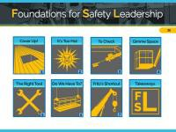

**MAIN MENU -** This is the menu slide that precedes the scenario slides. The icons are all hyperlinked and clicking on one will take you directly to the introductory slide for that particular scenario.

Also, at the bottom right corner of each scenario slide, there is a main menu icon. Clicking on it will take you back to the main menu slide so you can click on the next scenario you want to work through.

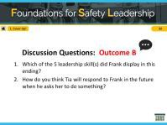

When you are ready to discuss the training’s takeaway messages, click the “Takeaways” icon.



**ACTIVE BUTTONS -** On each scenario’s introductory slide, there are hyperlinked icons for the two teaching modes. Clicking on one will take you to that activity.

* **Watch** activity slides contain three animated video sections and discussion questions
* **Read** activity slides contain key points from the full scenario, plus discussion questions. The expectation is that the students will read the scenario or instructor will read it aloud to the class.

**KEEPING TRACK OF WHERE YOU ARE -** In the upper left-hand corner of each slide there is an icon and text to give you a quick indication of which scenario and activity you are on.



**1. Cover Up!**

**SCENARIO CHARACTER NAMING SCHEME -** The first letter of each character’s name is based on their job position: **S**uperintendent, **F**oreman, **E**xperienced worker, or **T**rainee/apprentice.

## Facilitating the discussion for any/all of the teaching modes

Consider drawing a table like this one. After each of the outcomes (A and B), you can ask the class to discuss if and how well the characters demonstrated the leadership skills. Keep in mind that most of the scenarios don’t cover all six skills.

|  |  |  |
| --- | --- | --- |
| **Leadership Skills** | **Outcome A** | **Outcome B** |
| **Lead by Example** | **___YES ___NO** | **___YES ___NO** |
| **Engage and Empower** | **___YES ___NO** | **___YES ___NO** |
| **Actively Listen** | **___YES ___NO** | **___YES ___NO** |
| **Practice 3-way Communication** | **___YES ___NO** | **___YES ___NO** |
| **Develop – teach, coach, feedback** | **___YES ___NO** | **___YES ___NO** |
| **Recognize** | **___YES ___NO** | **___YES ___NO** |

**Key Terms and Concepts**

* **Safety Climate Definition** – How well a company’s policies, procedures, and practices are actually implemented on the jobsite.
* **Safety Leader Definition** - Safety leaders have the **courage** to demonstrate that s/he values safety by working and communicating with team members to identify and limit hazardous situations even in the presence of other job pressures such as scheduling and costs. There are many skills that safety leaders can use to demonstrate leadership.
* Critical safety leadership skills and actions are covered in the FSL4Res training:

|  |  |
| --- | --- |
| **Skills and Actions of an Effective Safety Leader** | |
| **Leadership Skills** | **Good Leadership Actions** |
| **Leads by Example** | * Establishes safety expectations as a core value * Shares safety vision with team members * Demonstrates a positive attitude about safety * ‘Walks the Talk’ * Leads up! |
| **Engages and Empowers Team Members** | * Engages, encourages, and empowers team members to identify and act upon unsafe situations by…   + Reporting hazards and safety concerns   + Providing solutions   + Reporting near misses   + Stopping work if necessary |
| **Actively Listens** | * Actively listens to **hear** what team members are saying * Treats team members with respect when they are speaking and listens to hear what is said vs. coming up with a response * Pays attention to non-verbal cues and asks clarifying questions |
| **Practices 3-way Communication** | * Is direct and concise, and makes sure s/he has the listener’s attention * Asks team member to repeat message, and clarify misunderstandings |
| **Develops Team Members Through Teaching, Coaching, and Feedback** | * Respectfully teaches and coaches workers * Watches the learner fix the hazardous situation or perform the task to make sure it's done correctly * Focuses on potential consequences rather than on the team member * Uses the FIST principle: Facts, Impact, Suggestions, Timely |
| **Recognizes Team Members for a Job**  **Well Done** | * Privately and/or publicly acknowledges team members for going above and beyond when it   comes to safety |

Each scenario illustrates the foreman’s response to a fall safety hazard. Because the goal of the FSL4Res is to teach leadership skills, please focus the discussion on the leadership skills rather than the safety hazard.

# Foundational Material

**(TIME 50-55 minutes)**

***Welcome****!*

# NOTES FOR SLIDE 1 SLIDE 1

Introductions:

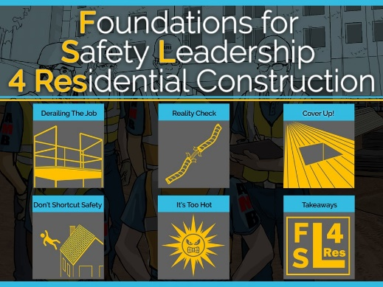

* Name
* Trade
* Position
* Years in construction

Most of the slides we’ll be going over are in the student handout starting on page 4. You can follow along and take notes.

***Goal of the FSL4Res Training***

# NOTES FOR SLIDE 2 SLIDE 2

The overall goal of this training is to give you the opportunity to learn or enhance some critical safety leadership skills that you can use to improve the safety climate and safety outcomes on jobsites.

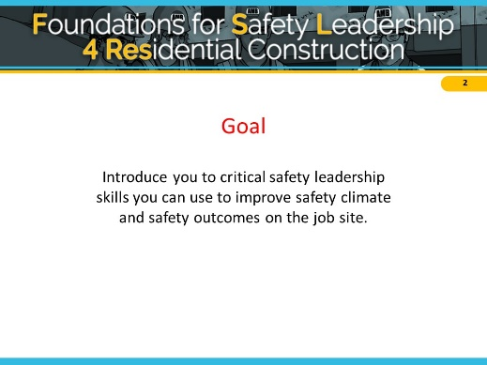

**ASK CLASS:**

**HOW MANY OF YOU HAVE HEARD THE TERM SAFETY CLIMATE? DO YOU HAVE SOME THOUGHTS ABOUT WHAT IT MEANS?**

**(AFTER SOME DISCUSSION, LET THEM KNOW YOU’LL BE PRESENTING THE DEFINITION IN A FEW MINUTES)**

# NOTES FOR SLIDE 3 SLIDE 3

***Learning Objectives***

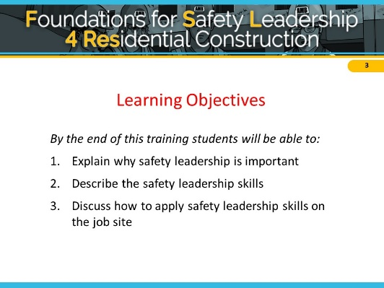We expect that by the end of today’s training each of you will be able to:

1. Explain why safety leadership is important
2. Describe the critical safety leadership skills and
3. Discuss how an effective leader can apply them on the jobsite.

***Characteristics of Ineffective and Effective Leaders***

# NOTES FOR SLIDE 4 SLIDE 4

To get us started let’s brainstorm about the types of actions that effective and ineffective leaders display. It can be someone you work or have worked with, or maybe a coach, a teacher, or a parent, or even a friend. Ok, now tell me some behaviors that make or made them ineffective leaders.

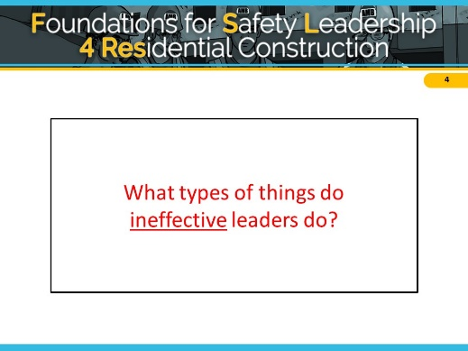

**< ON A WHITE BOARD OR FLIPCHART MAKE 2 COLUMNS, ONE WITH HEADING ‘INEFFECTIVE’ AND THE OTHER HEADING ‘EFFECTIVE’ >**

**ADDITIONAL INSTRUCTOR NOTES FOR INEFFECTIVE LEADERS**

**If students provide only a few (or no) ideas, you can ask a few of these questions.**

* **What are some of the basic behaviors ineffective leaders display**? (e.g. lies to protect themselves, withholds information, blames worker, blames superiors, reacts angrily to a problem without addressing the problem and seeking solutions)
* **In what ways might ineffective leaders communicate with their team members?**

(e.g., yell, say “just do it and don’t ask questions”, threaten them with retaliation)

* **How might an ineffective leader fail to create a sense of teamwork?** (e.g. say things like, “I’m in charge here and you’ll do as I say.” “You don’t need to ask X for their opinion.” “I’ll tell you when something is risky.”)
* **How might an ineffective leader fail to lead by example?** (e.g. is a poor role model by having team members wear PPE and demands safety from them, but doesn’t ‘walk the talk,’ ignores worker safety concerns, thinks that conducting a weekly toolbox talk that may or may not be relevant to the work being done is enough to comply with OSHA regulations and doesn’t need to do anything else, etc.)

# NOTES FOR SLIDE 5 SLIDE 5

Now, think of someone who you believe is or was a very effective leader, or may have even been a really great leader, and tell me some behaviors that type of person displayed.

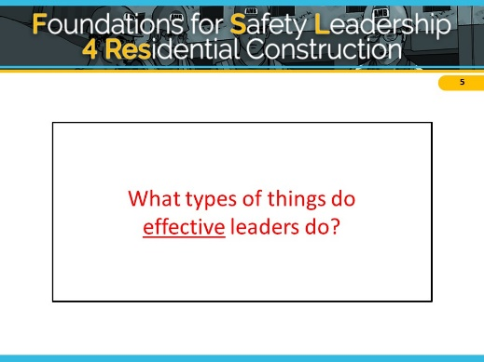

**< WRITE EFFECTIVE LIST ON THE BOARD OR FLIPCHART >**

**ADDITIONAL INSTRUCTOR NOTES FOR EFFECTIVE LEADERS**

**If students provide only a few (or no) ideas, you can ask a few of these questions.**

* **What are some behaviors effective leaders demonstrate?** (e.g. never goes back on their word, tells the truth, works hard)
* **How do effective leaders communicate with other people?** (e.g. listens to hear vs. listens to speak)
* **How might an effective leader create a sense of teamwork**? (e.g. s/he might ask about a team member’s family or the weekend, make sure team members know each other, highlight the importance of working together as a team to improve safety and ensure no one is working on their own, etc.)
* **How might an effective leader lead by example?** (e.g. always wears PPE, never takes or encourages workers to take shortcuts, gets the resources necessary to work safely, conducts productive daily safety huddles and pre-task planning meetings during which s/he asks workers for input on how to best carry out their tasks safely, makes sure team members are working safely, is fair, holds everyone accountable for being safe and reporting hazards, etc.)

# NOTES FOR SLIDE 6 SLIDE 6

***Importance of Safety Leadership – Safety Climate***

**ASK CLASS:**

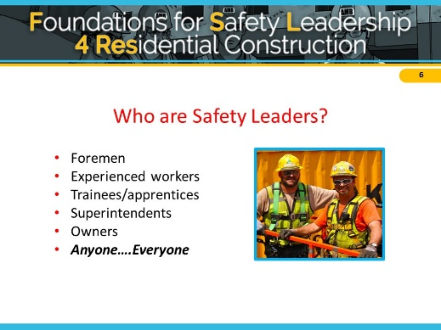

**WHO ARE THE SAFETY LEADERS ON A JOBSITE?**

Anyone, regardless of their title or role, who values their safety and well-being and that of their fellow workers, is responsible for being an effective safety leader. This means that everyone needs to develop and use safety leadership skills.

# NOTES FOR SLIDE 7 SLIDE 7

Safety leaders work at all levels of a company:

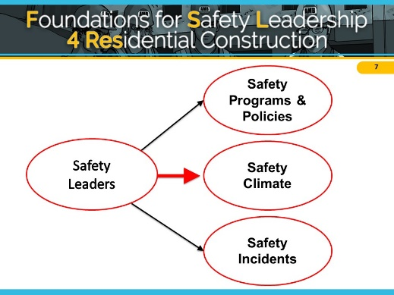

* Leaders at the highest level develop the safety programs and policies
* Everyone on the jobsite is a leader when it comes to reducing safety incidents

But it is the

* Frontline supervisors and foremen who make sure programs and policies are implemented and enforced which creates a strong jobsite safety climate

# NOTES FOR SLIDE 8 SLIDE 8

When we use the term safety climate, we are talking about how well a company’s safety policies, procedures, and practices are actually implemented on the jobsite.

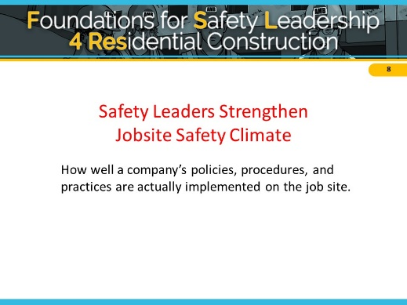

When team members practice safety leadership skills they are helping to create a strong safety climate to ensure that everyone works productively, efficiently, and safely.

**ASK CLASS:**

**CAN WORKERS TELL WHEN THERE’S A MISMATCH BETWEEN WHAT MANAGEMENT OR SUPERVISORS SAY ABOUT SAFETY AND WHAT IS ACTUALLY DONE ON THE JOBSITE? HOW MIGHT THAT AFFECT THEIR THOUGHTS ABOUT SAFETY AND THE JOBSITE SAFETY CLIMATE?**

**IS THERE A DIFFERENCE BETWEEN A PRIORITY AND A VALUE?**

**HOW MIGHT SAFETY CLIMATE BE AFFECTE****D IF SAFETY IS JUST A PRIORITY AND NOT A VALUE?**

***Costs of Poor Safety Leadership***

# NOTES FOR SLIDE 9 SLIDE 9

It’s been shown that over the course of their career, a construction worker has a 78% chance of getting injured at work. (Dong et al, 2014)

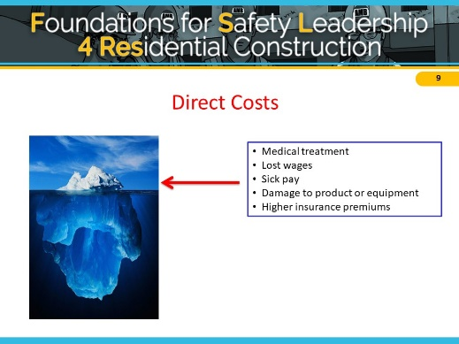

The total cost of these injuries to workers, contractors, and the construction industry as a whole is over $11 billion per year or about $27,000 per injured construction worker.

There are costs which are easier to see called Direct

Costs, and others which may not be so obvious, called Indirect Costs. Leaders can play a big part in whether or not a company experiences these costs.

**ASK CLASS:**

**WHAT DO YOU THINK ARE EXAMPLES OF DIRECT COSTS OF JOBSITE INJURIES?**

Direct costs include medical treatment, lost wages, sick pay, damage to work product or equipment, and increased insurance premiums.

# NOTES FOR SLIDE 10 SLIDE 10

**ASK CLASS:**

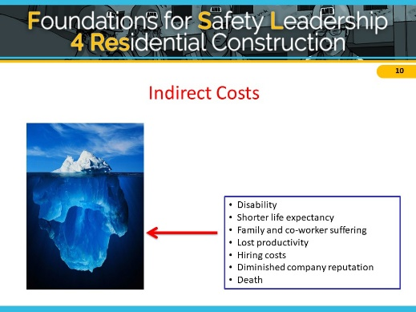

**WHAT ARE SOME EXAMPLES OF INDIRECT COSTS?**

Indirect costs include things like family and co-worker suffering, lost productivity related to incident investigations and work stoppage, hiring costs to replace an injured worker, and the company’s diminished public reputation, especially if the incident is covered by local media. This can reduce the company’s ability to win bids.

**ASK CLASS:**

**ARE SOME OF THESE COSTS MORE IMPORTANT THAN OTHERS?**

***Benefits of Effective Leadership***

# NOTES FOR SLIDE 11 SLIDE 11

**ASK CLASS:**

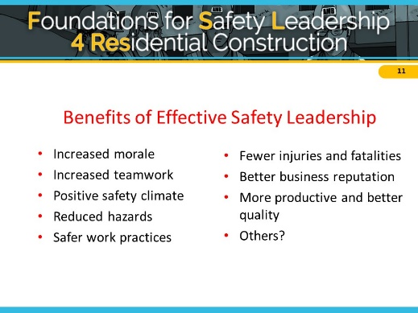

**SO, TO SUMMARIZE, TELL ME WHAT YOU THINK SOME OF THE BENEFITS ARE OF BEING AN EFFECTIVE SAFETY LEADER ON A JOBSITE?**

(After you make a list on the board, present the slide list and if there’s time, tie this back to costs from slide 9 and 10)

So far, we’ve gone over the costs of ineffective safety leadership and benefits of effective leadership and how good leadership can improve safety climate and safety outcomes. But we actually haven’t defined what a safety leader is or what skills she or he can use on the jobsite. That’s what we’re going to cover next before we get into the scenarios.

# Safety Leadership Skills

# NOTES FOR SLIDE 12 SLIDE 12

**ASK CLASS:**

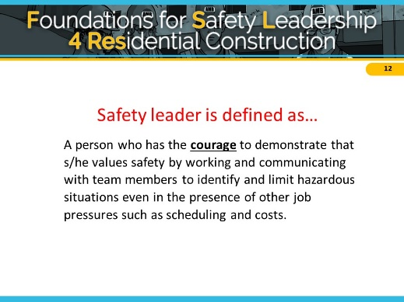

**HOW WOULD YOU DEFINE A SAFETY LEADER?**

In the FSL4Res course, we define a **safety leader** as... A person who has the courage to demonstrate that s/he values safety by working and communicating with team members to identify and limit hazardous situations even in the presence of other job pressures such as scheduling and costs.

**ASK CLASS:**

**WHAT DO YOU THINK ABOUT THE WORD COURAGE? DOES IT TAKE COURAGE TO BE A LEADER? DOES THE AMOUNT OF COURAGE DEPEND ON YOUR ROLE OR POSITION ON THE JOBSITE?**

**WHEN A COMPANY VALUES SAFETY AND IT’S NOT JUST A PRIORITY, HOW MIGHT THAT AFFECT THE NEED FOR COURAGE?**

# NOTES FOR SLIDE 13 SLIDE 13

The FSL4Res course focuses on critical skills that you as a safety leader can use to create a strong jobsite safety climate and reduce safety incidents.

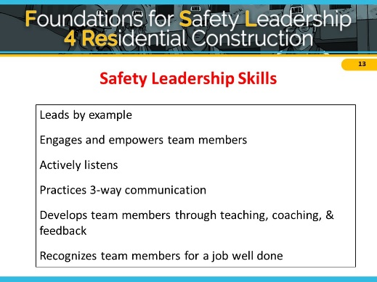

Here they are…

**DISTRIBUTE WALLET CARD WITH SKILLS AND TELL CLASS:**

These wallet cards list the skills.

I’d encourage you to put it in your wallet and look at it every so often to refresh your memory of what you learned today.

Next, we are going to discuss the specific actions you can use to demonstrate each of these on the jobsite.

***Leads by Example***

# NOTES FOR SLIDE 14 SLIDE 14

Leading by example is probably the most important of the safety leadership skills in the FSL4Res course.

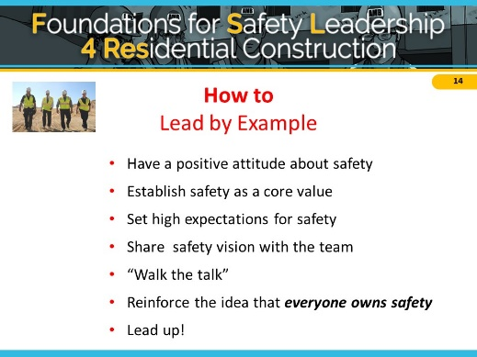

**ASK CLASS: WHAT DO YOU THINK IT MEANS TO LEAD BY EXAMPLE?**

Team members learn from their leaders. They notice when they cut corners, don’t follow safety policies or procedures, or give inconsistent safety messages.

**ASK CLASS: HOW DOES COURAGE PLAY INTO LEADING BY EXAMPLE?**

First, you need to personally value and consistently demonstrate a positive attitude about safety. You should also establish safety as the team’s core value by building it into all aspects of the job.

As a safety leader you must set high safety expectations for every team member. Let them know on a regular basis that you expect them to always use safe work practices and ensure that other team members do too, and immediately report hazardous conditions and all injuries or near misses.

These actions send the message that safety is an integral part of working every day and not just a way to avoid safety violations. The next way to lead by example is to develop and share your safety vision with your team.

**ASK CLASS: WHAT DO YOU THINK IT MEANS TO HAVE A SAFETY VISION?**

You can talk about the importance of safety for you and for them in terms of the direct and indirect costs just discussed. You can emphasize that safe work goes hand-in-hand with productive and quality work. Another part of creating a vision is to consider the safety implications of all your decisions and share those with your team.

An action you can put into place immediately is to not practice the old way of “Do as I say, but not as I Do,” and instead, “Walk the talk” by always following safe work procedures and practicing safe practices.

As a leader, you need to consistently communicate that everyone owns safety. It’s not just the foreman’s or safety person’s responsibility. Everyone is responsible for keeping the jobsite safe for themselves and others. A final way to lead by example is to lead up by working to persuade individuals like company owners and others in supervisory positions to improve jobsite safety and health.

**ASK CLASS: HOW DOES COURAGE PLAY INTO LEADING UP?**

Some ideas for things you can do to lead up include:

* Find out what has (and hasn’t) worked in the past to motivate them to improve safety and health policies
* Try to get them to think about safety in a new way
* Present solutions, rather than only pointing out problems
* Find others (workers, foremen, etc.) to help you convey your message

***Engages and Empowers Team Members***

# NOTES FOR SLIDE 15 SLIDE 15

The next leadership skill is to engage and empower team members in the safety process.

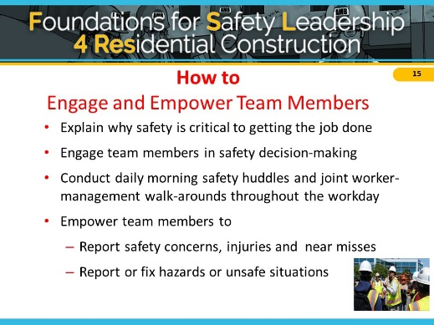

**ASK CLASS:**

**WHAT ARE SOME IDEAS FOR DOING THAT?**

You can explain why working safely is critical to getting the job done and not just say “be safe”.

You can engage the team in safety-related decisions so they can see how they, too, own safety. These skills can be used with the whole group as well as with individual workers.

Involving workers in daily huddles and joint management walk-arounds lets the team know that safety is valued, it is an essential aspect of how work gets done, and they are a critical part of the overall safety effort.

Finally, as a leader, you need to empower team members to report jobsite hazards, safety concerns, and near misses, and to act upon unsafe situations and make it clear that there will be no negative consequences or retaliation when they do. You can develop an “action list” to show how issues raised are addressed and post the list in a prominent place to help ensure accountability and build trust.

***Actively Listens***

# NOTES FOR SLIDE 16 SLIDE 16

Being able to communicate effectively is at the core of all the other leadership skills and is critical to becoming an effective safety leader.

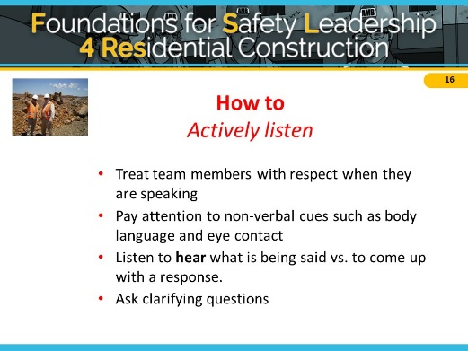

We’ll discuss how to be an Active rather than Passive listener.

**ASK CLASS:**

**HAVE YOU EVER TRIED TELLING SOMEONE SOMETHING IMPORTANT AND YOU**

**CAN TELL THEY AREN’T LISTENING? HOW CAN YOU TELL?**

Learning to actively listen first involves treating your team member with respect and giving that person your full attention. Don’t check phones, emails, or read other materials during the conversation. Pay special attention to your and the speaker’s body language because it can sometimes convey more information than words. Maintain eye contact; avoid making negative facial expressions or raising your voice. If you’re feeling resentful or insulted, make an extra effort to maintain professional conduct.

Most importantly, you need to listen to hear what the person is saying rather than listening just to come up with a response. Finally, ask clarifying questions to ensure you understand what speaker is saying or asking.

***Practices 3-Way Communication***

**NOTES FOR SLIDE 17 SLIDE 17**

This safety leader skill relates to being able to communicate effectively.

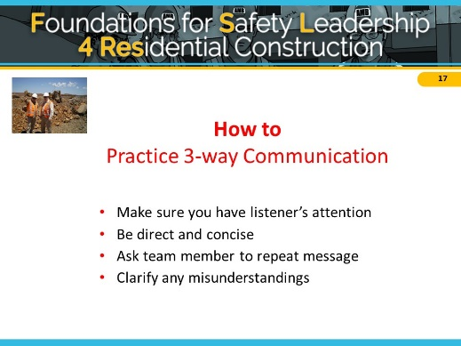

This skill outlines a simple strategy you can use to reduce misunderstandings between you and the person you’re speaking with.

**ASK CLASS:**

**HAVE YOU EVER GIVEN SOMEONE INSTRUCTIONS TO DO SOMETHING, THEY SAY SURE THING, AND THEN GO AND DO SOMETHING ELSE? COULD IT BE THAT THEY DIDN’T UNDERSTAND WHAT YOU WERE ASKING THEM TO DO?**

Practicing 3-way communication helps ensure everyone understands your message or instructions. This is done by making sure you have the listener’s attention, being direct and concise, and most importantly, having the listener repeat what you said to be sure the message was understood. This also allows you to clarify any misunderstandings.

**CLASS ACTIVITY:**

**PRACTICE 3-WAY COMMUNICATION WITH SOMEONE IN THE CLASS THROUGH THE SANDWICH OR AIRPLANE EXERCISE:**

SANDWICH EXERCISE: “Hey [student’s name], can you go get me a sandwich?” After the student responds, comment that they did not get you the right kind of sandwich and they didn’t get you chips or a drink, either!

AIRPLANE EXERCISE: First, say, “I need paper airplanes now” and you have 3 minutes to make one. Don’t give them any construction drawings. After 2 or 3 minutes have them hold up what they’ve produced. After they’ve handed in or shown their airplanes, do the exercise again but this time give them instructions (e.g. “fold your paper in half lengthwise, fold corners into center line”) and ask 1 person to repeat the instructions back to you.

***Develops Team Members through Teaching, Coaching, and Feedback***

# NOTES FOR SLIDE 18 SLIDE 18

Effective safety leaders work to develop their team members by teaching and coaching them on how to do things correctly and safely on the jobsite. They also provide feedback to let them know how they are doing and if any changes are needed.

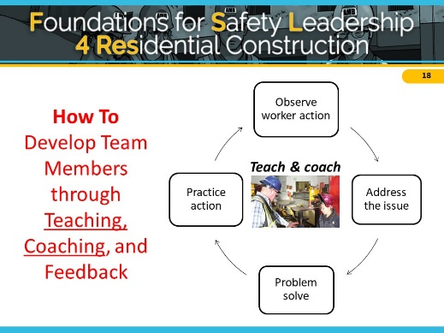

**ASK CLASS:**

**WHAT IS THE DIFFERENCE BETWEEN TEACHING, COACHING, AND FEEDBACK?**

#### Teaching = telling Coaching = watching

**Feedback = evaluating performance**

First, we’ll talk about teaching and coaching.

When you want to teach a team member a new or better way to do something, respectfully ask questions to understand why s/he is doing it that way and then problem-solve together (even if you already have a solution) to find a better or safer approach to completing the task.

Show the team member how to perform the activity correctly, then watch him/her to be sure they have learned how to do it. If they need to be corrected, treat the person with respect and be a coach.

Encourage team members to constantly update their knowledge and skills so they can do their jobs better and safer.

# NOTES FOR SLIDE 19 SLIDE 19

Providing constructive feedback is another leadership skill you can use to develop your team members.

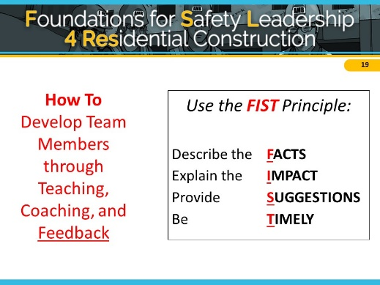

When giving constructive feedback, try hard to focus on the situation or behavior rather than the person.

The FIST principle can help you do that.

First, describe the **Facts**: What is the situation or activity/behavior for which you are providing feedback?

When and where did it occur? What were the circumstances?

Next, explain the **Impact**: What are the potential consequences that may result (good or bad)?

Then, offer **Suggestions**: Work together to problem-solve and come up with solutions. Think of ways team members might use the same approach in the future.

Finally, be **Timely**: Don’t wait to provide feedback. It is more effective when you give it close to when the situation/behavior occurred.

**CLASS ACTIVITY:**

**PRACTICE THE FIST PRINCIPLE**

**FOR EXAMPLE, USE THE FIST PRINCIPLE TO GIVE A TEAM MEMBER CONSTRUCTIVE FEEDBACK ABOUT ALWAYS BEING LATE TO WORK.**

***Recognizes Team Members for a Job Well Done***

# NOTES FOR SLIDE 20 SLIDE 20

The next skill effective safety leaders display is to recognize team members when they go above and beyond to maintain a strong positive jobsite safety climate.

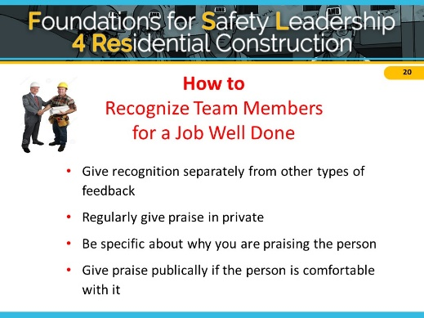

**ASK CLASS:**

#### WHY IS IT IMPORTANT TO DO THIS? (e.g.

**Appreciation motivates and encourages team members to continue working to maintain and improve the jobsite safety climate)**

Like other types of feedback, recognition should be given in a timely manner, and it must be sincere. It’s also important to separate this type of “way to go” or praise feedback from the type of feedback we just discussed. It may be as simple as saying “good job,” giving a hand shake, or saying “thank you” for going the extra mile for safety or for something really well done.

It’s important to know your team members as individuals so you can use praise and acknowledgement effectively. For those who are comfortable with public praise, it is a great way to show others that safety is valued. However, a person uncomfortable with public praise may be more embarrassed rather than pleased.

**ASK CLASS:**

**WHAT ARE SOME THINGS YOU MIGHT WANT TO CONSIDER WHEN GIVING PRAISE?**

**(There are generational differences, as well as differences between individuals. Some workers like to feel valued and appreciated while others feel uncomfortable with praise in public. Think about personality of individuals and jobsite culture or climate).**

**IS THERE EVER A DOWNSIDE TO GIVING RECOGNITION? (Coworker reaction, perceived favoritism, preferential treatment)**

**----------------------------------------**

So we’ve covered the costs of ineffective safety leadership, the benefits and importance of effective safety leadership, and presented the safety leadership skills covered in this course. Next we’re going to work through some real-world construction scenarios to see how the skills are or are not applied on the jobsite.

Before we start that though, as we go through the scenarios I want you to keep in mind that practicing and using these skills is really not very time-consuming. And that they can be easily inserted into daily workflow and are likely to improve productivity.

# Applying Leadership Skills in Real World Scenarios

**(TIME 60-80 minutes)**

***SCENARIO STRUCTURE AND CHECKLIST***

# NOTES FOR SLIDE 21 SLIDE 21

### Have students turn to page 15 in handout

Depending on how we are doing on time, we may not go through each scenario, but we will be covering all safety leadership skills. You can find the scripts for all the scenarios in your handout, to read after the class.

**Additional Instructor Notes**

While the primary goal of the scenarios is to demonstrate the safety leadership skills, they also illustrate important fall safety hazards. As you go through the scenario, you might find it useful to mention them, but please do NOT spend time discussing the hazards themselves, because that is covered in much greater detail in other safety training materials. If while watching the scenarios students identify a particular safety issue, use the moment to recognize them for noticing it, but then quickly get back to the leadership skills.

# NOTES FOR SLIDE 22 SLIDE 22

As we work through each scenario together, we will be analyzing if the characters use any or all of the safety leadership skills and then discuss what they could have done better.

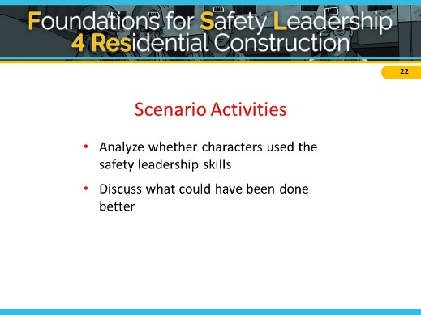

**FOR INSTRUCTOR–** HERE’S WHEN YOU COULD CREATE THE FACILITATION TABLE (shown earlier) ON A WHITEBOARD OR FLIP CHART TO USE FOR THE SCENARIOS



# NOTES FOR SLIDE 23 SLIDE 23

Each scenario starts with a description of a safety situation on a construction site. This is followed by two possible outcomes, where a leader either doesn’t use (Outcome A) or does use (Outcome B) one or more of the leadership skills.

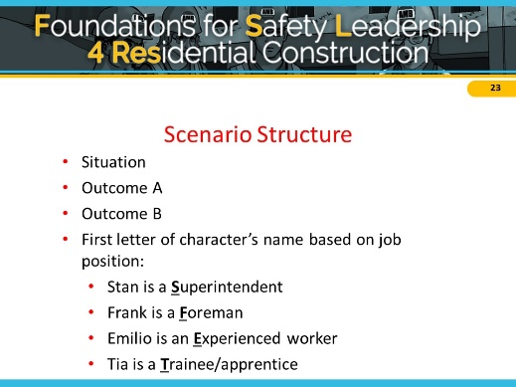

In each scenario, you’ll be introduced to a number of different characters. The first letter of each character’s name is based on their job position. For example in one of them, Stan is a **S**uperintendent, Emilio is an

**E**xperienced worker, Frank is a **F**oreman, and Tia is a **T**rainee/apprentice.

# NOTES FOR SLIDE 24 SLIDE 24

On page 17 of your handout, there is a checklist like this one of the leadership skills that you can use as a sort of cheat sheet as we work through the scenarios.

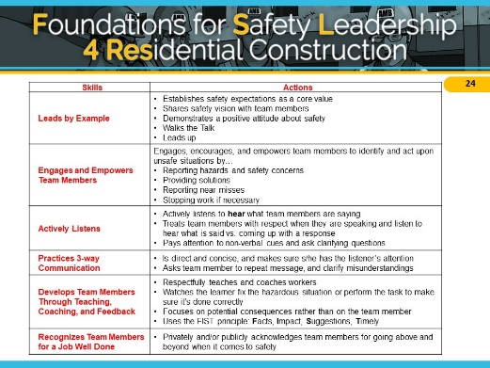

They are also on the back of your wallet card.

***Overall Description of Jobsite***

# NOTES FOR SLIDE 25 SLIDE 25

* 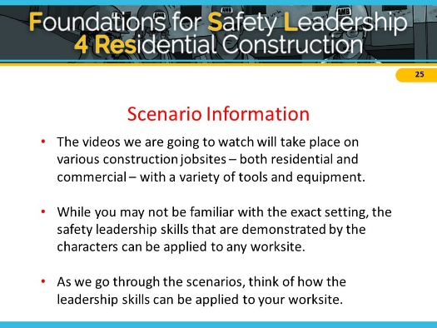The videos we are going to watch take place on various construction jobsites – both residential and commercial – with a variety of tools and equipment.
* While you may not be familiar with the exact setting, the safety leadership skills that are demonstrated by the characters can be applied to any worksite.
* As we go through the scenarios, think of how the leadership skills can be applied to your worksite.

# NOTES FOR SLIDE 26 SLIDE 26

***Scenario Main Menu***

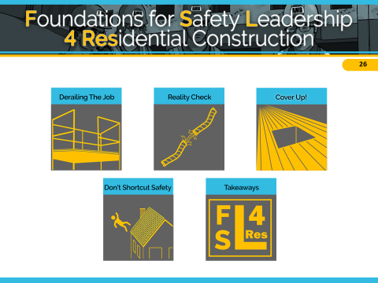Today we’re going to work through [list the scenarios you’ve picked]. If we have time, we’ll do some others.

**CLICK THE SCENARIO ICON YOU WISH TO USE**



**Additional Instructor Notes**

Slide 26 is the main menu for all the scenarios. You can click on any of the icons and you will be taken to the introductory slide of that scenario. You’ll also find an icon of this slide in the bottom right corner of each scenario slide. You can click on it and you’ll be taken back to slide 26 so you can click on the next scenario you want to work through.

When you are ready to discuss the FSL4Res takeaway messages, click the “Takeaways” icon on Slide 26, or simply show the Takeaway slide after you’ve gone through all the scenarios you want to present.

# *1. DERAILING THE JOB*

Tomas – *Derby Drywall* Trainee

Steve –*Derby Drywall* Supervisor

Felix – *Haglin Homebuilding* Foreman

Trevor – *Haglin Homebuilding* Trainee

Ellen – *Haglin Homebuilding* Experienced Carpenter

**Situation**

A crew from the Derby Drywall company is trying to finish taping the drywall in a two-story residential home. Their supervisor, Steve, told them earlier that the job must be completed by the end of the day because they have another job starting tomorrow.

Tomas, a trainee, is unable to finish his taping work on the stairwell because one of the scaffold guardrails is in his way. Keeping in mind what Steve said, Tomas removes the guardrail and finishes taping, but forgets to reinstall the guardrail before leaving for the day.

When the Haglin Homebuilding carpentry crew arrives to begin installing the crown molding, Trevor, a trainee, notices the missing guardrail and tells Felix, his foreman, about it.

**Outcome A**

Felix thanks Trevor for letting him know and tells him to “deal with it.” Trevor isn’t sure if he should put the guardrail back up since Felix didn’t tell him to but decides it’s better to be safe than sorry.

Later, Felix notices that the guardrail is up, but doesn’t say anything to Trevor or any other crew members.

**Outcome B**

Felix is surprised and asks if this has happened before. The workers nod and Ellen says she noticed the same thing last week, but she put it back up without saying anything.

Felix reminds the crew that if the guardrails aren’t attached, someone could fall and get seriously injured. He thanks Trevor and Ellen for paying attention to hazards and for speaking up. Felix says he’s going to talk to the drywall company supervisor.

Later that day, Steve, the Derby Drywall supervisor, stops by the site. Felix calls over Trevor and Ellen and tells Steve about the guardrail being removed. Steve gets defensive, exclaiming that he and his crew always put safety first! He also admits that he’s under pressure from the owner because another job started today.

In a stern voice, Felix says to Steve that Derby’s actions are putting workers at risk of falling. Steve agrees but points out that his crew is unable to work easily or quickly around guardrails. Felix and Steve then work together to develop a process for ensuring that guardrails are in place at all times.

# NOTES FOR SLIDE 27 SLIDE 27

The primary safety leadership moment illustrated in “Derailing the Job” is what can happen when production and scheduling are prioritized over safety.

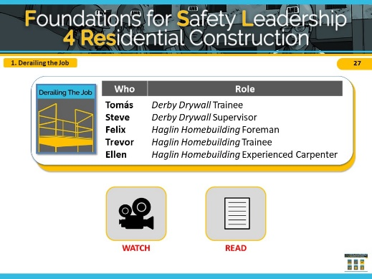

This scenario shows a two-story single-family home being built in a new residential neighborhood.

As soon as the drywall crew is finished, the carpenters will begin putting up the crown molding.

Remember that these scenarios are meant to illustrate how the safety leadership *skills* you’ve learned can be used to address a safety situation

**INSTRUCTOR INFORMATION -** This scenario is designed to illustrate the following safety leadership skills:

1. Lead by example
2. Actively listen
3. Engage and empower team members
4. Recognize team members

**CLICK ON DESIRED TEACHING MODE…**

**WATCH**

# NOTES FOR SLIDE 28 SLIDE 28

**VIDEO WILL START AUTOMATICALLY**

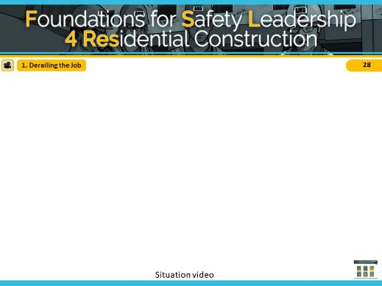

**ADVANCE SLIDE**

# NOTES FOR SLIDE 29 SLIDE 29

Reveal the discussion questions and/or use the facilitation table to go through skills.

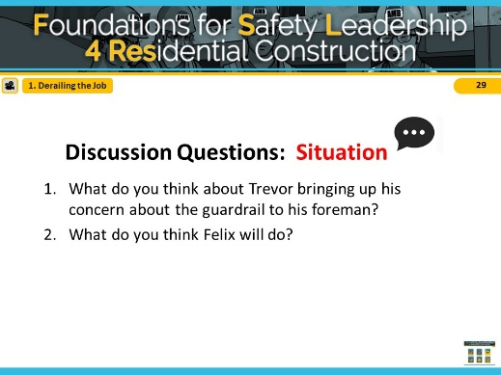

**ADVANCE SLIDE**

# NOTES FOR SLIDE 30 SLIDE 30

**VIDEO WILL START AUTOMATICALLY**

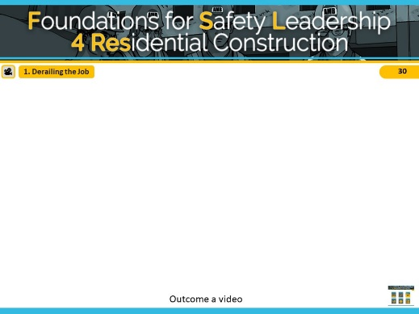

**ADVANCE SLIDE**

# NOTES FOR SLIDE 31 SLIDE 31

Reveal the discussion questions and/or use the facilitation table to go through skills.

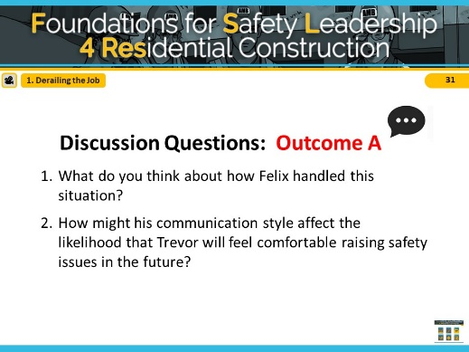

In Outcome A, Felix did not use any safety leadership skills and he missed opportunities to utilize the skills and promote a safe worksite.

**ASK CLASS: What leadership skills could he have used in this scenario?** *[Short Discussion]*

**ADVANCE SLIDE**

# NOTES FOR SLIDE 32 SLIDE 32

**VIDEO WILL START AUTOMATICALLY**

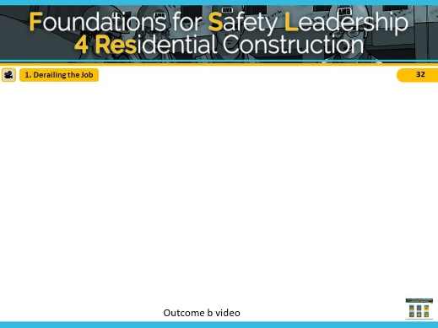

**ADVANCE SLIDE**

# NOTES FOR SLIDE 33 SLIDE 33

Reveal the discussion questions and/or use the facilitation table to go through skills.

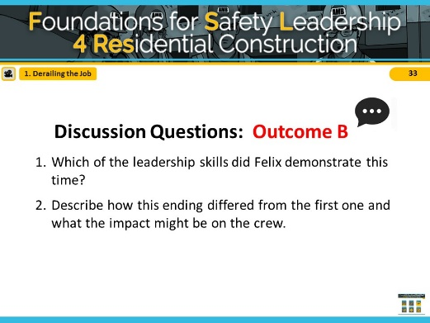

To recap: In Outcome B, when the guardrail concern was brought to his attention, Felix lead by example and actively listened by asking clarifying questions and showing his team that safety is important by bringing the issue to the drywall supervisor’s attention. He engaged and empowered his team members when he explained why safety is critical and shared how he’s going to talk to the drywall supervisor and included them in the conversation. Finally, he recognized his crew for bringing the issue to his attention and thanked them for putting safety first.

**CLICK SCENARIO MENU ICON TO RETURN TO MAIN MENU**

**READ**

# NOTES FOR SLIDE 34 SLIDE 34

#### Refer students to page 18 in the student handout

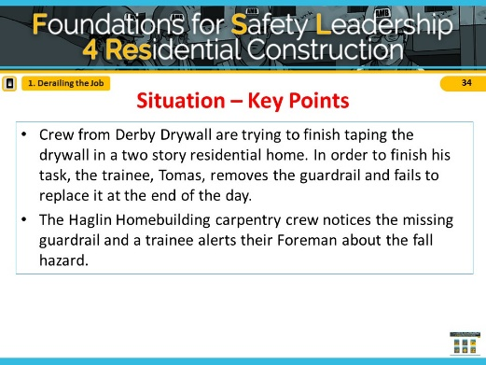

Ask students to read the situation in the “**Derailing**

**The Job**” script (or instructor reads aloud).

**ADVANCE SLIDE**

# NOTES FOR SLIDE 35 SLIDE 35

Reveal the discussion questions and/or use the facilitation table to go through skills.

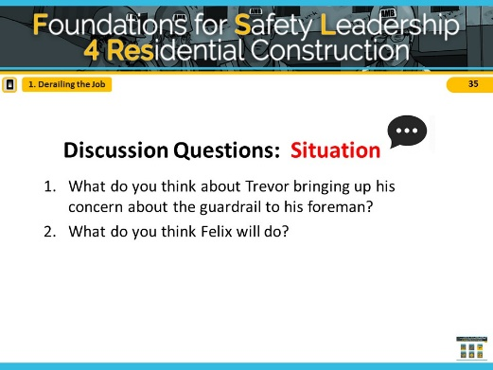

**ADVANCE SLIDE**

# NOTES FOR SLIDE 36 SLIDE 36

Ask students to read Outcome A in “**Derailing the Job**” script (or instructor reads aloud).

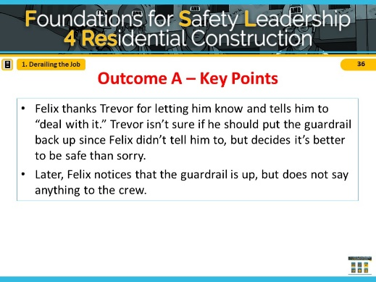

**ADVANCE SLIDE**

# NOTES FOR SLIDE 37 SLIDE 37

Reveal the discussion questions and/or use the facilitation table to go through skills.

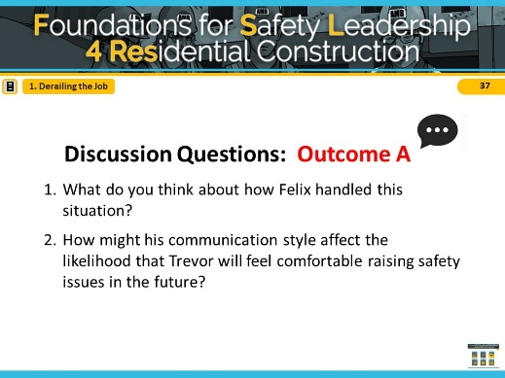

In Outcome A, Felix did not use any safety leadership skills and missed opportunities to utilize the leadership skills and promote a safe worksite.

**ASK CLASS: What leadership skills could he have used in this scenario?** *[Short Discussion]*

**ADVANCE SLIDE**

# NOTES FOR SLIDE 38 SLIDE 38

Read/have students read outcome B in “**Derailing the Job**” script (or instructor reads aloud).

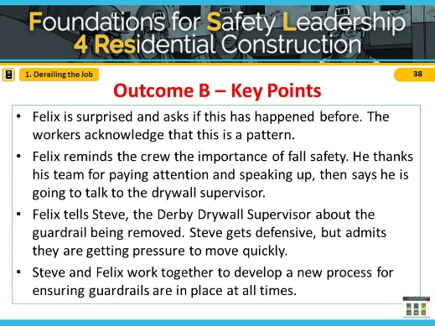

**ADVANCE SLIDE**

# NOTES FOR SLIDE 39 SLIDE 39

Reveal the discussion questions or use the facilitation table to go through skills

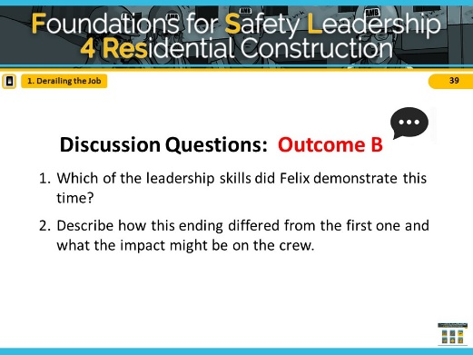

To recap: In Outcome B, when the guardrail concern was brought to his attention, Felix lead by example and actively listened by asking clarifying questions and showing his team that safety is important by bringing the issue to the drywall supervisor’s attention. He engaged and empowered his team members when he explained why safety is critical and shared how he’s going to talk to the drywall supervisor and included them in the conversation. Finally, he recognized his crew for bringing the issue to his attention and thanked them for putting safety first.

**CLICK SCENARIO MENU ICON TO RETURN TO MAIN MENU**

# *2. REALITY CHECK*

Foster – *Five Star Roofing* Foreman

Eduardo – *Five Star Roofing* Experienced worker

Troy – *Five Star Roofing* Trainee

Tara – *Five Star Roofing* Trainee

**Situation**

As Eduardo, an experienced roofer, arrives at the worksite, he sees trainees Troy and Tara start to climb onto the roof to begin their work. Eduardo asks if they’ve secured the ladder and inspected all of the fall protection harnesses, anchor points, and lines they’ll be using.

Troy snaps back, saying they’d just put the ladder up and the rest of the equipment was checked yesterday. Tara chimes in, saying she’s sure it’s all fine.

**Outcome A**

Eduardo shrugs. The job has a short timeline and yesterday’s check is probably okay. He tells Troy and Tara to get up on the roof and get started.

Troy reaches the roof and connects his harness to the roof anchor line. As he walks across the roof to retrieve some shingles, he stumbles, but catches himself before falling. Relieved that he is OK after this close call, Troy inspects the anchor line and notices a section that is badly frayed. He realizes that if he had fallen, the anchor line might have snapped and he could have been seriously injured.

**Outcome B**

Troy and Tara’s reaction makes Eduardo wonder if they actually know how to inspect the fall protection equipment. Or worse, maybe they think its okay to cut corners. He tells them that even though they checked the harnesses, anchor points, and lines the day before, their company requires them to be checked every day, since their fall protection equipment is what keeps them from being injured. Eduardo tells Foster, the foreman, his concerns and suggests it might be a good time to have a huddle to discuss procedures and expectations.

Foster agrees, calls the crew together, and asks them to bring their fall protection equipment with them. He asks Tara and Troy to explain the process for checking the harnesses, anchor points and lines. After a minute or so, Troy admits that they’re not 100% sure what to look for because they’ve always trusted others to check. Rather than being angry, Foster thanks him for being honest and then carefully goes over the OSHA rules and manufacturer's recommendations for checking equipment. When he’s done, he asks Troy and Tara to take turns repeating the rules and demonstrating how to inspect everything.

While doing his checks, Troy finds that part of his anchor line is frayed and shows everyone. As a group, they discuss why this is dangerous and how it reinforces why all equipment must be inspected daily. Foster then watches Troy inspect a new anchor line and properly connect it.

Foster tells them again how much he appreciates their good work, and for admitting when they didn’t know how to do something, particularly when it could have such serious safety consequences. Then Tara surprises Foster by thanking him for recognizing their value as team members, and for saying so.

# NOTES FOR SLIDE 40 SLIDE 40

The primary safety leadership moment illustrated in “**Reality Check**” is what can happen when productivity is put over safety.

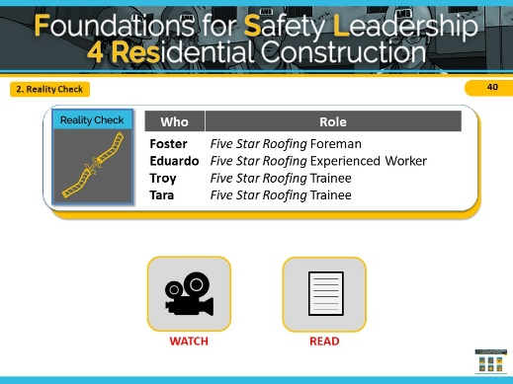

This scenario is about a roof of a new two-story single-family home being shingled by the company Five Star Roofing.

Remember that these scenarios are meant to illustrate key safety leadership skills. Focus on how a safety leader would communicate the needs of the task while prioritizing safety.

*The safety hazard in this scenario is* ***following safety procedures related to fall protection****.*

**INSTRUCTOR INFORMATION -** This scenario is designed to illustrate the following safety leadership skills:

1. Lead by example
2. Actively listen
3. Develop team members
4. 3-way communication
5. Recognize team members

**CLICK ON DESIRED TEACHING MODE…**

**WATCH**

# NOTES FOR SLIDE 41 SLIDE 41

**VIDEO WILL START AUTOMATICALLY**

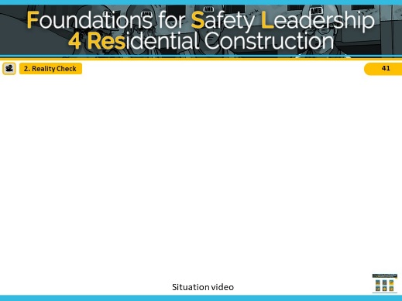

**ADVANCE SLIDE**

# NOTES FOR SLIDE 42 SLIDE 42

Reveal the discussion questions and/or use the facilitation table to go through skills.

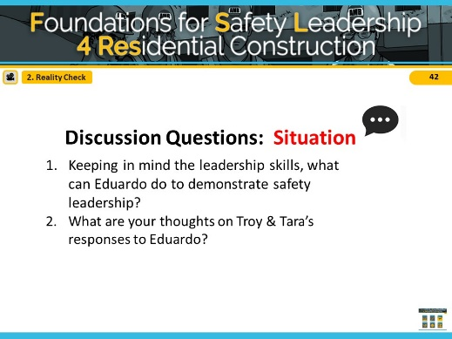

Spend a few minutes getting students’ ideas and then say, Ok, let’s see how your ideas match the two alternative endings we came up with

**ADVANCE SLIDE**

# NOTES FOR SLIDE 43 SLIDE 43

**VIDEO WILL START AUTOMATICALLY**

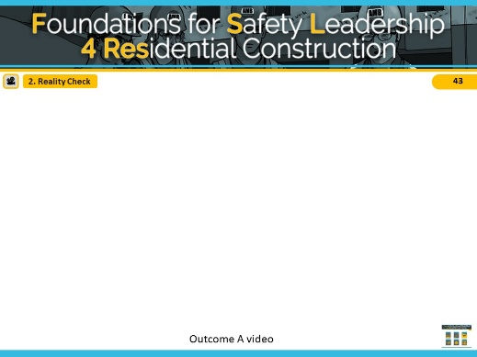

**ADVANCE SLIDE**

# NOTES FOR SLIDE 44 SLIDE 44

Reveal the discussion questions and/or use the facilitation table to go through skills.

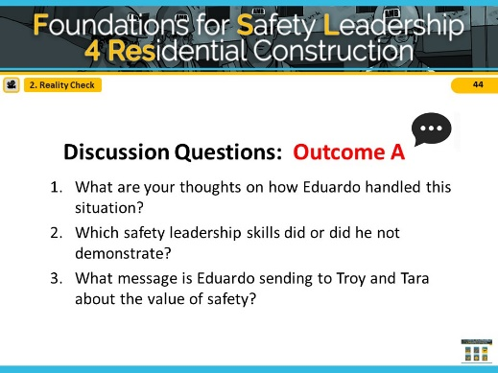

In Outcome A, Eduardo did not use any safety leadership skills and missed opportunities to utilize the leadership skills and promote a safe worksite.

**ASK CLASS: What leadership skills could he have used in this scenario?** *[Short Discussion]*

**ADVANCE SLIDE**

# NOTES FOR SLIDE 45 SLIDE 45

**VIDEO WILL START AUTOMATICALLY**

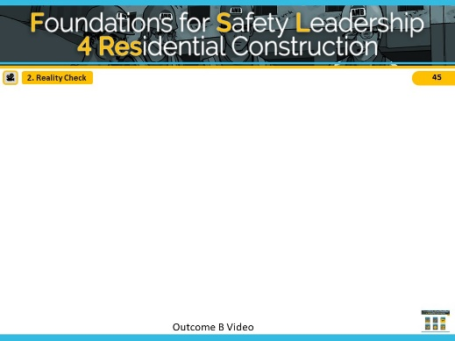

**ADVANCE SLIDE**

# NOTES FOR SLIDE 46 SLIDE 46

Reveal the discussion questions and/or use the facilitation table to go through skills.

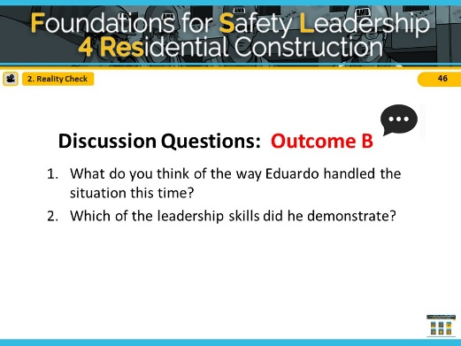

The first leadership skill Eduardo demonstrated was that he actively listened to how Troy and Tara responded and sensed that they might not actually know how to check the rigging. Then, rather than demanding they check it themselves; he led by example by talking to the foreman Foster and offered to go check it with them. Foster was able to develop the three workers by using his teaching and coaching skills. He used his 3-way communication skills by asking them to reiterate what he had told them. Lastly, he demonstrated his ability to give positive feedback by telling them how glad he was that they admitted not knowing about rigging and recognized them for being good team members and valued workers.

**CLICK SCENARIO MENU ICON TO RETURN TO MAIN MENU**

**READ**

# NOTES FOR SLIDE 47 SLIDE 47

#### Refer students to page 20 in the student handout

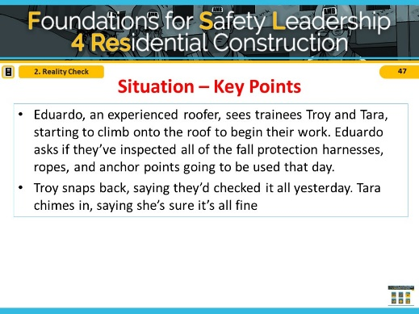

Read/Have students read the situation in the “**Reality**

**Check**” script (or instructor reads aloud).

**ADVANCE SLIDE**

# NOTES FOR SLIDE 48 SLIDE 48

Reveal the discussion questions and/or use the facilitation table to go through skills.

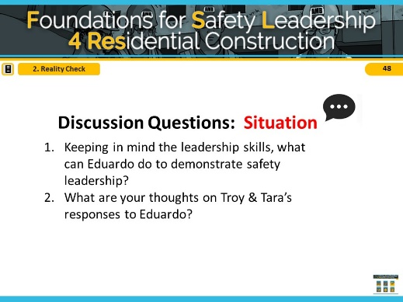

Spend a few minutes getting students’ ideas and then say, Ok, let’s see how your ideas match the two alternative endings we came up with.

**ADVANCE SLIDE**

# NOTES FOR SLIDE 49 SLIDE 49

Ask students to read Outcome A in “**Reality Check**” script (or instructor reads aloud).

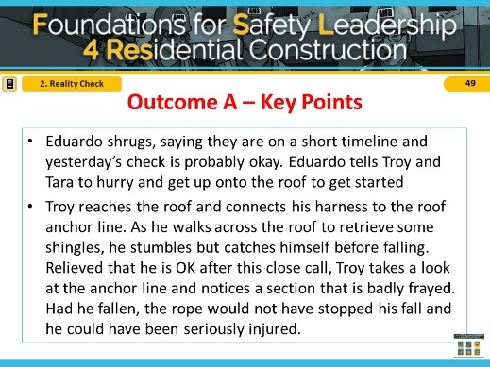

**ADVANCE SLIDE**

# NOTES FOR SLIDE 50 SLIDE 50

Reveal the discussion questions and/or use the facilitation table to go through skills.

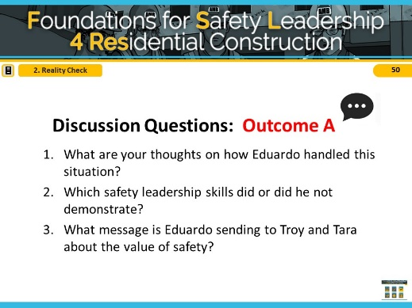

In Outcome A, Eduardo did not use any safety leadership skills and missed opportunities to utilize the leadership skills and promote a safe worksite.

**ASK CLASS: What leadership skills could he have used in this scenario?** *[Short Discussion]*

**ADVANCE SLIDE**

# NOTES FOR SLIDE 51 SLIDE 51

Read/have students read outcome B in “**Reality Check**” script (or instructor reads aloud).

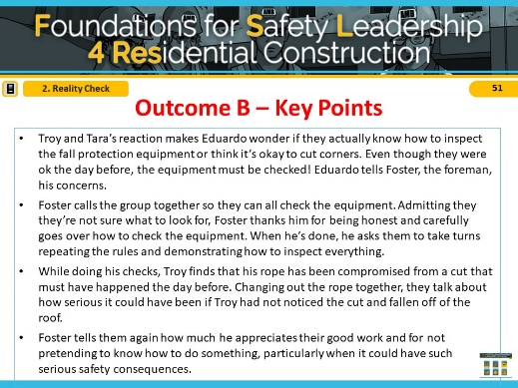

**ADVANCE SLIDE**

# NOTES FOR SLIDE 52 SLIDE 52

Reveal the discussion questions or use the facilitation table to go through skills

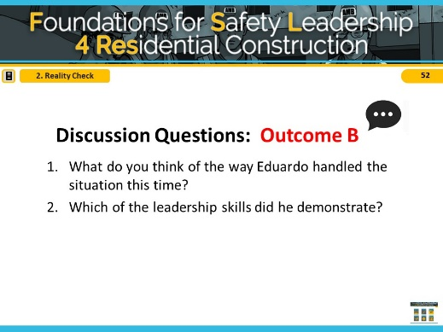

The first leadership skill Eduardo demonstrated was that he actively listened to how Troy and Tara responded and sensed that they might not actually know how to check the rigging. Then, rather than demanding they check it themselves; he led by example by talking to the foreman Foster and offered to go check it with them. Foster was able to develop the three workers by using his teaching and coaching skills. He used his 3-way communication skills by asking them to reiterate what he had told them. Lastly, he demonstrated his ability to give positive feedback by telling them how glad he was that they admitted not knowing about rigging and recognized them for being good team members and valued workers.

**CLICK SCENARIO MENU ICON TO RETURN TO MAIN MENU**

# *3. COVER UP!*

Stan – *Volt Electric* Superintendent Frank – *Volt Electric* Lead Foreman Tia/Tio – *Volt Electric* Trainee/Apprentice

**Situation**

To perform her tasks, Tia, a trainee with Volt Electric, has to walk by a large hole in the floor where some damaged plywood needs to be replaced. Stan, Volt’s superintendent, knows it’s a serious fall hazard that needs to be addressed immediately. The GC has been slow to respond to safety requests, so he asks his lead foreman, Frank, to take care of it.

**Outcome A**

Frank tells Tia she needs to cover the hole in the floor. Tia nods and decides she’ll take care of it in 15 minutes when she’s done securing the electrical wire to the stud. She knows Frank hates it when one person holds up someone else’s work.

Meanwhile, two drywall installers don’t see the hole until the last minute when a nearby worker yells, “Stop!” which gives them just enough time to avoid it.

Frank gets word of this, goes back over to Tia, and yells at her for not covering the hole immediately. He adds that if the worker had stepped into the hole, she would have been seriously injured, or maybe worse, and points out that this isn’t the first time she’s ignored his instructions. Tia, feeling humiliated, apologizes and explains that she didn’t realize he wanted her to drop everything.

**Outcome B**

Frank tells Tia she needs to cover the hole in the floor immediately because it’s a serious fall hazard. He tells her to stop what she’s doing, get a piece of plywood, secure it over the hole, and spray paint the word “hole” on it. He reminds her to tie off so she won’t become a victim while fixing the problem.

When he’s finished, he asks her to repeat his instructions to make sure they’re on the same page. Tia repeats Frank’s instructions word for word and Frank gives her the thumbs-up.

When she’s done covering the hole, Tia thinks how glad she is Frank asked her to confirm what he wanted her to do and by when he wanted it done because there have been times when she hasn’t understood exactly what other foremen she’s worked with were asking her to do.

A few minutes later, when Frank comes by to thank Tia for removing the fall hazard, two drywall installers walk across the piece of plywood she just put down.

# NOTES FOR SLIDE 53 SLIDE 53

The key safety leadership moment illustrated in“Cover Up” is how a safety leader can effectively communicate with a team member about how and why to carry out a safety-related task.

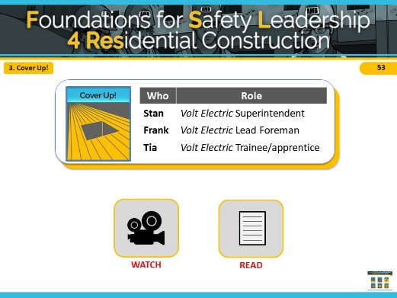

This scenario takes place on a mixed commercial-residential jobsite where there’s a large hole in the sub-floor floor creating a fall hazard.

Remember that these scenarios are meant to illustrate how the safety leadership skills you’ve learned can be used to address a safety situation

**INSTRUCTOR INFORMATION -** It is designed to illustrate the following safety leadership skills:

1. Practice 3-way communication
2. Recognize team members for a job well done

**CLICK ON DESIRED TEACHING MODE…**

**WATCH**

# NOTES FOR SLIDE 54 SLIDE 54

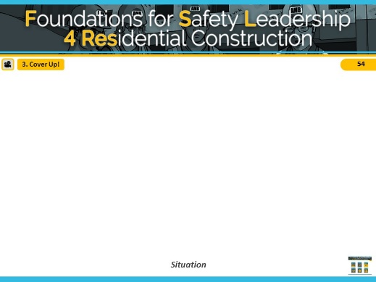

**VIDEO WILL START AUTOMATICALLY**

**ADVANCE SLIDE**

# NOTES FOR SLIDE 55 SLIDE 55

Reveal the discussion questions and/or use the facilitation table to go through skills.

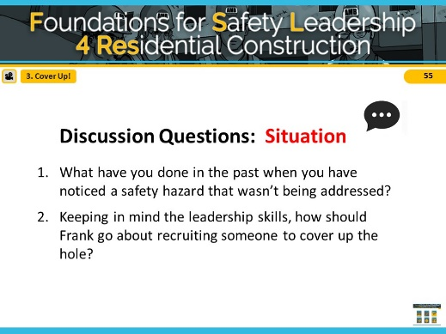

**ADVANCE SLIDE**

# NOTES FOR SLIDE 56 SLIDE 56

**VIDEO WILL START AUTOMATICALLY**

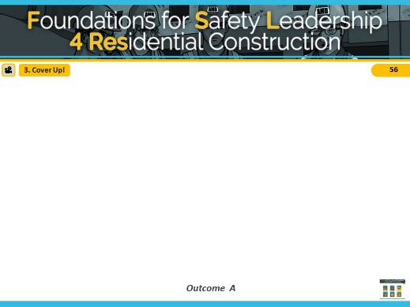

**ADVANCE SLIDE**

# NOTES FOR SLIDE 57 SLIDE 57

Reveal the discussion questions and/or use the facilitation table to go through the skills.

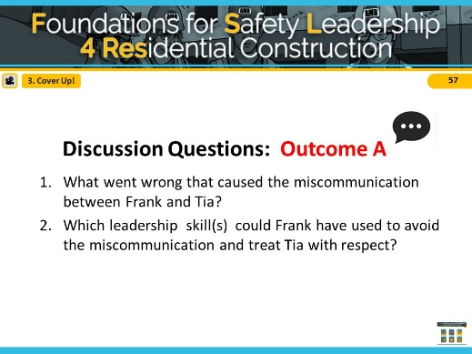

In Outcome A, Frank did not use any safety leadership skills and missed opportunities to utilize the leadership skills and promote a safe worksite.

**ASK CLASS: What leadership skills could he have used in this scenario?** *[Discuss]*

**ADVANCE SLIDE**

# NOTES FOR SLIDE 58 SLIDE 58

**VIDEO WILL START AUTOMATICALLY**

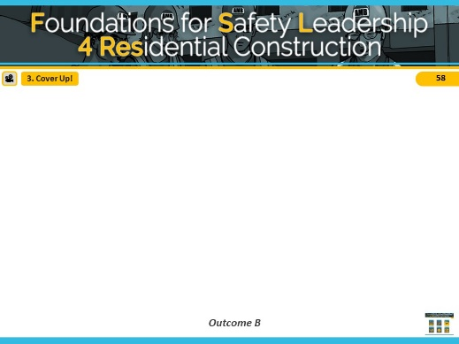

**ADVANCE SLIDE**

# NOTES FOR SLIDE 59 SLIDE 59

Reveal the discussion questions and/or use the facilitation table to go through the skills.

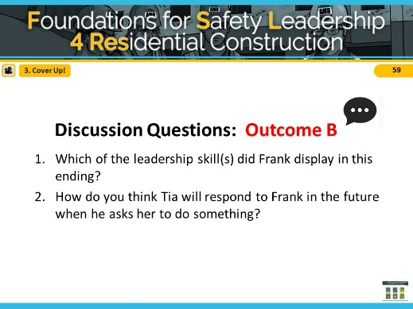

To recap our conversation: In Outcome B, Frank did practice 3-way communication. This ensured that Tia understands exactly what Frank wanted and by when he wanted it done. The 2 minutes that it took for Frank to do this helped prevent Tia from being humiliated and also prevented the drywall installers from getting hurt. By recognizing Tia for doing a good job carrying out his instructions, Frank made Tia feel valued, and she is likely to be even more safety-conscious in the future.

**CLICK THE SCENARIO MENU ICON TO RETURN TO MAIN MENU**

**READ**

# NOTES FOR SLIDE 60 SLIDE 60

#### Refer students to page 21 in the student handout

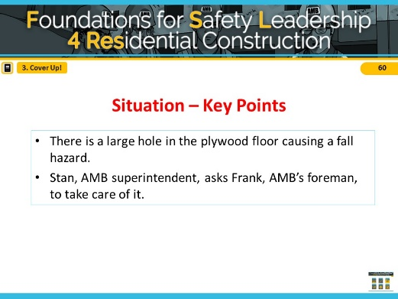

Read/ have students read the situation in the "**Cover Up!”** script (or instructor reads it aloud).

**ADVANCE SLIDE**

# NOTES FOR SLIDE 61 SLIDE 61

Reveal the discussion questions and/or use the facilitation table to go through skills.

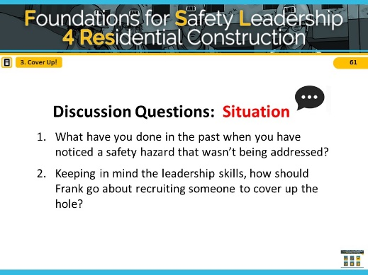

**ADVANCE SLIDE**

# NOTES FOR SLIDE 62 SLIDE 62

Read/have students read Outcome A in **“Cover Up!”** script (or instructor reads it aloud).

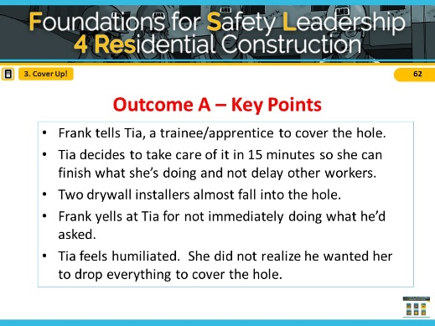

**ADVANCE SLIDE**

# NOTES FOR SLIDE 63 SLIDE 63

Reveal the discussion questions and/or use the facilitation table to go through skills.

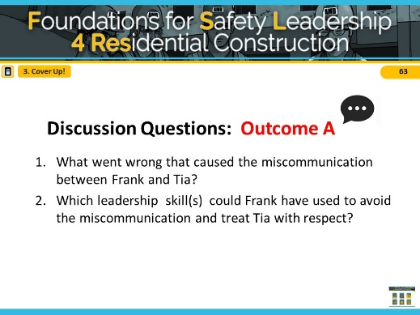

In Outcome A, Frank did not use any safety leadership skills and missed opportunities to utilize the leadership skills and promote a safe worksite.

**ASK CLASS: What leadership skills could he have used in this scenario?** *[Short Discussion]*

**ADVANCE SLIDE**

# NOTES FOR SLIDE 64 SLIDE 64

Read/have students read outcome B in **“Cover Up!”** script (or instructor reads it aloud).

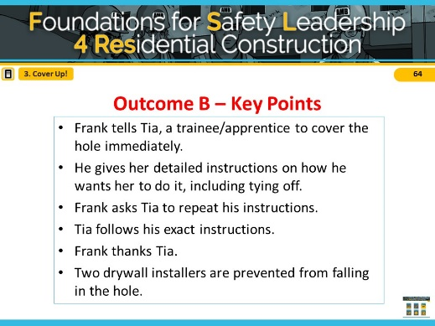

**ADVANCE SLIDE**

# NOTES FOR SLIDE 65 SLIDE 65

Reveal the discussion questions and/or use the facilitation table to go through skills.

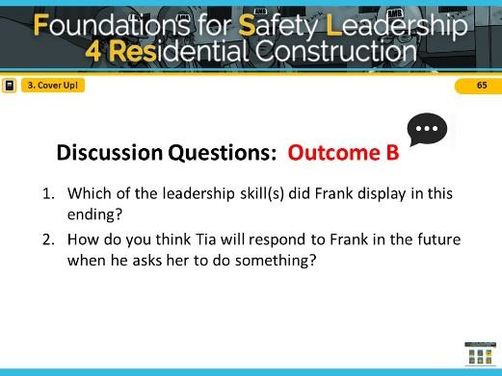

To recap our conversation: In Outcome B, Frank did practice 3-way communication. This ensured that Tia understands exactly what Frank wanted and by when he wanted it done. The 2 minutes that it took for Frank to do this helped prevent Tia from being humiliated and also prevented the drywall installers from getting hurt. By recognizing Tia for doing a good job carrying out his instructions, Frank made Tia feel valued, and she is likely to be even more safety-conscious in the future.

**CLICK THE SCENARIO MENU ICON TO RETURN TO MAIN MENU**

# *4. DON’T SHORTCUT SAFETY*

Sonia – *ACME Homes* Supervisor

Franklin – *ACME Homes* Foreman

Aaron – *ACME Homes* Apprentice

**Situation**

Sonia, the superintendent from ACME homes, has a final walk through coming in just a few hours and she is scrambling to get the home completed. The shutters for the home have been on backorder for weeks and just arrived this morning. There are no exterior trim workers on site, but her company’s framing crew is working on a nearby house.

Sonia asks Franklin, the foreman of the framing crew, if someone from his crew can install the shutters on two upper floor windows to complete the house. Franklin knows that this will be an easy task since the worker will be able to stand on the porch roof below the windows to get the job done, and not have to use a ladder. Franklin agrees to send Aarón, the apprentice, to do the job since he just had training on exterior trim work last week.

**Outcome A**

Franklin tells Aarón to stop what he’s doing and to go install the shutters on the other house saying that it should only take a few minutes. Franklin instructs Aarón to remember what he learned in school last week about how to do exterior trim work. Franklin then turns to Sonia to talk about some other issues on the site.

Aarón gets his screw gun, heads down to the house and goes to work. Once he installs the last shutter, he steps back to make sure the shutters are even and look good. As Aarón steps back to get a better view, he steps on the gutter, loses his balance, and falls to the ground.

**Outcome B**

Franklin introduces Aarón to Sonia and tells him about the missing shutters. Franklin asks if Aarón remembers his training and can install the shutters to help out the superintendent. Aarón nods, grabs his screw gun, and heads toward the other house.

Franklin did not see Aarón grab any equipment other than the screw gun and wonders how Aarón is going to do the job safely. Franklin wants to speak with Sonia about some other issues but decides it can wait and follows Aarón down the street.

As Aarón steps out of the window onto the porch roof, Franklin notices that he’s not tied off and shouts to him to stop immediately.

Franklin gathers his entire crew and grabs some fall protection equipment from his truck for demonstration. He reminds the crew that they must always use fall protection when working at heights, even for tasks they can get done quickly. Franklin shows them how to create a secure tie-off point so they can use a harness and a lanyard. He also takes the time to show the crew members how to use a new window frame anchorage device that the company just purchased.

While the task didn’t go as quickly as Sonia had hoped, she was pleased that Franklin took time with his crew to emphasize the importance of always using fall protection when working at heights, and to demonstrate how to do it properly. To show her appreciation, Sonia nominated Franklin for employee of the month and wrote up the story for the company newsletter.

# NOTES FOR SLIDE 66 SLIDE 66

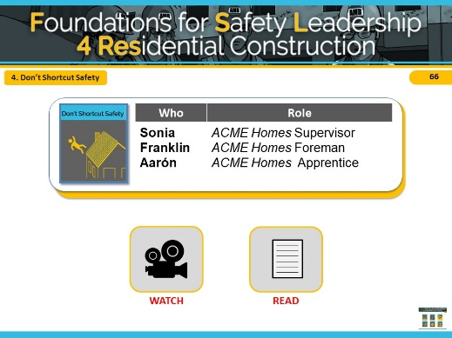

The final scenario is called **“**Don’t Shortcut Safety.”

It shows a residential worksite where shutters need to be installed before the homeowners come by in a few hours for a final walk through.

**INSTRUCTOR INFORMATION -** This scenario is designed to illustrate the following safety leadership skills:

1. Leads by example
2. Develop team members
3. Recognize team members

**CLICK ON DESIRED TEACHING MODE…**

**WATCH**

# NOTES FOR SLIDE 67 SLIDE 67

**VIDEO WILL START AUTOMATICALLY**

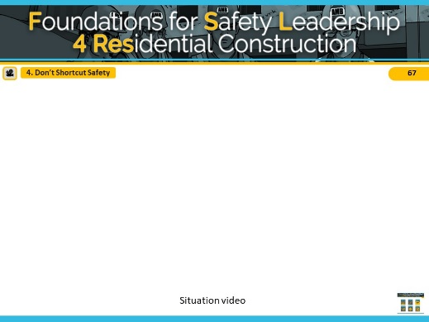

**ADVANCE SLIDE**

# NOTES FOR SLIDE 68 SLIDE 68

Reveal the discussion questions and/or use the facilitation table to go through skills.

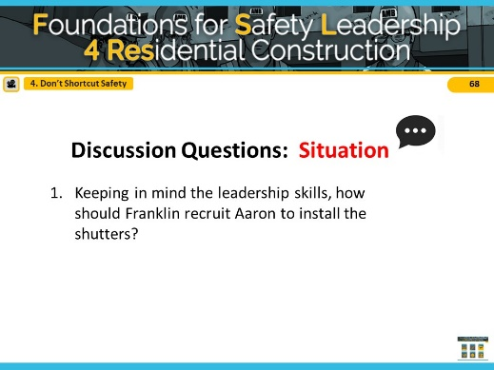

Spend a few minutes getting students’ ideas and then say, Ok, let’s see how your ideas match the two alternative endings we came up with.

**ADVANCE SLIDE**

# NOTES FOR SLIDE 69 SLIDE 69

**VIDEO WILL START AUTOMATICALLY**

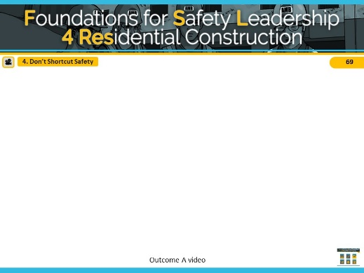

**ADVANCE SLIDE**

# NOTES FOR SLIDE 70 SLIDE 70

Reveal the discussion questions and/or use the facilitation table to go through skills.

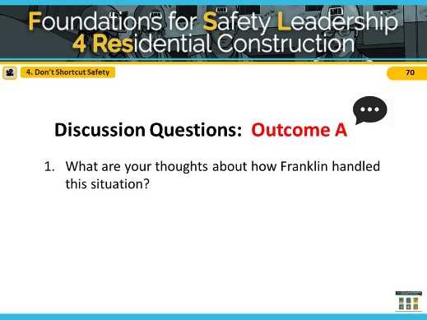

In Outcome A, Franklin did not use any safety leadership skills and missed opportunities to utilize the leadership skills and promote a safe worksite.

**ASK CLASS: What leadership skills could he have used in this scenario?** *[Short Discussion]*

**ADVANCE SLIDE**

# NOTES FOR SLIDE 71 SLIDE 71

**VIDEO WILL START AUTOMATICALLY**

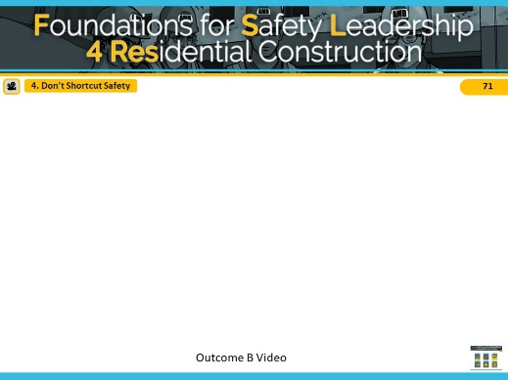

**ADVANCE SLIDE**

# NOTES FOR SLIDE 72 SLIDE 72

Reveal the discussion questions and/or use the facilitation table to go through skills.

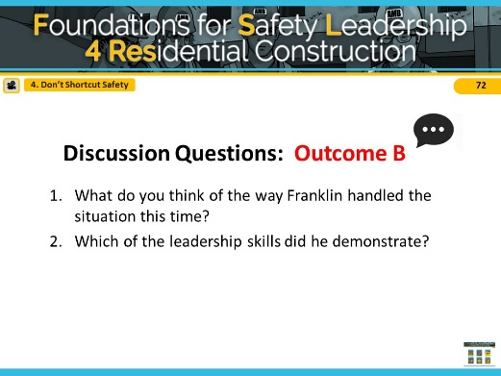

To recap our conversation: In this scenario outcome, Franklin did lead by example when he stops work as he sees Aarón performing the job in an unsafe manner. He developed his team members by calling them together to teach them about the various methods they can and must use to safely complete the task. His company leadership also recognized Franklin’s effort in the newsletter for going above and beyond for safety.

**CLICK SCENARIO MENU ICON TO RETURN TO MAIN MENU**

**READ**

# NOTES FOR SLIDE 73 SLIDE 73

#### Refer students to page 19 in the student handout

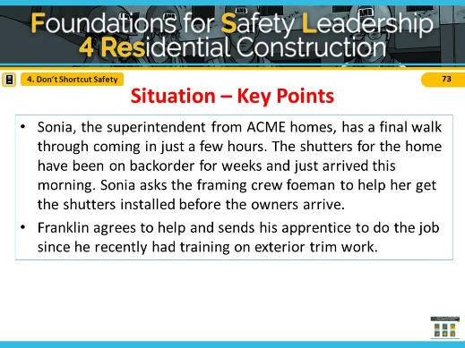

Read/Have students read the situation in the **“Don’t**

**Shortcut Safety”** script (or instructor reads aloud).

**ADVANCE SLIDE**

# NOTES FOR SLIDE 74 SLIDE 74

Reveal the discussion questions and/or use the facilitation table to go through skills.

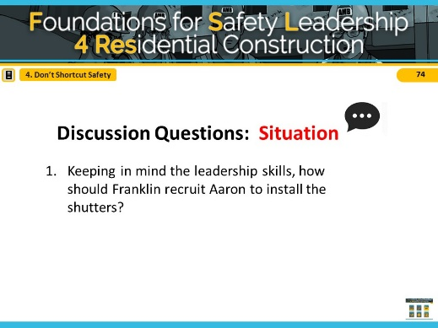

Spend a few minutes getting students’ ideas and then say, Ok, let’s see how your ideas match the two alternative endings we came up with.

**ADVANCE SLIDE**

# NOTES FOR SLIDE 75 SLIDE 75

Read/have students read Outcome A in **“Don’t Shortcut Safety”** script (or instructor reads aloud).

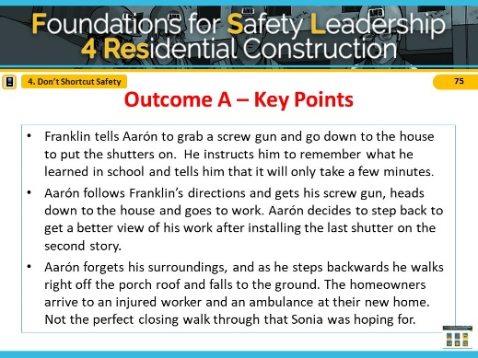

**ADVANCE SLIDE**

# NOTES FOR SLIDE 76 SLIDE 76

Reveal the discussion questions and/or use the facilitation table to go through skills.

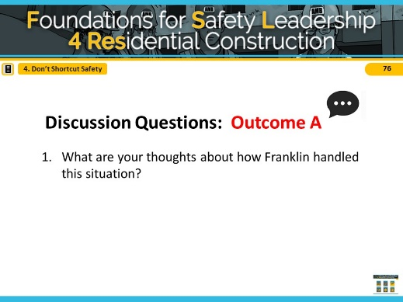

In Outcome A, Franklin did not use any safety leadership skills and missed opportunities to utilize the leadership skills and promote a safe worksite.

**ASK CLASS: What leadership skills could he have used in this scenario?** *[Short Discussion]*

**ADVANCE SLIDE**

# NOTES FOR SLIDE 77 SLIDE 77

Read/have students read outcome B in **“Don’t Shortcut Safety”** script (or instructor reads aloud).

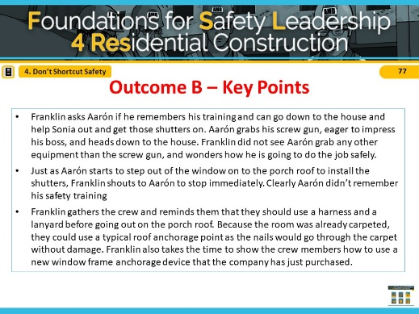

**ADVANCE SLIDE**

# NOTES FOR SLIDE 78 SLIDE 78

Reveal the discussion questions or use the facilitation table to go through skills

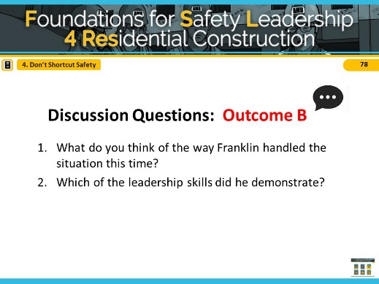

To recap our conversation: In this scenario outcome, Franklin did lead by example when he stops work as he sees Aarón performing the job in an unsafe manner. He developed his team members by calling them together to teach them about the various methods they can and must use to safely complete the task. His company leadership also recognized Franklin’s effort in the newsletter for going above and beyond for safety.

**CLICK SCENARIO MENU ICON TO RETURN TO MAIN MENU**

# Takeaways

# NOTES FOR SLIDE 79 SLIDE 79

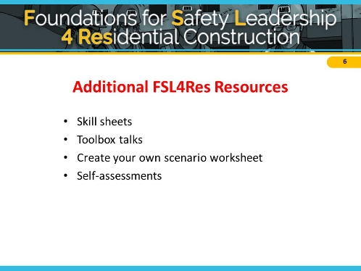At CPWR.com, you can find a number of different resources to use as you continue practicing the skills on the jobsite. If you would like to reference the information you have learned in this training, there are skill sheets, toolbox talks, and self-assessments on the website, along with other materials you may find helpful.

*You may provide class with printout of materials or review materials by going to CPWR.com if you have time.*

# NOTES FOR SLIDE 80 SLIDE 80

We’ve come to the end of the FSL4Res course and we’ve covered a lot.

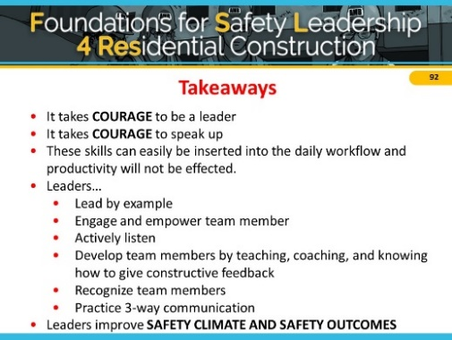

Before we uncover the take away messages, tell me one or two things you learned today, or even better, something you’re going to start or stop doing right away when you get back to the jobsite.

So, here’s are the key points I hope you will take away from this training and put into practice on the jobsite:

* It takes **COURAGE** to be a leader.
* It takes **COURAGE** to speak up.
* These skills can easily be inserted into the daily workflow and productivity will not be affected.
* Leaders…

1. Lead by Example
2. Engage and Empower team members
3. Actively listen
4. Practice 3-way communication
5. Develop team members by teaching, coaching, and knowing how to give constructive feedback
6. Recognize team members for going above and beyond for safety

And finally, if you use these skills on the jobsite and become a true safety leader, you can improve both jobsite **SAFETY CLIMATE and SAFETY OUTCOMES.**

**ADVANCE SLIDE**

# NOTES FOR SLIDE 81 SLIDE 81

Congratulations! You have officially completed the FSL4Res training course. The FSL4Res course was developed collaboratively by these organizations.

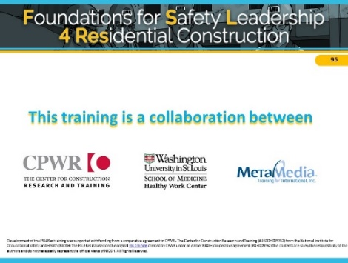

# Short Quiz

**Read each statement and choose the safety leadership skill that best fits each situation. Enter the letter in the blank. Use each skill only once.**

* 1. **Leading by E****xample**
  2. **Engaging and Empowering Team Members**
  3. **Actively Listening**
  4. **Practicing 3-Way Communication**
  5. **Developing Team Members Through Teaching, Coaching, and Feedback**
  6. **Recognizing Team Members for a Job Well Done**

1. After explaining how to address a safety hazard, a superintendent asks his foreman to repeat the steps back to him to make sure he understands his instructions. This is an example of: .
2. Being safe in everything you do on the job site, also called ‘Walking the Talk’, is an

example of: .

1. If an apprentice identifies a job hazard and helps to come up with a solution, her foreman should use to reward her.
2. An experienced worker respectfully tells a team member why what he is doing is unsafe and explains how he could do it more safely. This is an example of: .
3. A foreman realizes a trainee is unsure of how to complete a task after picking up on non-verbal cues like body language. This is an example of: ______ .
4. At a daily safety huddle, a foreman asks for input from her team on what hazards they may face during the day, and how they plan to avoid them. This is an example of:

.