Project LeAD
LEadership Apprentice Development
BUILDING FUTURE LEADERS FOR HEALTH AND SAFETY
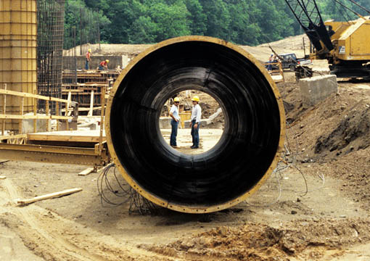

Student Guide

Table of Contents

VIDEO SET-UP..………………………..…...….2

MODULE 1 Motivate and inspire your crew……4

MODULE 2 Manage performance………………5

MODULE 3 Coaching…………………………...8

SUMMARY MODULE………………………....10

GOAL SETTING………………………………..10

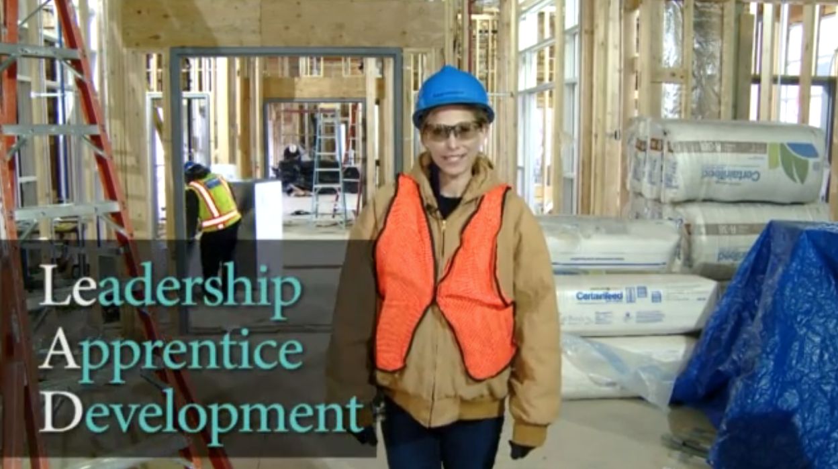
Introduction module

Goal: Introduce students to leadership concepts

Purpose of Project LeAD

To help you understand and develop your leadership capabilities for safety in the construction industry.

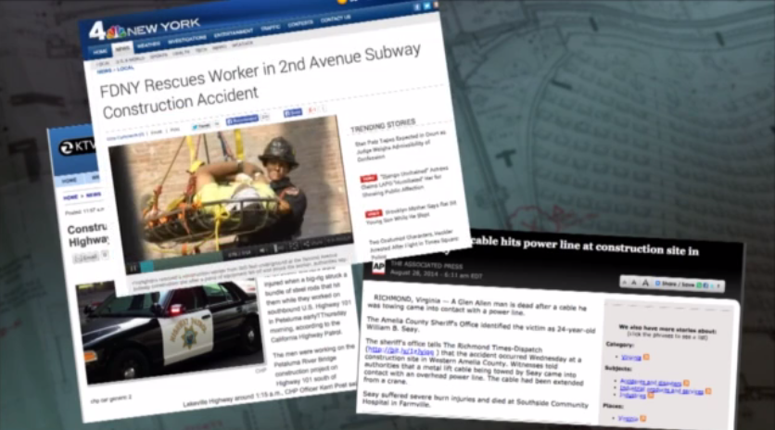
Background
One method of preventing safety incidents is to strengthen safety leadership skills of construction jobsite workers. This is because safety leadership is a key vehicle for creating and sustaining a positive jobsite safety culture.

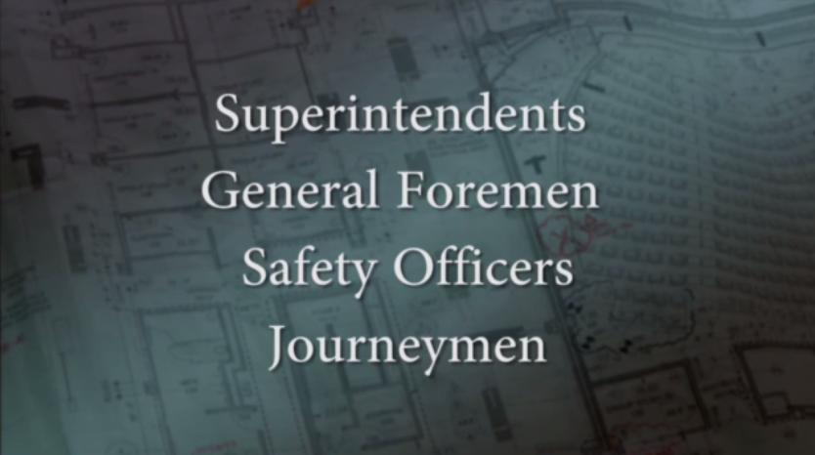
Who are safety leaders?
Any one on a construction jobsite can be a leader! Everyone listed on the right are the obvious answers, but apprentices can be leaders too!

It is everyone’s responsibility to ensure that a job runs safely and smoothly.
Apprentices!

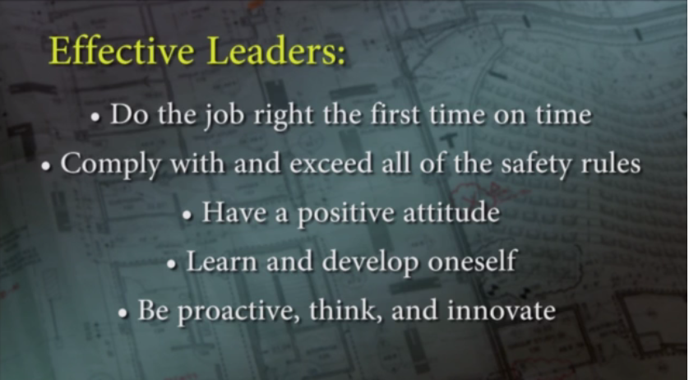
What can effective leaders accomplish?

Can you think of other outcomes of effective leadership?

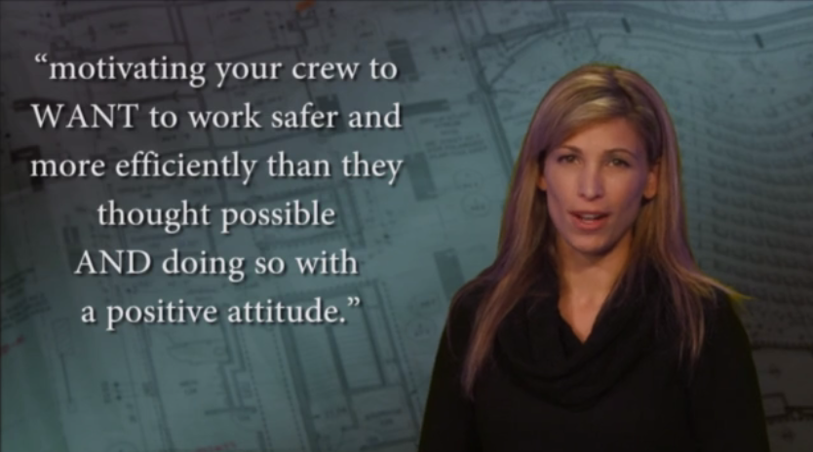
Definition of leadership in the construction industry

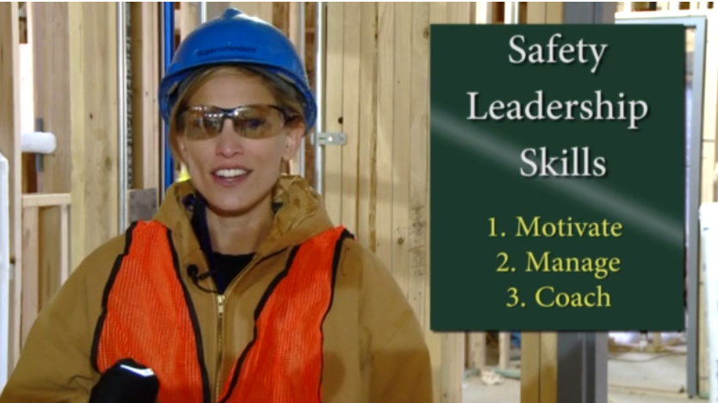
3 Safety Leadership Skills

Note the 3 safety leadership skills that are important for creating and sustaining a positive jobsite safety culture.

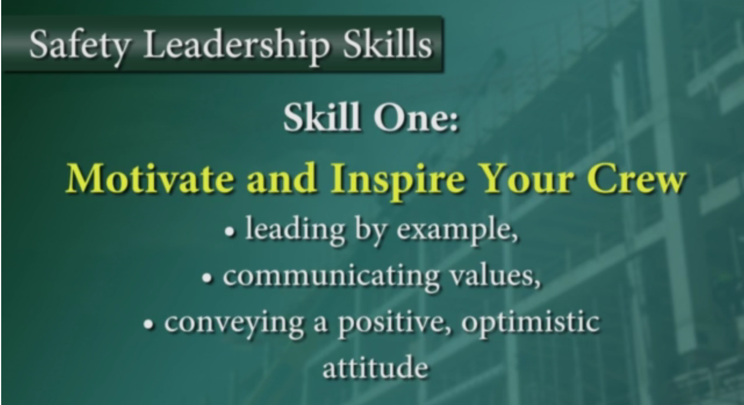
Module 1 – Motivate and Inspire Your Crew

Goal: Learn about motivating your team

Leading by example

This is the most common method to motivate workers.

- Show your team what’s acceptable and what’s not
- Take action to correct a safety hazard when needed
- Make the call to stop work if needed

Communicating values

Not only should you show your team what you value through your actions, you should also make sure your team hears about your values.

- What do you value?
- How can you communicate these values through your actions?

Convey a positive, optimistic attitude

Encourage your team in a positive manner.

- Be up beat, positive and express enthusiasm during work.
- Set high expectations for your team

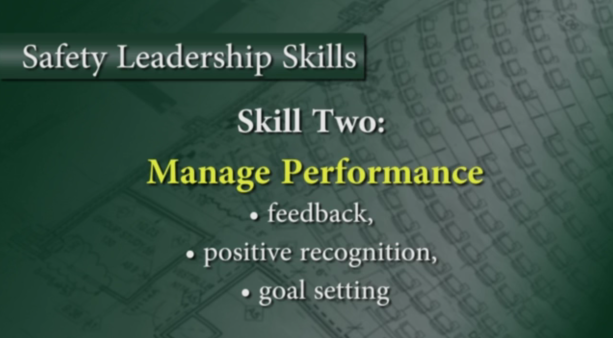
Module 2 – Manage Performance

Goal: Learn about managing teams

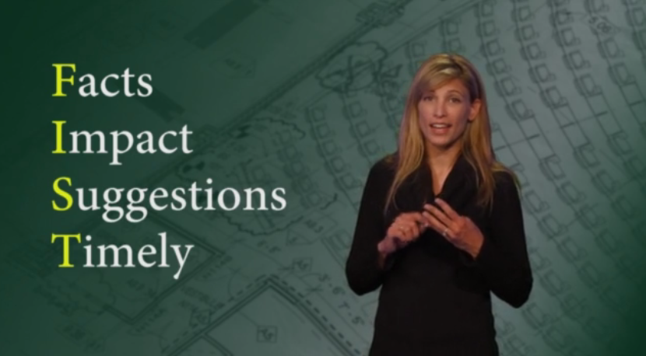
Feedback

Feedback helps people understand if they’re doing a good job or if they could be doing something better.

- Praise in public, criticize in private
- Use the FIST to remember how to give feedback
- Do not wait until the job is over!

Positive recognition

Let your team know you appreciate their effort on a daily basis.

- Ways to recognize team members:
  - Hand shake
  - Thank you on the spot or during meetings
  - Lunch
  - Mention feedback you got from upper management
  - T-shirts, safety stickers, gift cards

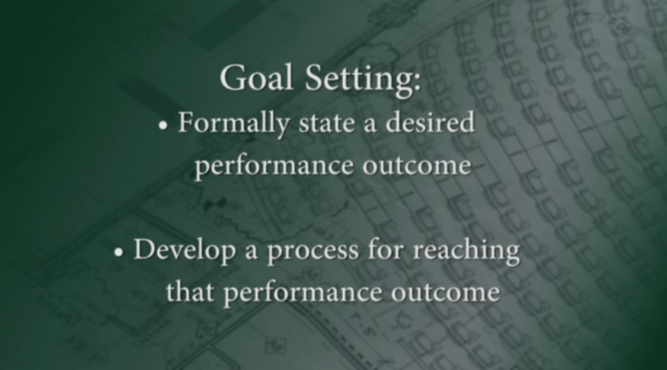
Goal setting

Goal setting can help individuals who are not performing to the best of their abilities, and to motivate individuals to continue performing well.

If you are given a task with no end in sight, it’s easy to complete it without realizing that you ever achieved something!

Create SMART Goals to help manage team performance. Specifically, what would you need to DO to achieve your goal – today, this week, this month? These can be small steps too. Use the cheatsheet on the following page to create SMART goals.
SMART Goals
- Specific
- Measurable
- Ambitious
- Realistic
- Time-based

SMART goals
Ask yourself:
Who is involved?
What do I want to accomplish?
When will it be done?
Where will this take place?
Why should this be done?
Specific:
What does the outcome of the goal look like?
Establish concrete criteria for measuring the outcome of the goal and progress toward the goal

Ask yourself:
How much?
How many?
How will I know when it is accomplished?
Measurable:
How will you know if you succeed?
If your goal is to spend 3 more minutes with your family per month, you will not find it motivating.

On the other hand, it cannot be impossible to attain or you will feel defeated

A goal must represent an objective toward which you are both willing and able to work

If your goal were to never be late again, what happens if you are late once?
Ambitious and Realistic:
To be motivating, a goal must be challenging to obtain

With no time frame, there is no urgency to your goal

But, if you can anchor your goal with an end date, you've set your unconscious mind into motion to begin working on the goal
Time-based:
Set a time frame

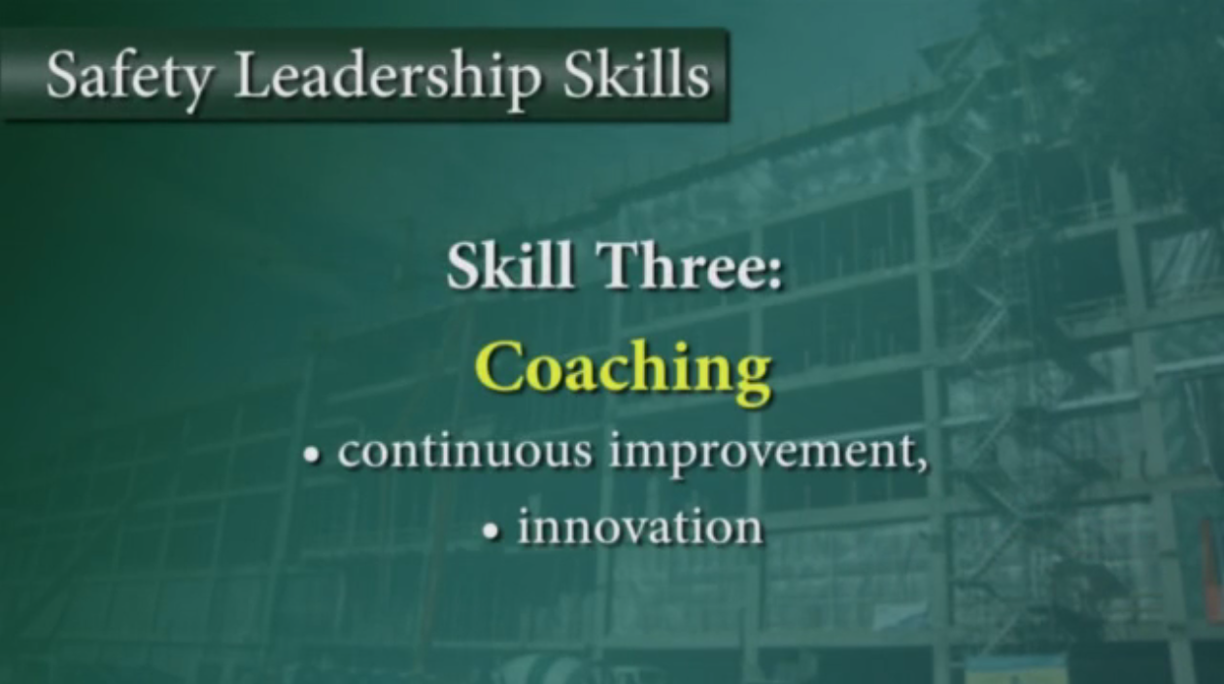
Module 3 - Coaching

Goal: Learn about coaching teams

If you motivate your team and you put forth effort to manage their performance, you will be an effective leader today. If you want to take your crew and your organization to the next level, you need to coach your team for continuous improvement an innovation.

Listen, show compassion, and treat people like individuals
- Negativity, yelling and screaming will not inspire your team
- Adapt to the individual needs of your team
- Show your team that you care about each of them

Teaching
- Give your team a hands on learning experience
- Have patience when teaching
- Do not belittle
- Teaching increases skills and motivation

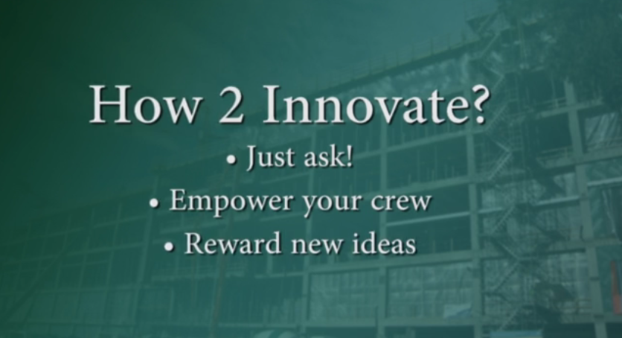
Innovation
- Your team should feel like they are all a part of finding solutions and decision making
- Encourage problem solving

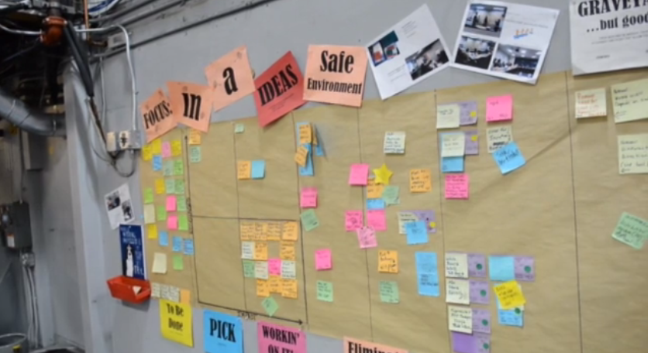
- TIP – Create an idea board for everyone to post ideas to improve safety, productivity, and the quality of your product. Review the board frequently with your team and take action.

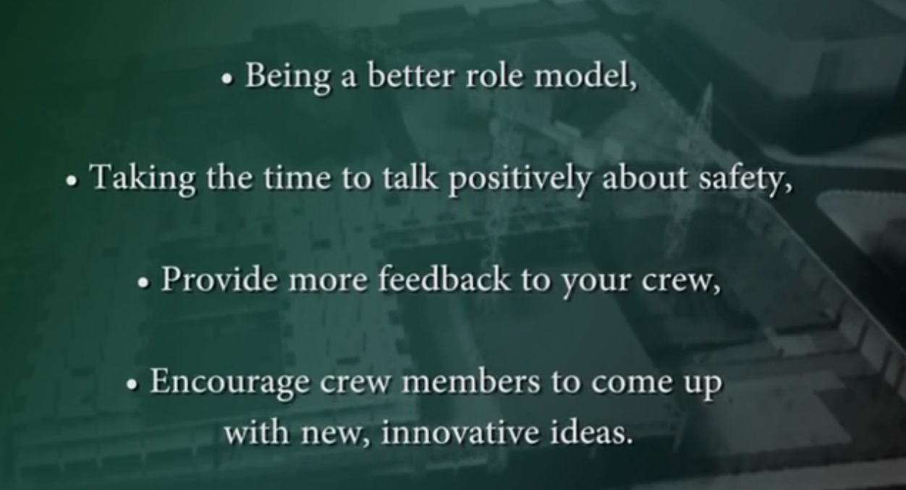
Summary Module

Goal: Summarize leadership skills and goal set

Effective leadership results in:
- Greater productivity and a successful business
- Team safety and health
- Learning
- Positive moral
- More motivation

Remember You’re not going to prove yourselves over the next week, you’ll prove your leadership capabilities over the next 10 years!

Safety Leadership SMART Goals

Take some time to consider what your safety leadership goals are. What SMART goals will help you become a better safety leader on the construction jobsite next week, next month, next year, and 10 years from now? Refer to pages 6-7 in this guide to write your SMART goals.

- __________________________________________________________________________________________________________________________

- __________________________________________________________________________________________________________________________

- __________________________________________________________________________________________________________________________

- __________________________________________________________________________________________________________________________

- __________________________________________________________________________________________________________________________

